POSITIVE PARTNERSHIPS · PROFESSIONAL LEARNING
Facilitator Guide
Secondary Education
SESSION  1 | SESSION  2 | SESSION  3 | SESSION  4 | SESSION  5 | SESSION  6

One page for every slide. Each page shows the slide, what it is for, what to do and say, the activity and how long to spend.
Workshop day 8:30 - 4:00 · Timings are indicative · PHASE 5 DRAFT

How to use this guide
The guide follows the six slide decks exactly. Every visible slide has its own page, in deck order, so you can keep the guide open beside the presenter view and turn one page per slide.
Each session opens with a planning page: the intent, what participants will leave with, what to prepare, and a run sheet with clock times.
EVERY SLIDE PAGE HAS
Header strip | The session colour, the session name and the slide number in the deck.
Slide and facts | A picture of the slide, the suggested minutes, the running clock, the grouping, and the Participant Guide page if there is one.
Purpose | One line on why the slide is there.
What to do | Numbered steps, in order.
Key messages | What participants should take from the slide.
You might say | Wording you can use or adapt, where the team has written it.
Activity card | Format, grouping, time, the prompt, steps, how to bring the room back and how to close.
Keep in mind | Cautions and what to avoid.
Background and thread | Context for you, and how the slide links to other sessions.

SESSION COLOURS
Each session keeps the colour used in the Participant Guide, so the page a participant has open matches the colour on your page.

The day at a glance
Time | Session |  | Slides | Page
8:30 - 9:45 | 1 | The Lens | 17 slides | p. 5
9:45 - 10:45 | 2 | Understanding Autistic Experience  Sensory and Thinking | 23 slides | p. 23
10:45 - 11:00 |  | Morning tea
11:00 - 12:30 | 3 | Autistic Experience at Secondary School  Communication, Connection and Identity | 28 slides | p. 47
12:30 - 1:00 |  | Lunch
1:00 - 2:15 | 4 | Learning Design  Redesigning a lesson, task or handover, tested against real students | 21 slides | p. 76
2:15 - 3:15 | 5 | Working in Partnership  Who should I involve in this journey? | 18 slides | p. 99
3:15 - 4:00 | 6 | Flourishing & Full Circle  One change, one purposeful conversation | 11 slides | p. 118

The thread through the day
Participants hold two or three real, different students in mind from Session 1 onwards. Several Participant Guide pages carry forward:
- Session 1: Think about your students and My starting point (returned to in Session 6).
- Session 3: the secondary day map, the audit and the Carry into design card (brought to Session 4).
- Session 4: the trio design and the private My students check.
- Session 5: Bridge to the next family conversation (brought to Session 6).
- Session 6: Start · Continue · Reconsider and Plan the next conversation.

Ways of working
- Keep the students participants have in mind anonymous. Initials or roles only, in the room and on paper.
- Discuss systems, routines and environments, not identifiable students, families or colleagues.
- Every activity has an option to pass. Participants may move, write, listen or step out as they need.
- Look at the environment, task and routine before asking a student to change.
- Include strengths, interests and joy alongside barriers and support needs.
- Treat observations as questions to explore with the student and family, not conclusions about what a student feels.
- Participants write in their Participant Guide. Page numbers are on every slide page of this guide.

Before the day
☐ Local Traditional Custodians name confirmed and Acknowledgement of Country prepared in your own words.
☐ Student voice video tested with sound, captions on and transcript available.
☐ Participant Guides (Session summary p. 3; activities pp. 4 - 5), pens and plain paper.
☐ Venue details for housekeeping: exits, facilities, quiet space, breaks and feedback arrangements.
☐ Whiteboard or chart paper to capture recurring words and questions.
☐ Tables set for small-group discussion.
☐ Overwhelm and sensory joy video clips cued and tested with sound
☐ Autistic thinking video clip cued (once sourced)
☐ Participant Guide open at p. 6 - 9
☐ Pens, and Participant Guide p. 7 for the sensory activity
☐ Small groups set up for the sensory activity
☐ Participant Guide for every participant (pages 11 to 16)
☐ Purple, blue and orange Post-it notes on each table, and wall space to group them by colour
☐ Communication experiences video and masking video cued, with captions and a transcript
☐ Sample Year 9 timetable: one per participant who does not have a real timetable to use
☐ Pens in at least two colours for the day map
☐ Carry into design card: one per participant, if using the printed card as well as p. 16
☐ Replacement closing image for slide 28 (the current image includes a puzzle piece)
☐ Signs for three corners of the room: A lesson, An assessment task, A handover.
☐ A3 trio sheet (PL Secondary - Session 4 - A3 trio sheet): one per trio, sections 1 - 4 used across the session.
☐ "My students" card: one per person, for the private check and the commitment.
☐ Printed option cards on each table (Executive functioning meets assessment, Predictability across the timetable, Supports that travel, Visual supports).

SESSION  1 | 8:30 - 9:45 · 75 MINUTES · 17 SLIDES  The Lens

SESSION INTENT
Welcome participants, centre student voice and establish a neurodiversity-affirming, strengths-based approach. Participants bring two or three different students to mind and begin examining the assumptions that shape school experience, using an environment-first lens.
PARTICIPANTS LEAVE WITH
- Hold two or three different students in mind as a reference point for the day.
- Use consistent language for neurodiversity, neurodivergence and autism.
- Describe a neurodiversity-affirming, environment-first lens and the idea of dynamic disability.
- Identify assumptions in one familiar school routine and how curiosity could change the next response.

RUN SHEET
Clock | Segment | Slides | Minutes
8:30 - 8:36 | Opening and acknowledgements | 1-4 | 6
8:36 - 8:45 | Welcome, introductions and housekeeping | 5-6 | 9
8:45 - 9:05 | Students in mind and student voice | 7-9 | 20
9:05 - 9:18 | The lens: language, affirming stance, social model | 10-12 | 13
9:18 - 9:33 | Look again at school | 13-14 | 15
9:33 - 9:40 | DSE and dynamic disability | 15-16 | 7
9:40 - 9:45 | Today's workshop and transition | 17 | 5

PREPARE
☐ Local Traditional Custodians name confirmed and Acknowledgement of Country prepared in your own words.
☐ Student voice video tested with sound, captions on and transcript available.
☐ Participant Guides (Session summary p. 3; activities pp. 4 - 5), pens and plain paper.
☐ Venue details for housekeeping: exits, facilities, quiet space, breaks and feedback arrangements.
☐ Whiteboard or chart paper to capture recurring words and questions.
☐ Tables set for small-group discussion.

SESSION 1 | The Lens | SLIDE 1 of 17

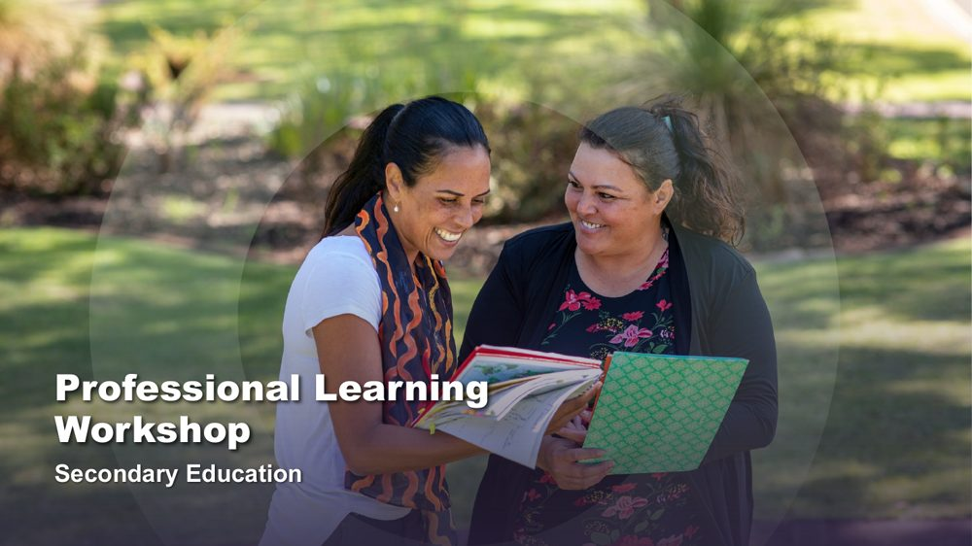 | Professional Learning Workshop - Secondary Education  SUGGESTED TIME  2 min  CLOCK  8:30 - 8:32

Introduce the shared starting point for the day: how educators understand students and school.
WHAT TO DO  - Have the title slide on screen as participants arrive and settle.  - Welcome participants and introduce the delivery team.  - Name this as professional learning about understanding Autistic experience and improving access, belonging and partnership.  - Frame the day around curiosity and support, not fixing students or making them appear less Autistic.  - Keep this opening brief so the student reflection and student voice retain enough time. | KEY MESSAGES  - The day begins with the lens educators bring to students and school.  - Curiosity will connect the six sessions.

SESSION 1 | The Lens | SLIDE 2 of 17

 | Acknowledgement of Country  SUGGESTED TIME  2 min  CLOCK  8:32 - 8:34

Acknowledge the Traditional Custodians of the land on which the workshop is taking place.
WHAT TO DO
- Deliver the Acknowledgement of Country in your own words, following organisational protocol.
- Name the Traditional Custodians of the land where the workshop is being held, where this has been confirmed.
- Allow a brief pause before moving on.

KEEP IN MIND
- Do not read a generic script you have not prepared; take time before the day to learn the local Country and custodians.
- Keep the Acknowledgement respectful and unhurried, even if the session is running late.

SESSION 1 | The Lens | SLIDE 3 of 17

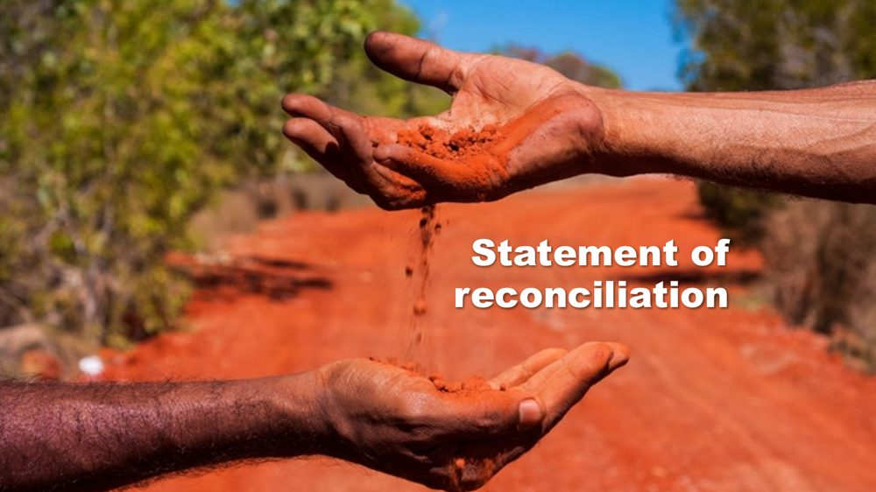 | Statement of reconciliation  SUGGESTED TIME  1 min  CLOCK  8:34 - 8:35

Share the organisation's commitment to reconciliation.
WHAT TO DO
- Share the organisation's statement of reconciliation as provided, following organisational protocol.
- Move on without adding commentary or discussion.

SESSION 1 | The Lens | SLIDE 4 of 17

 | First Nations advisory  SUGGESTED TIME  1 min  CLOCK  8:35 - 8:36

Advise First Nations participants that the workshop may contain images and voices of people who are no longer with us.
WHAT TO DO
- Read the advisory aloud or leave it on screen long enough for everyone to read it.
- Move on without further comment.

SESSION 1 | The Lens | SLIDE 5 of 17

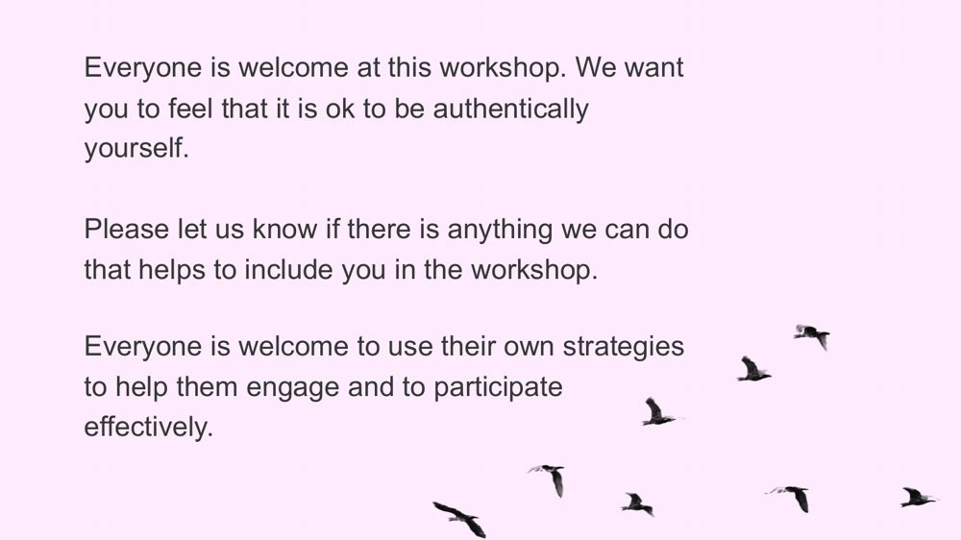 | Everyone is welcome  SUGGESTED TIME  6 min  CLOCK  8:36 - 8:42  GROUPING  Whole room

Welcome participants, establish an accessible way of working together and invite brief introductions.
WHAT TO DO  - Read or paraphrase the welcome: everyone is welcome to be authentically themselves and to use their own strategies to engage.  - Tell participants they may move, regulate, write, speak, listen or pass as needed.  - Invite participants to let the team know, at any time, if there is anything that would help include them.  - Invite brief introductions using first name, professional role and one hope for the day.  - Do not ask participants to identify a student, school or diagnosis. | KEY MESSAGES  - Different ways of participating are welcome.  - Participants bring useful knowledge and questions from their own settings.

ACTIVITY | Brief introductions with an option to pass whole room · 4 minutes
Your first name, your role and one thing you hope to understand better today.
- Model a concise introduction.
- Keep the round moving so no participant is pressured to give personal detail.
- Group the hopes into broad themes without naming individual students or schools.
Close: Let participants know where their themes sit across the six sessions.

KEEP IN MIND
- In a large room, use table introductions rather than a full-room round so the timing holds.

SESSION 1 | The Lens | SLIDE 6 of 17

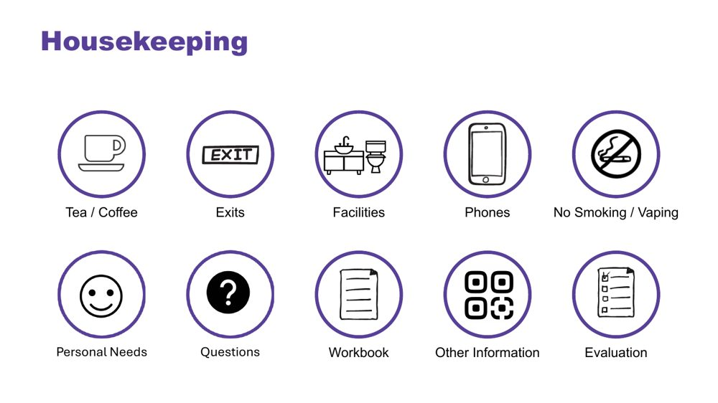 | Housekeeping  SUGGESTED TIME  3 min  CLOCK  8:42 - 8:45

Cover facilities, personal needs, questions and local arrangements.
WHAT TO DO
- Cover exits, facilities, breaks, phones, questions, participant materials, local arrangements and feedback plans.
- Point out any quiet or low-sensory space available at the venue.
- Explain how and when questions can be asked, including in writing.
- Cover venue-specific information here.

SESSION 1 | The Lens | SLIDE 7 of 17

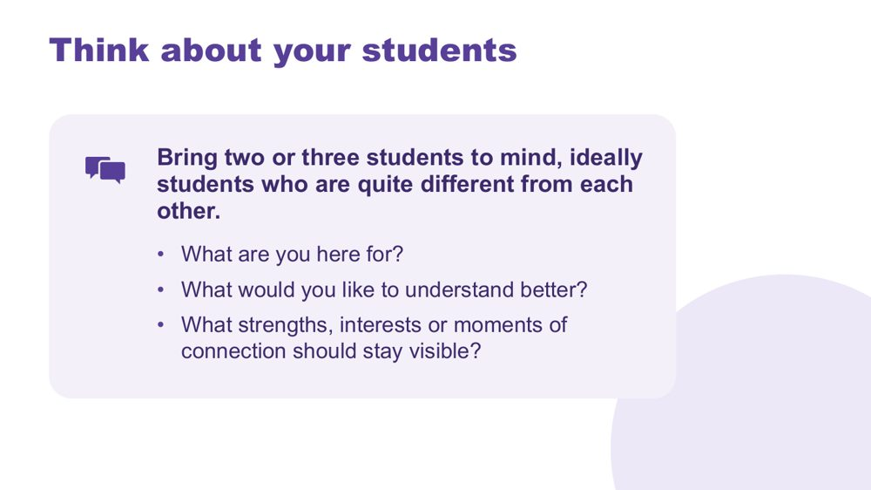 | Think about your students  SUGGESTED TIME  7 min  CLOCK  8:45 - 8:52  GROUPING  On your own  PARTICIPANT GUIDE  Page 4 - Think about your students

Give every participant a student-centred point of reference for the day.
WHAT TO DO  - Invite participants to bring two or three students to mind, ideally students who are quite different from each other.  - Suggest they might differ in age, communication or what school feels like for them.  - Ask participants to note initials or roles only, with no names or identifying details.  - Use the questions on screen to support private reflection.  - Give quiet thinking time before inviting any optional sharing.  - If participants share, redirect descriptions away from labels and towards what they want to understand.  - Ask participants to return to the same students during later mapping and design activities. | KEY MESSAGES  - See each student as a whole person, with strengths and interests as well as needs.  - Holding several different students builds a broad, mixed picture of Autistic experience.  - Questions can remain open while participants gather a fuller picture.

ACTIVITY | Private reflection on your own · 5 minutes
What are you here for? What would you like to understand better? What strengths, interests or moments of connection should stay visible?
- Ask participants to write without using students' names or school.
- Invite them to include strengths, interests or moments of connection as well as questions.
- Keep sharing optional.
Close: Ask participants to keep the reflection available for the rest of the day.

Thread The students brought to mind here return in the school-day mapping (Session 3), classroom design (Session 4) and final reflection (Session 6).

SESSION 1 | The Lens | SLIDE 8 of 17

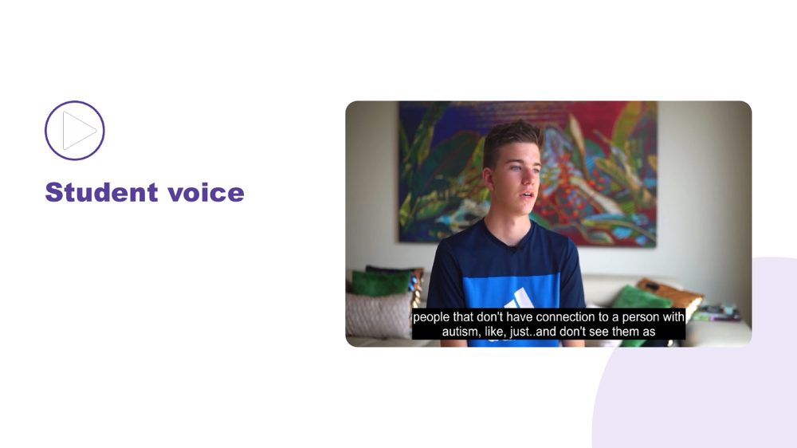 | Student voice  SUGGESTED TIME  6 min  CLOCK  8:52 - 8:58

Make space for Autistic young people to be heard in their own words.
WHAT TO DO  - Introduce the video as an opportunity to listen rather than diagnose, compare or extract a single lesson.  - Ensure captions are on and a transcript is available.  - Play the video without interrupting. | KEY MESSAGES  - Student voice is part of the workshop evidence.  - Each speaker's account is their own.

SESSION 1 | The Lens | SLIDE 9 of 17

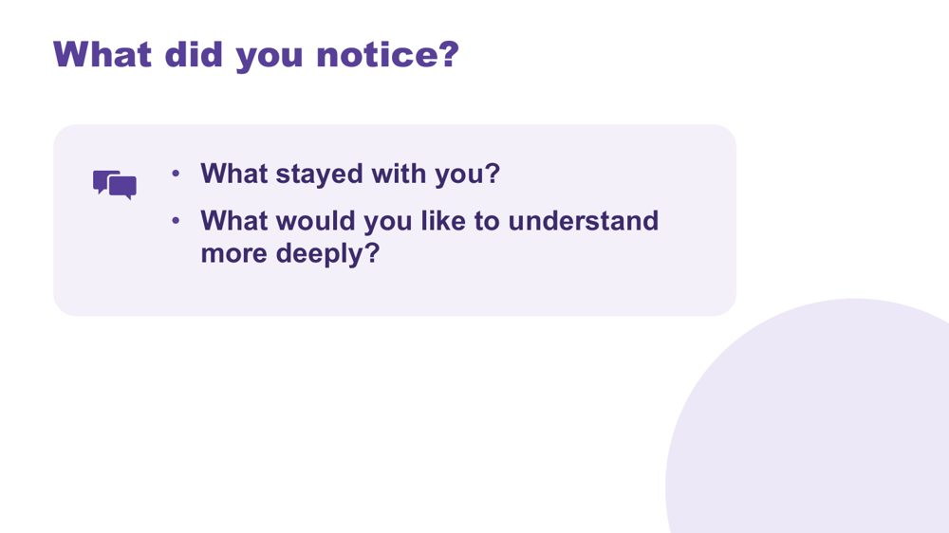 | What did you notice?  SUGGESTED TIME  7 min  CLOCK  8:58 - 9:05  GROUPING  On your own  PARTICIPANT GUIDE  Page 4 - What did you notice?

Support reflection on the student voice material.
WHAT TO DO
- Invite brief private reflection on the questions before discussion.
- Invite observations grounded in what speakers said rather than interpretations of appearance or behaviour.
- Avoid asking participants to compare a speaker with a student they teach.
- Record a few recurring words or questions without forcing consensus.
- Record questions that need follow-up through the appropriate program or local channel.

ACTIVITY | Think, write and optional share on your own · 6 minutes
What did you notice? What stayed with you? What would you like to understand more deeply?
- Give a minute or two of quiet writing time.
- Invite a few optional contributions from the room.
- Capture recurring words or questions where everyone can see them.
Close: Link participants' questions to the sensory, thinking, communication and school-day content that follows.

SESSION 1 | The Lens | SLIDE 10 of 17

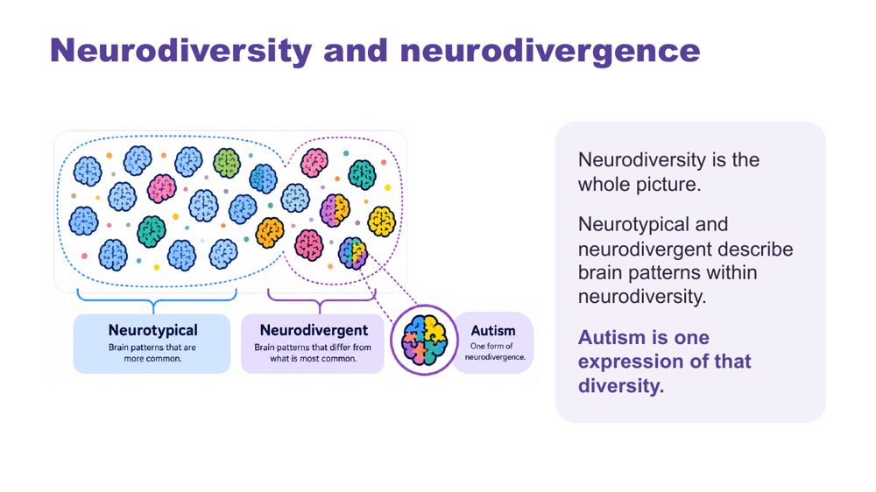 | Neurodiversity and neurodivergence  SUGGESTED TIME  4 min  CLOCK  9:05 - 9:09

Introduce the language for neurodiversity and neurodivergence.
WHAT TO DO  - Explain neurodiversity and neurodivergence using the workshop definitions on the slide.  - Keep the explanation brief and connected to the student-centred curiosity established earlier.  - Respect the language individuals use for themselves. | KEY MESSAGES  - Neurodiversity includes everyone.  - Neurotypical and neurodivergent describe brain patterns within neurodiversity; autism is one expression of that diversity.  - Use one consistent language frame across the workshop.  - Terminology should support dignity and curiosity rather than categorising students by worth.

SESSION 1 | The Lens | SLIDE 11 of 17

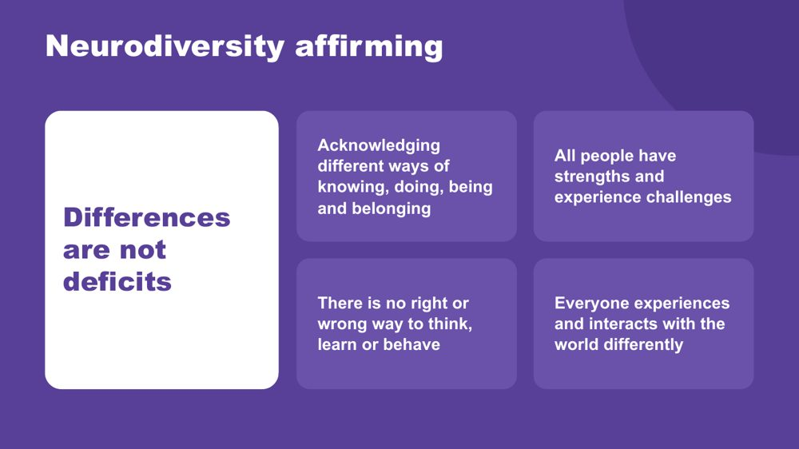 | Neurodiversity affirming  SUGGESTED TIME  5 min  CLOCK  9:09 - 9:14

Establish the practical, strengths-based stance participants will use throughout the day.
WHAT TO DO  - Walk through the principles on the slide.  - Connect the principles to the students participants brought to mind earlier.  - Ask what becomes visible when strengths, interests, joy and ways of connecting are included.  - Clarify that a strengths-based approach does not erase difficulty, access needs or fluctuating capacity.  - Model language that describes the environment and support needed without blaming the student. | KEY MESSAGES  - Begin with the person.  - Include strengths and joy alongside barriers and support needs.  - Stay curious about access and support.

SESSION 1 | The Lens | SLIDE 12 of 17

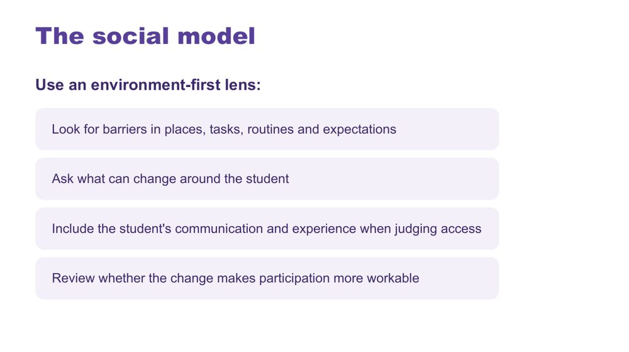 | The social model  SUGGESTED TIME  4 min  CLOCK  9:14 - 9:18

Connect the workshop lens with an environment-first view of barriers.
WHAT TO DO  - Explain the social model through barriers in places, tasks, routines and expectations.  - Walk through the environment-first steps on the slide.  - Direct discussion towards what can change around the student.  - Emphasise including the student's communication and experience when judging access. | KEY MESSAGES  - Look for barriers before asking the student to change.  - Environment and support are part of the experience being examined.

KEEP IN MIND
- Avoid implying that all difficulty disappears when an environment changes.

SESSION 1 | The Lens | SLIDE 13 of 17

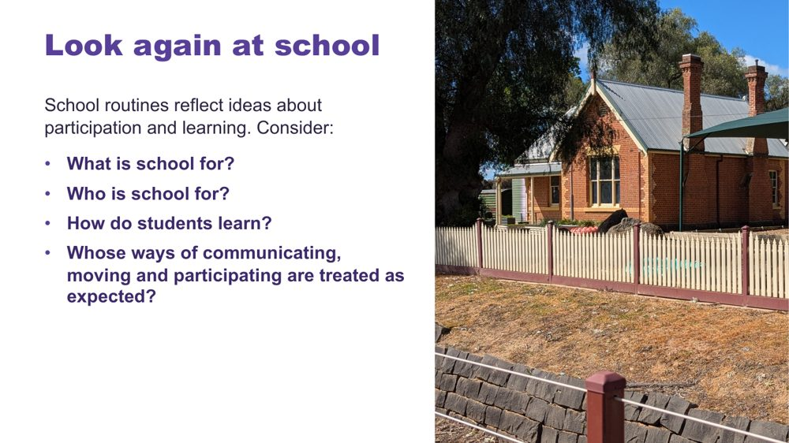 | Look again at school  SUGGESTED TIME  5 min  CLOCK  9:18 - 9:23  PARTICIPANT GUIDE  Page 5 - Look again at school

Help participants notice assumptions about the purpose, audience and methods of school.
WHAT TO DO  - Use the school questions to open reflective thinking; there is no single correct answer.  - Give a short moment of private thinking on the four questions.  - Invite participants to notice assumptions built into everyday routines, expectations and decisions. | KEY MESSAGES  - Assumptions shape what schools notice, reward and change.

KEEP IN MIND
- Keep the tone reflective rather than blaming individual educators.

SESSION 1 | The Lens | SLIDE 14 of 17

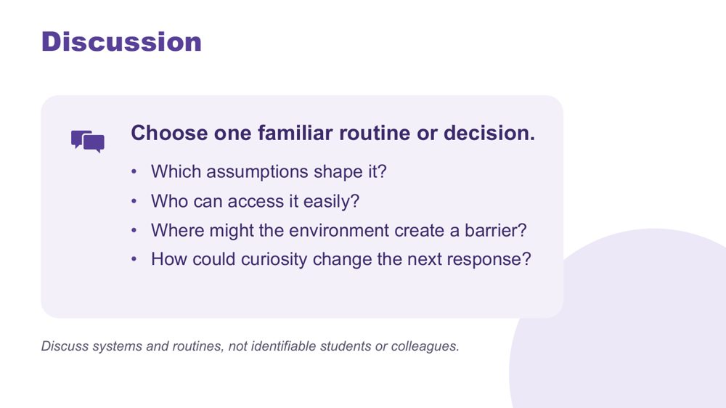 | Discussion  SUGGESTED TIME  10 min  CLOCK  9:23 - 9:33  GROUPING  Small groups  PARTICIPANT GUIDE  Page 5 - Look again at school (discussion)

Apply the questions to one familiar routine or decision and consider how curiosity could change the next response.
WHAT TO DO  - Move participants into small groups.  - Give each group one of the school questions to begin with, then the discussion prompts on screen.  - Ask groups to choose one familiar routine or decision to examine.  - Remind groups to discuss systems and routines, not identifiable students or colleagues.  - When examples become student-focused, ask what the environment, task or expectation contributed.  - Invite one concise observation from each group. | KEY MESSAGES  - Being curious gives us time to change the environment or task before placing more demands on a student.

ACTIVITY | Small-group discussion small groups · 10 minutes
Choose one familiar routine or decision. Which assumptions shape it? Who can access it easily? Where might the environment create a barrier? How could curiosity change the next response?
- Give each group one question to begin with.
- Ask groups to discuss systems and routines rather than naming individual students or colleagues.
- Invite one concise observation from each group.
Bring the room back
- Invite one example where curiosity could change the next response.
Close: Point out that the discussion has moved from assumptions about students to questions about access, environment and learning design.

KEEP IN MIND
- Keep the tone reflective rather than blaming individual educators.

SESSION 1 | The Lens | SLIDE 15 of 17

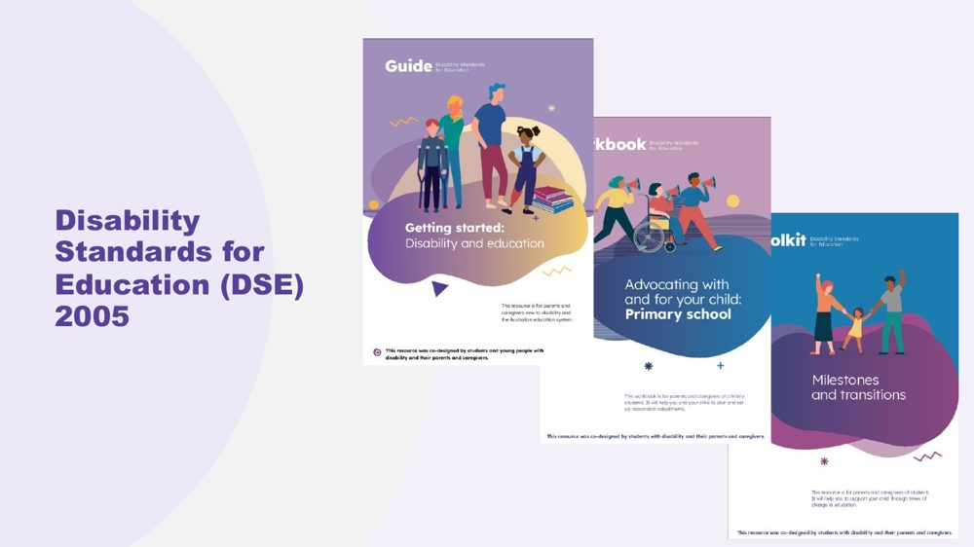 | Disability Standards for Education (DSE) 2005  SUGGESTED TIME  3 min  CLOCK  9:33 - 9:36

Point participants to the Disability Standards for Education 2005 and the Department of Education resources that support them.
WHAT TO DO
- Introduce the Disability Standards for Education 2005 briefly as part of the context for access and adjustments.
- Point participants to the three Department of Education resources listed below.
- Note that the workbook is written for parents and carers, so educators know what families may be reading.
- Refer detailed or school-specific questions to the appropriate program or local channel.

KEEP IN MIND
- Do not give legal advice or add legal claims beyond the published resources.

RESOURCES
- Getting started - Department of Education, Australian Government - https://www.education.gov.au/disability-standards-education-2005/resources/getting-started
- Advocating with and for your child: A workbook for parents and carers - Department of Education, Australian Government - https://www.education.gov.au/disability-standards-education-2005/resources/advocating-and-your-child-workbook-parents-and-carers
- Milestones and transitions - Department of Education, Australian Government - https://www.education.gov.au/disability-standards-education-2005/resources/milestones-and-transitions

SESSION 1 | The Lens | SLIDE 16 of 17

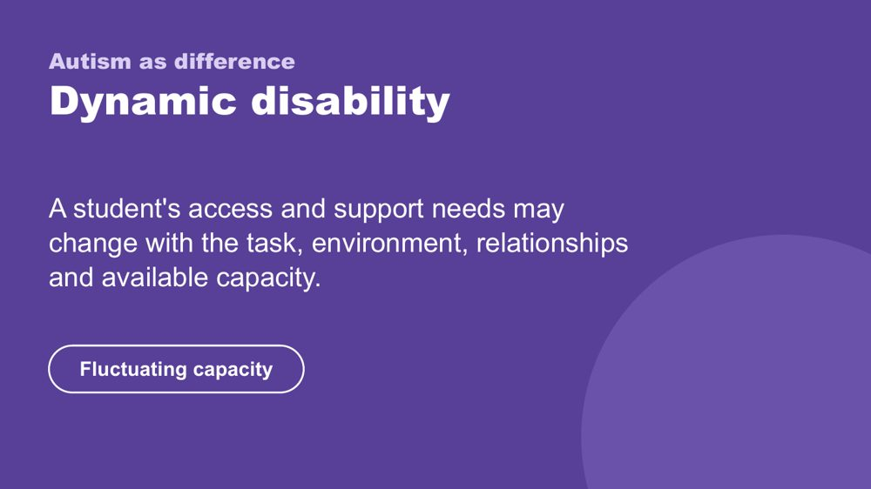 | Autism as difference - dynamic disability  SUGGESTED TIME  4 min  CLOCK  9:36 - 9:40

Introduce the framing of autism as difference and dynamic disability.
WHAT TO DO  - Explain how access and support needs can vary with the task, environment, relationships and available capacity.  - Name fluctuating capacity: what a student can do one day or in one setting may not be available in another.  - Connect the concept back to the need for curiosity across settings and days. | KEY MESSAGES  - Support should respond to the student and context rather than a fixed assumption.  - Strengths and substantial support needs can both belong in the picture.

KEEP IN MIND
- Avoid presenting one pattern of ability, need or capacity as universal.
- Do not add clinical, diagnostic or legal claims.

SESSION 1 | The Lens | SLIDE 17 of 17

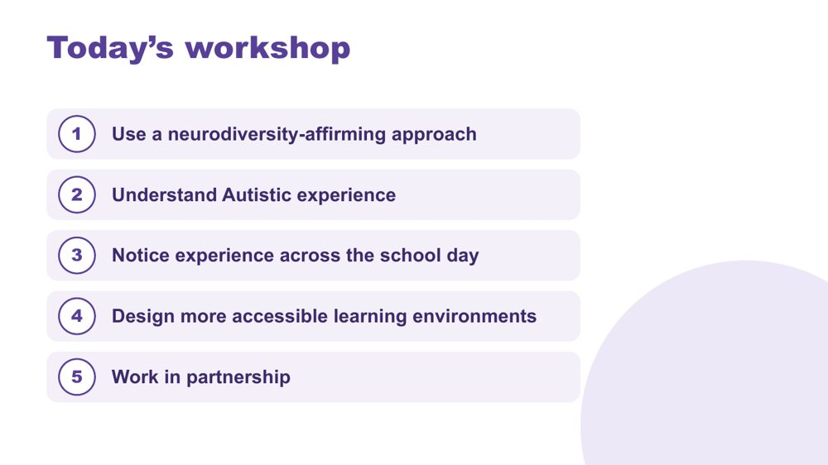 | Today's workshop  SUGGESTED TIME  5 min  CLOCK  9:40 - 9:45  PARTICIPANT GUIDE  Page 5 - My starting point

Orient participants to the learning progression across the full day.
WHAT TO DO  - Walk through the five aims on the slide without turning it into a detailed agenda.  - Explain that Sessions 1 and 2 build a shared understanding and that the secondary school application becomes explicit from Session 3.  - Point out morning tea at 10:45 - 11:00 and lunch at 12:30 - 1:00.  - Remind participants that timings are indicative.  - Invite participants to complete My starting point in the Participant Guide; it returns in Session 6.  - Preview that Session 2 explores sensory processing, Autistic thinking and internal signals. | KEY MESSAGES  - The day moves from lens and understanding to school-day experience, classroom design and partnership.  - Belonging, capacity and joy remain visible across the whole sequence.

Thread My starting point is revisited in Session 6 (Flourishing & Full Circle).

SESSION  2 | 9:45 - 10:45 · 60 MINUTES · 23 SLIDES  Understanding Autistic Experience  Sensory and Thinking

SESSION INTENT
Build a picture of the students participants have in mind through three lenses: sensory processing, Autistic thinking and internal signals. The session is strengths-based, includes first-person Autistic voices, and keeps attention on environments, task demands and support rather than treating any single pattern as universal.
PARTICIPANTS LEAVE WITH
- describe the eight senses and four sensory response patterns, including sensory joy and stimming
- look at the sensory and task demands of a classroom routine before the student's response
- name detail-first processing, deep focus (monotropism) and executive functioning as lenses for inquiry, and connect them to the students they have in mind
- consider early signs of overwhelm and who else needs to know them

RUN SHEET
Clock | Segment | Slides | Minutes
9:45 - 9:47 | Opening frame | 1 | 2
9:47 - 10:05 | Sensory processing, voices and profiles | 2-9 | 18
10:05 - 10:13 | Sensory activity | 10 | 8
10:13 - 10:26 | Autistic thinking | 11-17 | 13
10:26 - 10:35 | Thinking discussion | 18 | 9
10:35 - 10:44 | Internal signals and reading the signs | 19-22 | 9
10:44 - 10:45 | Close and tea | 23 | 1

PREPARE
☐ Overwhelm and sensory joy video clips cued and tested with sound
☐ Autistic thinking video clip cued (once sourced)
☐ Participant Guide open at p. 6 - 9
☐ Pens, and Participant Guide p. 7 for the sensory activity
☐ Small groups set up for the sensory activity

SESSION 2 | Understanding Autistic Experience | SLIDE 1 of 23

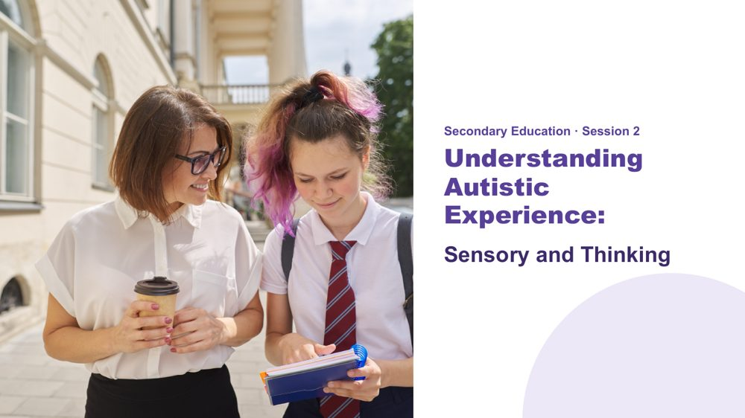 | Understanding Autistic Experience: Sensory and Thinking  SUGGESTED TIME  2 min  CLOCK  9:45 - 9:47  PARTICIPANT GUIDE  Page 6 - Session 2 summary

Orient the room to Session 2 and reconnect participants with the students they brought to mind in Session 1.
WHAT TO DO  - Orient the room before starting.  - Name the opening activity from Session 1: bringing two or three students to mind.  - Ask participants to keep those students in mind for the whole session.  - Name the three parts of the session: sensory processing, Autistic thinking and internal signals.  - Explain that the session offers areas to be curious about. It is not a checklist for deciding what a student experiences. | KEY MESSAGES  - This session is strengths-based.  - The three lenses are not deficit labels - they are tools for understanding.  - The goal is recognition and shared understanding of the Autistic experience.  - Common areas for inquiry do not replace knowing the individual student.  - Ask what the environment and task demand as well as what the student may need.

YOU MIGHT SAY
In this session we are going to build a picture of the students you have in mind. Not a list of what is hard, and not a catalogue of traits. A picture.
Each idea we look at is a piece. As we move through Session 2 and Session 3, the picture will be clearer.
Keep those students in mind as we go. This session is about them.

KEEP IN MIND
- Keep examples grounded in access and support.

Thread This is the opening frame. The "coming into focus" image logic starts here - fragments that build into a whole. Return to this at the close of Session 3.

SESSION 2 | Understanding Autistic Experience | SLIDE 2 of 23

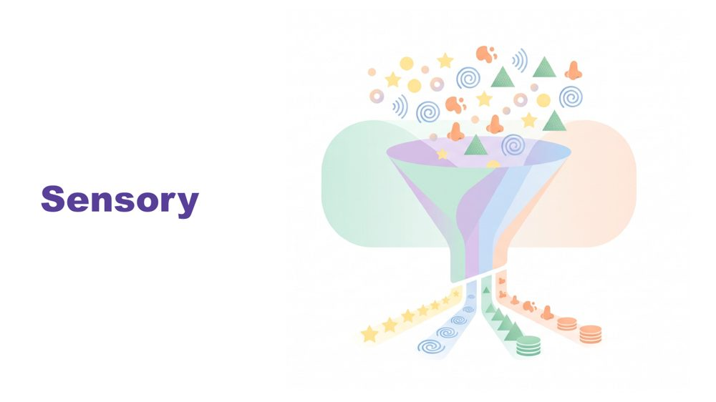 | Sensory  SUGGESTED TIME  1 min  CLOCK  9:47 - 9:48

Set sensory experience as the foundation for everything that follows.
WHAT TO DO  - Introduce sensory as the starting point, before thinking, communication or connection.  - Pause briefly.  - Move to the senses. | KEY MESSAGES  - Sensory inquiry should include joy and authentic expression as well as discomfort or overload.  - Observation is a starting point for curiosity, not proof of what a student feels.  - Context matters.

YOU MIGHT SAY
Before we talk about thinking, or communication, or connection - we start here. With the senses.
Because before a student has thought a single thought, the world has already arrived. And how it arrives matters.

KEEP IN MIND
- Avoid a long content lecture before the sensory activity.

Thread Sensory is the foundation. Later in the day, name explicitly that thinking, communication and connection all flow from this starting point.

SESSION 2 | Understanding Autistic Experience | SLIDE 3 of 23

 | What is sensory processing?  SUGGESTED TIME  1 min  CLOCK  9:48 - 9:49

Establish a shared definition of sensory processing.
WHAT TO DO
- Ask the room: What is sensory processing?
- Take one or two quick answers.
- Give the definition.

YOU MIGHT SAY
Sensory processing is the way the brain receives, processes and responds to information from the senses.

SESSION 2 | Understanding Autistic Experience | SLIDE 4 of 23

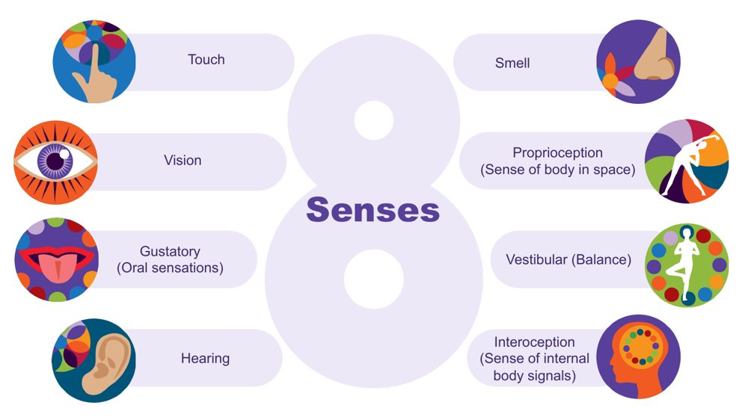 | The eight senses  SUGGESTED TIME  3 min  CLOCK  9:49 - 9:52

Extend the familiar five senses to eight and introduce interoception to return to later.
WHAT TO DO  - Start from the five senses many of us were taught: touch, vision, taste, hearing and smell.  - Ask the room to name the three less well known senses. Give time to respond.  - Name them: proprioception, vestibular and interoception.  - Describe proprioception and vestibular with a school example for each.  - Name interoception and park it: say you will come back to it.  - Connect the senses to everyday school environments. | KEY MESSAGES  - There are 8 senses, not 5.  - The hidden three are often where Autistic differences are most significant.  - Interoception is flagged here and developed in depth later - plant that seed.

YOU MIGHT SAY
Proprioception is the sense of where the body is in space. Students who crash into things, seek heavy pressure, or need to feel their body may be seeking proprioceptive input.
Vestibular is balance and movement. A student who needs to rock, spin, or keep moving in class may be regulating through this sense.
Interoception is the body's inside sense - and it is one of the most important for understanding a student's experience at school. Park it for now.
We will come back to interoception, it connects to a lot of what follows.

Background Touch (tactile) gives information about texture, pain, pressure and temperature. Vision gives depth, colour, size, shape and position. The gustatory sense includes taste and other oral sensations such as texture, temperature and how much pressure is needed when chewing. Hearing (auditory) tells us how far away, how loud and how familiar a sound is, and its pitch. Smell (olfactory) can link strongly to emotional memory. Proprioception comes through joints, muscles, ligaments and deep in the skin; differences may mean bumping into things. The vestibular sense sits in the middle ear, tracks speed and direction of head movement and supports balance; a student may love spinning, or may feel off balance on stairs. There is lots of crossover between the senses: in any situation we use all or most of them.
Thread Interoception returns as a full section in the internal signals slides at the end of this session.
RESOURCES
- Interoception webinar recording and resources on the Positive Partnerships website

SESSION 2 | Understanding Autistic Experience | SLIDE 5 of 23

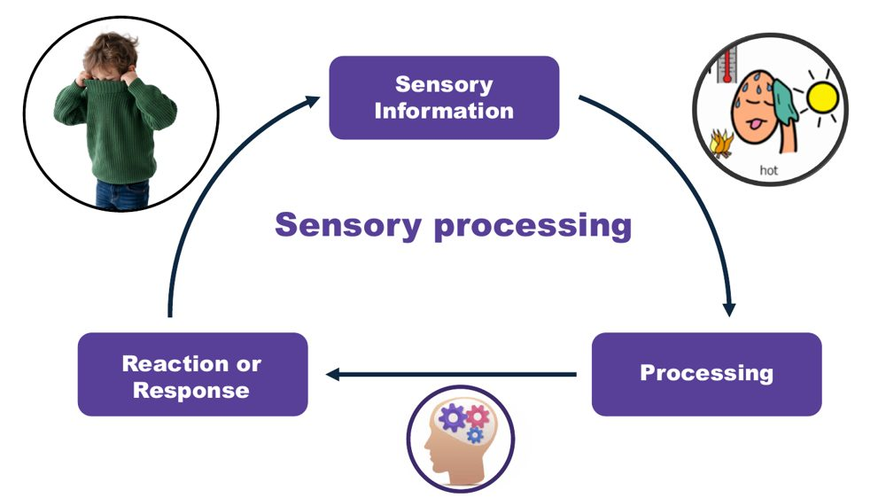 | Sensory processing: information, processing, response  SUGGESTED TIME  2 min  CLOCK  9:52 - 9:54

Show the three steps of sensory processing and that the response is not a choice.
WHAT TO DO  - Walk through the three steps using the jumper example.  - List what sensory processing helps us do.  - Finish on the point that the response is not a choice. | KEY MESSAGES  - The way the brain processes and responds to sensory information is not a choice.

YOU MIGHT SAY
Think about what is involved in someone taking their jumper off when they get too hot. First, sensory information is received to tell them they are getting too hot. This is processed and related to previous experiences. A response is generated - taking the jumper off.
Sensory processing helps us stay safe, keep track of what our body is doing, understand our environment, learn, and filter out information so we can pay attention and engage.
The way our brain processes sensory information and responds is not a choice.

SESSION 2 | Understanding Autistic Experience | SLIDE 6 of 23

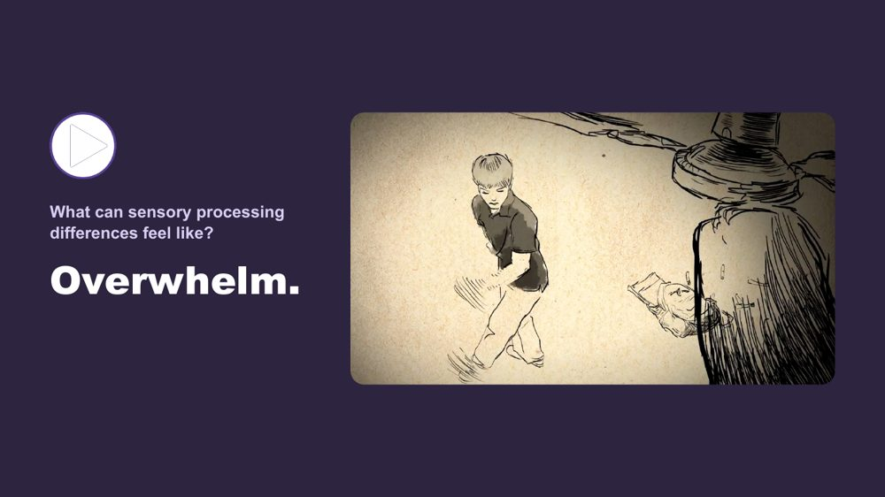 | What can sensory processing differences feel like? Overwhelm  SUGGESTED TIME  3 min  CLOCK  9:54 - 9:57

Help participants understand what sensory overload can feel like, through a first-person account.
WHAT TO DO
- Introduce the two short clips before playing the first.
- Name the pattern: at a few points today we stop and hear from Autistic people directly.
- Play the overwhelm clip.
- After the clip, give a moment. Do not speak immediately.

YOU MIGHT SAY
We are going to watch two short clips. One shows what sensory overload can feel like from the inside. One shows sensory joy - what it is like when the senses are working with you rather than against you. Both are real. Both belong in the room.
We do this in a few places today - we stop and hear from Autistic people directly. That is not an add-on. It is the evidence.
Some of you will have seen something you recognised. Some of you may not have. Both responses are fine.

Thread This video does the same job as the thinking video and the communication video later in the day - it shifts the room from intellectual understanding to felt recognition.

SESSION 2 | Understanding Autistic Experience | SLIDE 7 of 23

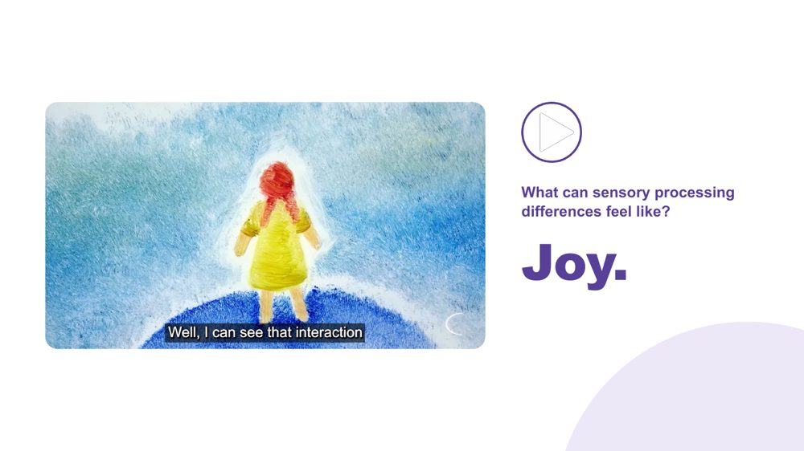 | What can sensory processing differences feel like? Joy  SUGGESTED TIME  3 min  CLOCK  9:57 - 10:00

Balance the overwhelm clip with sensory joy so sensory experience is not framed only through distress.
WHAT TO DO  - Play the joy clip.  - Name that sensory experience is a source of richness as well as difficulty. | KEY MESSAGES  - Sensory experience includes both difficulty and joy.  - First-person accounts are more powerful than any explanation.  - Recognition - not information - is the goal here.

YOU MIGHT SAY
Sensory experience is not only a source of difficulty. For many Autistic people, it is also a source of richness, depth, and genuine pleasure.
The same nervous system that can be overwhelmed by sound can be transported by music. Both are true.

SESSION 2 | Understanding Autistic Experience | SLIDE 8 of 23

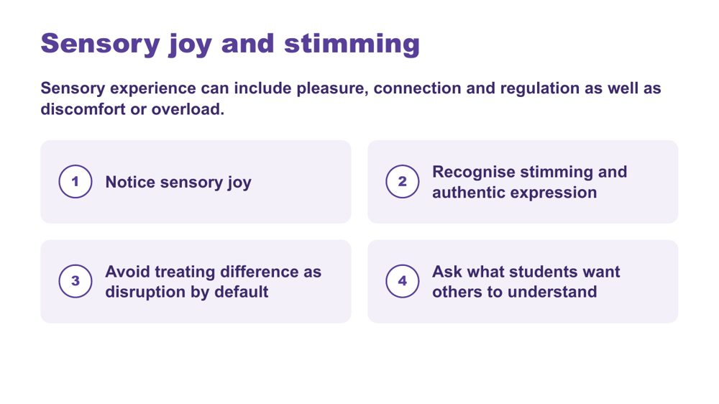 | Sensory joy and stimming  SUGGESTED TIME  2 min  CLOCK  10:00 - 10:02

Recognise sensory joy, stimming and authentic expression as part of sensory experience.
WHAT TO DO  - Read the framing line: sensory experience can include pleasure, connection and regulation as well as discomfort or overload.  - Walk through the four points on the slide.  - Ask participants where they see sensory joy in the students they have in mind. | KEY MESSAGES  - Sensory inquiry should include joy and authentic expression as well as discomfort or overload.  - Stimming can be pleasure, connection, regulation and authentic expression.  - Ask what students want others to understand.

KEEP IN MIND
- Do not discourage harmless stimming.
- Do not frame typical-looking behaviour as the goal.
- Avoid treating difference as disruption by default.

SESSION 2 | Understanding Autistic Experience | SLIDE 9 of 23

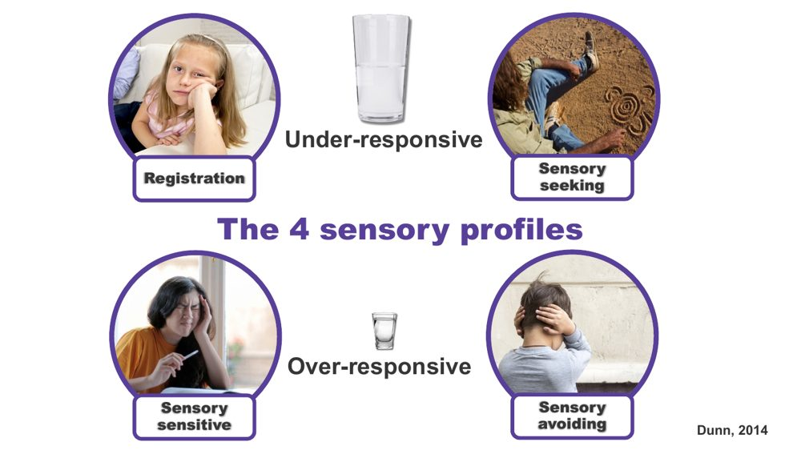 | The 4 sensory profiles  SUGGESTED TIME  3 min  CLOCK  10:02 - 10:05

Introduce four patterns of sensory response as a way to understand a student, not as labels.
WHAT TO DO  - Explain that these are patterns of sensory response, not types of autism.  - Talk through each pattern briefly.  - Name that a student can be seeking in some senses and avoiding in others.  - Mention where educators may meet this framework: occupational therapy reports or a Sensory Profile questionnaire such as the School Companion form. | KEY MESSAGES  - Four patterns: registration, seeking, sensitive, avoiding.  - Students can show different patterns across different senses.  - Patterns can shift with load and context.  - All patterns are the nervous system doing what it needs.  - A sensory profile is not a choice.

YOU MIGHT SAY
Registration (under-responsive): doesn't notice what others notice. May seem to miss cues others respond to.
Sensory seeking: actively looks for more input. Movement, touch, sound. The body asking for what it needs.
Sensory sensitive (over-responsive, passive): notices everything. Distracted, finds busy environments very hard, but does not necessarily act on it.
Sensory avoiding (over-responsive, active): actively works to reduce input. Covers ears, avoids crowds, avoids certain textures.
This is a map, not a label.

KEEP IN MIND
- Treat observations of seeking or avoiding as a starting point for curiosity, not certainty about internal experience.

Background These four profiles are part of a sensory processing framework developed by Professor Winnie Dunn, an occupational therapist at the University of Missouri. The profiles are also called seeker, bystander (registration), avoider and sensor. Everyone has a different comfort level (a different sized cup) for sensory information, and a person may have a different sized cup for different senses, so they can show several profiles. A student may show more than one pattern, and it may shift with the day, the environment or the load they are already carrying. Understanding how sensory differences affect individuals in all environments is critical to supporting success.

SESSION 2 | Understanding Autistic Experience | SLIDE 10 of 23

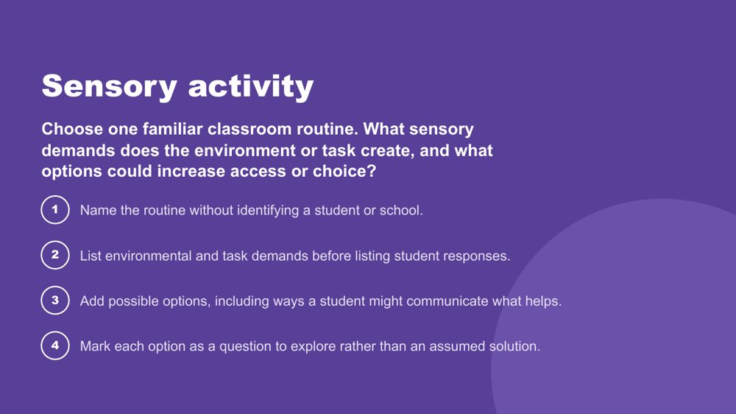 | Sensory activity  SUGGESTED TIME  8 min  CLOCK  10:05 - 10:13  GROUPING  Small groups  PARTICIPANT GUIDE  Page 7 - Sensory activity

Apply an environment-first sensory lens to a familiar classroom routine, without simulating Autistic experience.
WHAT TO DO  - Set up small groups.  - Read the prompt on the slide.  - Run the four steps.  - Ask participants to identify options and choice rather than one support for every student.  - Bring the room back and ask what educators can change, offer or investigate. | KEY MESSAGES  - Look at environmental and task demands before student responses.  - Options are questions to explore, not assumed solutions.

ACTIVITY | Environment-first sensory review small groups · 8 minutes
Choose one familiar classroom routine. What sensory demands does the environment or task create, and what options could increase access or choice?
- Name the routine without identifying a student or school.
- List environmental and task demands before listing student responses.
- Add possible options, including ways a student might communicate what helps.
- Mark each option as a question to explore rather than an assumed solution.
Bring the room back
- What could educators change, offer or investigate before increasing demands on the student?
Close: Ask what educators can change, offer or investigate before increasing demands on the student.

KEEP IN MIND
- Do not run an autism simulation.
- Keep students and schools unidentifiable.
- Treat lighting, sound, movement, proximity, transitions and materials as participant-generated examples, not universal triggers.

SESSION 2 | Understanding Autistic Experience | SLIDE 11 of 23

 | Thinking  SUGGESTED TIME  1 min  CLOCK  10:13 - 10:14

Move from sensory into Autistic thinking.
WHAT TO DO
- Name the shift from how the world arrives to how the mind works with it.
- Remind participants to keep the students they have in mind.

KEEP IN MIND
- Do not present these thinking concepts as universal features of every Autistic student.

SESSION 2 | Understanding Autistic Experience | SLIDE 12 of 23

 | The Detail-First Brain  SUGGESTED TIME  3 min  CLOCK  10:14 - 10:17  PARTICIPANT GUIDE  Page 8 - Strengths I can see

Introduce bottom-up, detail-first processing and the strengths it produces.
WHAT TO DO  - Open with the contrast between filtering first and taking in what is actually there.  - Name this as bottom-up processing.  - Connect it to sensory intensity, literal language, pattern recognition and deep focus.  - Move through the strengths slowly: pattern recognition, systems thinking, deep memory, logical precision, honesty and directness, depth of connection, intense engagement.  - For each strength, invite the room to connect it to the students they have in mind.  - Invite participants to note strengths for Student A, B and C on p. 8 - Strengths I can see, now or during the thinking discussion. | KEY MESSAGES  - Autistic cognition builds from detail up - bottom-up processing.  - This connects to sensory intensity, literal language, and everything that follows.  - The strengths listed are genuine features, not compensations.  - Educators who leave with vocabulary for these strengths will notice and build on them in the classroom.

YOU MIGHT SAY
Most brains filter first - they predict what is there based on expectation and fill in the rest. The detail-first brain does not filter first. It takes in what is actually there. Then it builds the whole picture from those pieces upward. That is bottom-up processing.
This is the architecture that connects sensory intensity, literal language, pattern recognition, and deep focus. They are not a list of separate Autistic traits. They are features of the same way of taking in the world.
Pattern recognition - where do you see this in class, and in which student?
Deep memory - what does one of them know by heart? Does it look different in another?
Honesty and directness - how does this show up at school?
These are not future potential. They are present now.

KEEP IN MIND
- Some educators may be used to a deficit or "despite" lens ("despite X they can Y"), a consolation prize approach. These are genuine features of how this brain works.
- Avoid turning the content into a deficit list.

Background Bottom-up processing is supported by neuroimaging research showing stronger bottom-up signalling in Autistic brains, with less dominant top-down filtering. The environment is registered more fully, more specifically and less pre-organised before reaching conscious awareness. This produces precision and depth. It also produces load: the same fuller intake that supports pattern recognition can also lead to sensory overload. A student may pick up a tiny change in routine, a background sound, or an inconsistency in what someone said. They are not being pedantic. They are seeing accurately. The educator who names a student's pattern recognition as a strength is doing something meaningful for that student's identity and sense of self, and for how peers see them.

SESSION 2 | Understanding Autistic Experience | SLIDE 13 of 23

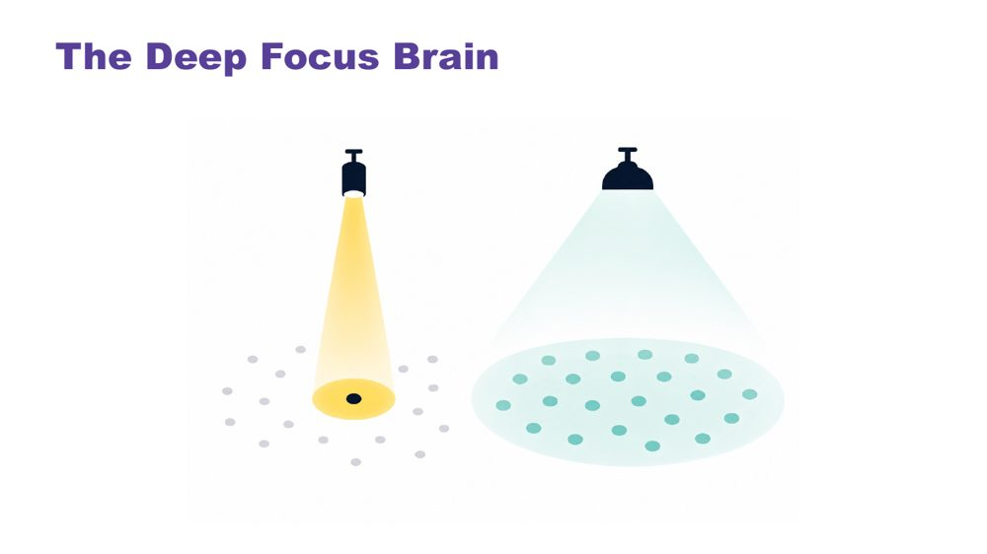 | The Deep Focus Brain  SUGGESTED TIME  3 min  CLOCK  10:17 - 10:20

Introduce monotropism: deep focus, deep interests, transitions and flow.
WHAT TO DO  - Open with a question: do your thoughts travel across many topics, or go deep on one?  - Give the room a moment to reflect.  - Move to the definition, using the visual on the slide.  - Name the key ideas: deep interests, transitions, flow.  - Use the recess example to show the cost of switching. | KEY MESSAGES  - Monotropism: deep focus on fewer things at a time, not distraction or obsession.  - Deep interests are the brain's most reliable route to learning, memory, and genuine engagement.  - Transitions have a real neurological cost - the attention is genuinely invested.  - Flow is the positive expression of this architecture - the brain at its best.  - Developed and extended with Autistic people.

YOU MIGHT SAY
Torch and floodlight: the non-Autistic brain tends to spread attention across many things at once, like a floodlight. The Autistic brain tends to channel it fully into one thing at a time, like a torch beam. Neither is wrong. They illuminate different things.
Tendril theory: the tendrils extend into whatever the mind is focused on. Switching means retracting all of them. That takes time and costs something.
River: the branching river spreads across many channels - broad, covering ground, but shallower in each stream. The single deep river goes all the way in one direction. Neither is wrong. The Autistic thinking brain tends to be the deep river, not scattered, not unfocused, going somewhere completely.
Deep interests are not obsessions or fixations. They are the brain's most natural access to learning, memory, and joy.
Transitions are hard not because the student is being difficult - but because the attention is genuinely, neurologically invested. The river does not change course quickly. With warning and scaffolding this becomes more manageable. The cost is always real.
Flow - full absorption, time disappearing - is this brain at its most powerful. It is worth protecting.
Asking a student absorbed in a construction task, reading about space, drawing or researching a topic they love to stop and pack up when the bell goes is not a simple request. Their attention is fully in that task.

KEEP IN MIND
- Many educators will recognise this in themselves. That is fine to acknowledge, but keep the focus on the students.

Background Monotropism was developed as a framework by Dinah Murray, Mike Lesser and Wenn Lawson, and has been extended by Autistic community voices. It proposes that the core feature of Autistic attention is channelling into fewer things with greater depth, rather than distributing broadly. This explains deep interests, transition difficulty and the experience of flow.
Thread This connects directly to the detail-first brain: the same processing style, one explaining how the world arrives, one explaining where attention goes once it has.
RESOURCES
- Tendril theory comic - https://eisforerin.com/2015/08/10/tendril-theory/

SESSION 2 | Understanding Autistic Experience | SLIDE 14 of 23

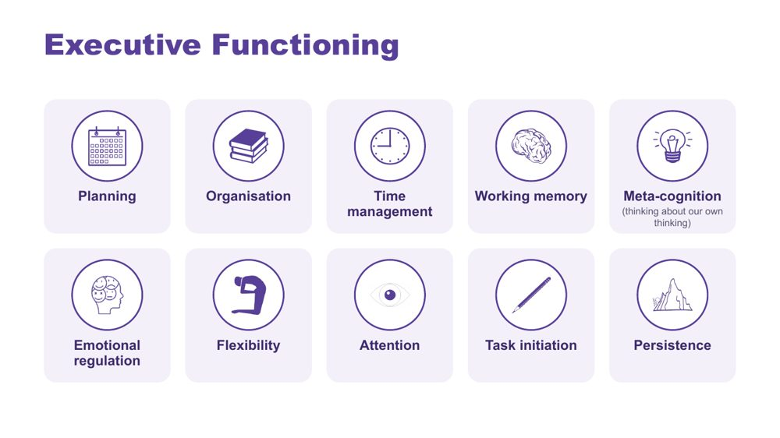 | Executive Functioning  SUGGESTED TIME  2 min  CLOCK  10:20 - 10:22

Name the ten areas of executive functioning and link each to the demands of a school day.
WHAT TO DO  - Name the ten areas on the slide.  - Ask what a task asks the student to plan, start, remember, sequence, organise, switch and complete.  - Ask participants where each area shows up across an ordinary school day for the students they have in mind. | KEY MESSAGES  - The terms are lenses for inquiry, not a checklist.  - Task design, timing and support can affect access.  - Explain each term before applying it.

YOU MIGHT SAY
Useful support responds to the specific demand rather than assuming a lack of effort or motivation. Different demands may need different kinds of support.

KEEP IN MIND
- Consider how instructions, interruptions, switching, starting, sequencing and task completion are organised in the setting, without claiming a single cause.
- Keep the focus on matching support to the individual student and context.

SESSION 2 | Understanding Autistic Experience | SLIDE 15 of 23

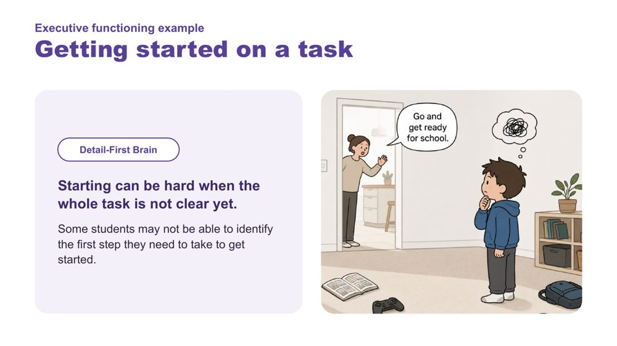 | Executive functioning example: Getting started on a task  SUGGESTED TIME  1 min  CLOCK  10:22 - 10:23

Link the detail-first brain to difficulty getting started.
WHAT TO DO  - Read the example.  - Link it back to the detail-first brain: starting can be hard when the whole task is not clear yet. | KEY MESSAGES  - Some students may not be able to identify the first step they need to take to get started.

SESSION 2 | Understanding Autistic Experience | SLIDE 16 of 23

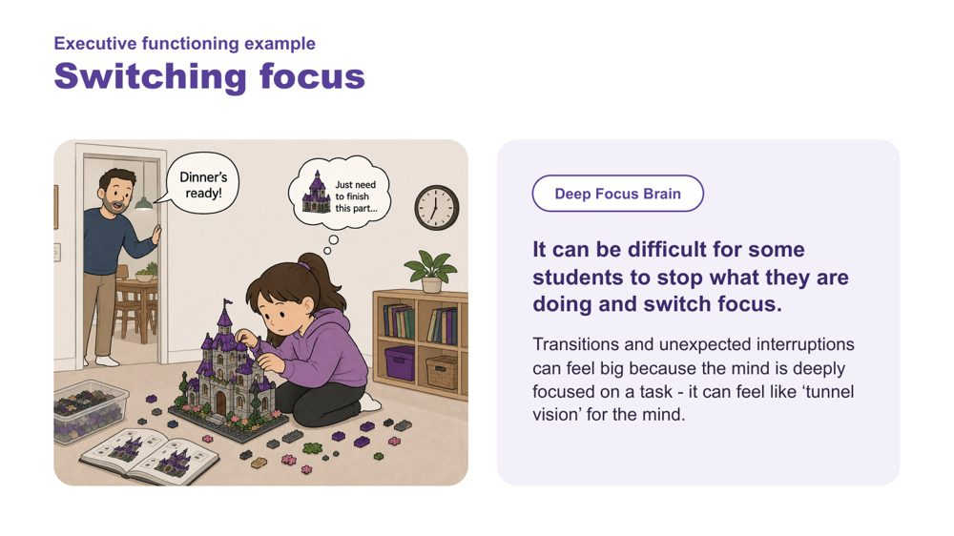 | Executive functioning example: Switching focus  SUGGESTED TIME  1 min  CLOCK  10:23 - 10:24

Link the deep focus brain to difficulty switching focus.
WHAT TO DO  - Read the example.  - Link it back to the deep focus brain and the recess example. | KEY MESSAGES  - Transitions and unexpected interruptions can feel big because the mind is deeply focused on a task - it can feel like 'tunnel vision' for the mind.

SESSION 2 | Understanding Autistic Experience | SLIDE 17 of 23

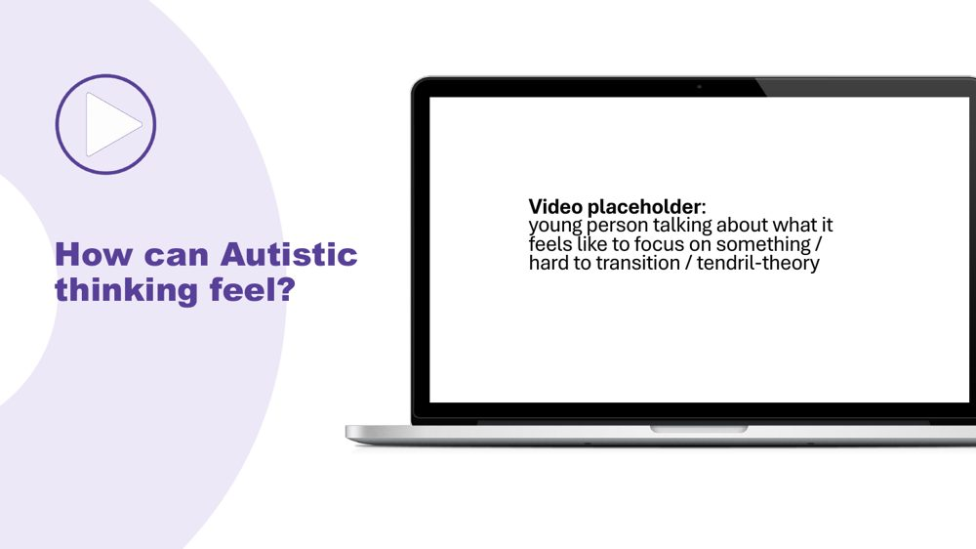 | How can Autistic thinking feel?  SUGGESTED TIME  2 min  CLOCK  10:24 - 10:26

Hear directly from an Autistic young person about deep focus and transitions.
WHAT TO DO  - Play the clip.  - Give a moment before moving on. | KEY MESSAGES  - Hearing from Autistic people directly is a central part of the learning.

Thread Same pattern as the sensory videos: from intellectual understanding to felt recognition.

SESSION 2 | Understanding Autistic Experience | SLIDE 18 of 23

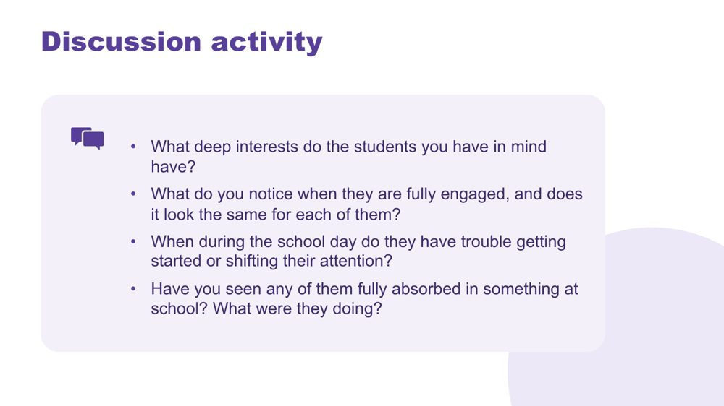 | Thinking discussion  SUGGESTED TIME  9 min  CLOCK  10:26 - 10:35  GROUPING  Pairs  PARTICIPANT GUIDE  Page 8 - Thinking discussion

Consolidate the thinking concepts through personal recognition of the students participants have in mind.
WHAT TO DO  - Direct people to the four questions on the slide.  - Give 8 minutes in pairs.  - Bring the room back and take 2-3 responses.  - Hold the space rather than adding more content.  - Optional extension if time allows: a task-demand review. Ask what a classroom task asks the student to notice, start, hold, switch, sequence or complete. Write the task in neutral language, list its demands in order, mark where the environment or instruction could reduce unnecessary demand, and write one question to explore with the student or team. | KEY MESSAGES  - This activity personalises the concepts: participants move from "I understand this" to "I can see this in the students I have in mind".  - The questions connect to the concepts: deep interests, starting and shifting, and flow.  - Educators who can name these things in a student leave the room with something practical to use in the classroom.  - The activity surfaces strengths alongside challenges: flow and deep interests sit alongside starting and shifting.

YOU MIGHT SAY
Everything you have just described, that IS the thinking brain at work. Noticing it is the beginning of working with it rather than against it.

ACTIVITY | Discussion pairs · 8 minutes
Think about the students you have in mind.
- What deep interests do the students you have in mind have?
- What do you notice when they are fully engaged, and does it look the same for each of them?
- When during the school day do they have trouble getting started or shifting their attention?
- Have you seen any of them fully absorbed in something at school? What were they doing?
Bring the room back
- What came up for people?
Close: Everything you have just described, that IS the thinking brain at work. Noticing it is the beginning of working with it rather than against it.

KEEP IN MIND
- You do not need to comment extensively on each response; the room hearing each other is the consolidation.
- Separate what a task requires from what the student appears to do; avoid inferring internal processes from behaviour alone.

Background The activity follows the same pattern as the sensory activity. The purpose is consolidation through personal recognition, not information transfer. What participants say to each other will likely do more work than the preceding slides.
Thread The last question, flow, sets up a question for Session 3: what happens to that focus when the student tries to communicate or connect?

SESSION 2 | Understanding Autistic Experience | SLIDE 19 of 23

 | Internal signals  SUGGESTED TIME  1 min  CLOCK  10:35 - 10:36

Introduce the final part of the session: what is happening inside.
WHAT TO DO  - Return to interoception, parked earlier in the sensory section.  - Name that internal experience may not be visible to an observer. | KEY MESSAGES  - Internal experience may not be visible to an observer.

Thread Interoception was named with the eight senses; this is where it comes back.

SESSION 2 | Understanding Autistic Experience | SLIDE 20 of 23

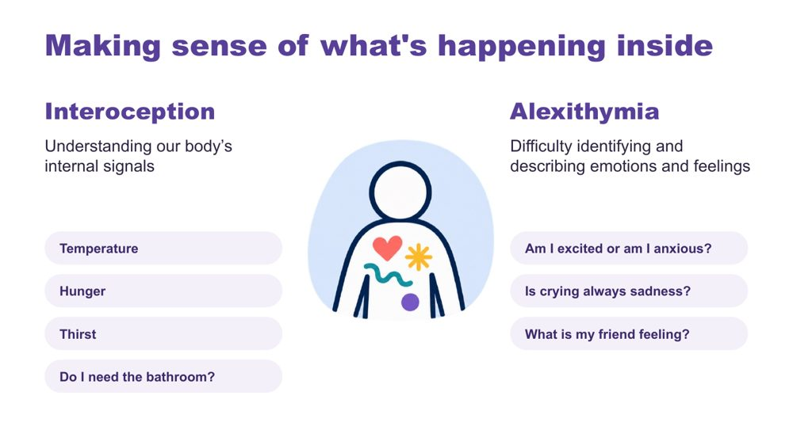 | Making sense of what's happening inside  SUGGESTED TIME  2 min  CLOCK  10:36 - 10:38

Introduce interoception and alexithymia using the examples on the slide.
WHAT TO DO  - Introduce interoception: understanding our body's internal signals (temperature, hunger, thirst, needing the bathroom).  - Introduce alexithymia: difficulty identifying and describing emotions and feelings.  - Use the slide's questions as examples: Am I excited or am I anxious? Is crying always sadness? What is my friend feeling? | KEY MESSAGES  - Interoception helps answer the question "how am I doing?"  - Internal experience may not be visible to an observer.

KEEP IN MIND
- Name interoception and alexithymia without improvising definitions.
- Do not assume a student's internal state from outward behaviour.

Background Interoception is needed for knowing when to go to the toilet; knowing when you are tired, hungry or thirsty; knowing if you are hot or cold; being aware that you are becoming angry or upset. It plays a part in being able to self-regulate.

SESSION 2 | Understanding Autistic Experience | SLIDE 21 of 23

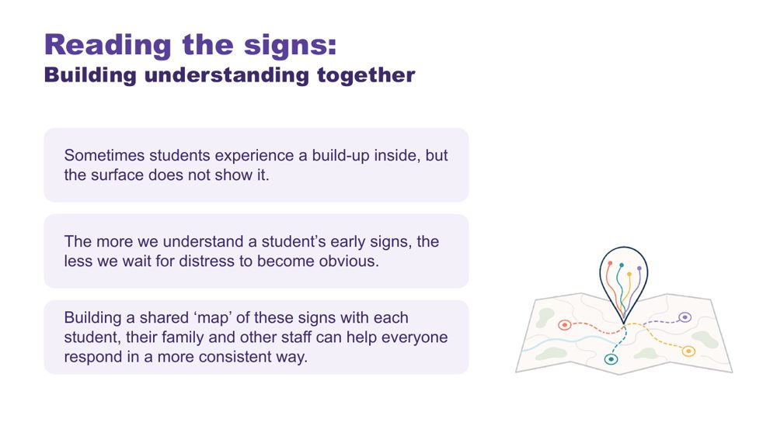 | Reading the signs: building understanding together  SUGGESTED TIME  2 min  CLOCK  10:38 - 10:40

Show why understanding a student's early signs, together, matters.
WHAT TO DO  - Read the three points on the slide.  - Name who builds the shared map: each student, their family and other staff. | KEY MESSAGES  - Sometimes students experience a build-up inside, but the surface does not show it.  - The more we understand a student's early signs, the less we wait for distress to become obvious.  - A shared map of signs helps everyone respond in a more consistent way.

KEEP IN MIND
- Analogies and observations support discussion but do not replace the student's own communication.

SESSION 2 | Understanding Autistic Experience | SLIDE 22 of 23

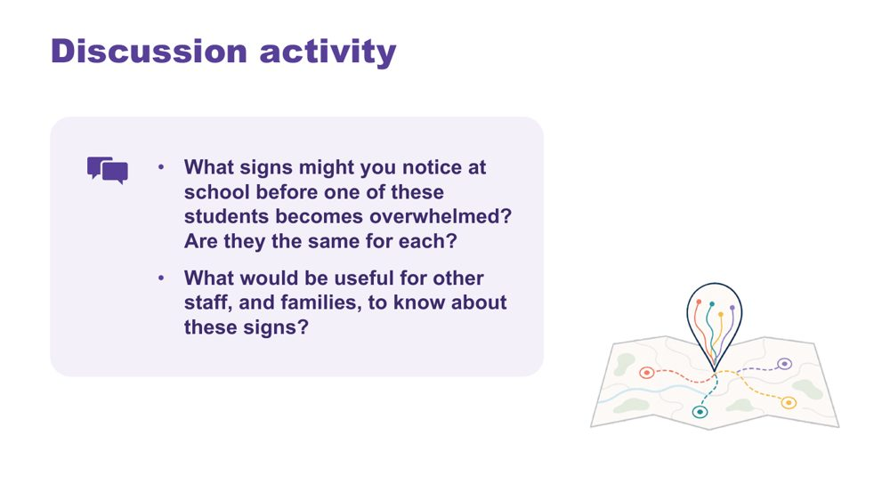 | Reading the signs discussion  SUGGESTED TIME  4 min  CLOCK  10:40 - 10:44  GROUPING  Pairs  PARTICIPANT GUIDE  Page 9 - Reading the signs

Help participants think about early signs of overwhelm at school and who needs to know them.
WHAT TO DO  - Read the two questions on the slide.  - Give pairs a few minutes.  - Take one or two responses. | KEY MESSAGES  - Signs may differ between students.  - Families and other staff are part of reading the signs.

ACTIVITY | Discussion pairs · 3 minutes
What signs might you notice at school before one of these students becomes overwhelmed? Are they the same for each?
- Note the signs you might see at school for each of the students you have in mind.
- Compare: are they the same for each?
- Discuss what would be useful for other staff, and families, to know about these signs.
Bring the room back
- What would be useful for other staff, and families, to know about these signs?

KEEP IN MIND
- Do not assume a student's internal state from outward behaviour.
- Use initials or roles only.

Thread Invite participants to consider how students can communicate capacity and what the environment can do with that information. This sets up the partnership work in Session 5.

SESSION 2 | Understanding Autistic Experience | SLIDE 23 of 23

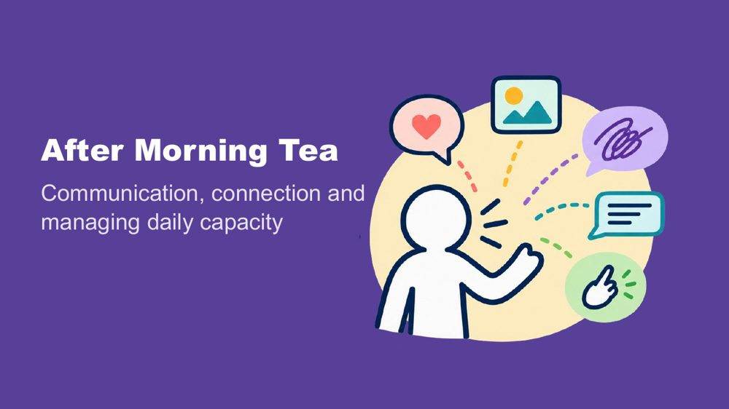 | After Morning Tea  SUGGESTED TIME  1 min  CLOCK  10:44 - 10:45

Close Session 2, confirm the tea break and preview what comes next.
WHAT TO DO  - Confirm the tea break (10:45 - 11:00).  - Preview Session 3: communication, connection and managing daily capacity across a secondary school day. | KEY MESSAGES  - The next session maps demand and capacity through a secondary school day.

SESSION  3 | 11:00 - 12:30 · 90 MINUTES · 28 SLIDES  Autistic Experience at Secondary School  Communication, Connection and Identity

SESSION INTENT
Connect communication, connection, capacity, masking and identity to the secondary school day. Participants think through one student's day across six periods, map a real or sample Year 9 timetable period by period for the students they have in mind, look at how masking can increase in the teenage years, then audit one part of the day that runs across classes and choose a focus to take into the design work after lunch.
PARTICIPANTS LEAVE WITH
- recognise that communication is multimodal and that how much a student speaks does not show how much they understand
- use double empathy to ask whose expectations shape an interaction, and name the many ways students connect
- map a secondary school day period by period, marking what costs energy (C), what lightens or gives energy back (L) and what is not known yet (?) for each of the students they have in mind
- recognise that masking can increase in the teenage years, and that a calm, quiet student may still be carrying a high load
- audit one part of the day that runs across classes and choose one thing to keep, reduce and explore, carrying the Reduce item into Session 4

RUN SHEET
Clock | Segment | Slides | Minutes
11:00 - 11:02 | Welcome back | 1 | 2
11:02 - 11:23 | Communication | 2-9 | 21
11:23 - 11:36 | Connection and double empathy | 10-13 | 13
11:36 - 11:45 | Managing daily capacity across the timetable | 14-17 | 9
11:45 - 12:00 | Map the secondary day: costs and lightens | 18-20 | 15
12:00 - 12:17 | Masking in the teenage years | 21-25 | 17
12:17 - 12:27 | Audit the secondary day and carry into design | 26-27 | 10
12:27 - 12:30 | Close: positive Autistic identity | 28 | 3

PREPARE
☐ Participant Guide for every participant (pages 11 to 16)
☐ Purple, blue and orange Post-it notes on each table, and wall space to group them by colour
☐ Communication experiences video and masking video cued, with captions and a transcript
☐ Sample Year 9 timetable: one per participant who does not have a real timetable to use
☐ Pens in at least two colours for the day map
☐ Carry into design card: one per participant, if using the printed card as well as p. 16
☐ Replacement closing image for slide 28 (the current image includes a puzzle piece)

SESSION 3 | Autistic Experience at Secondary School | SLIDE 1 of 28

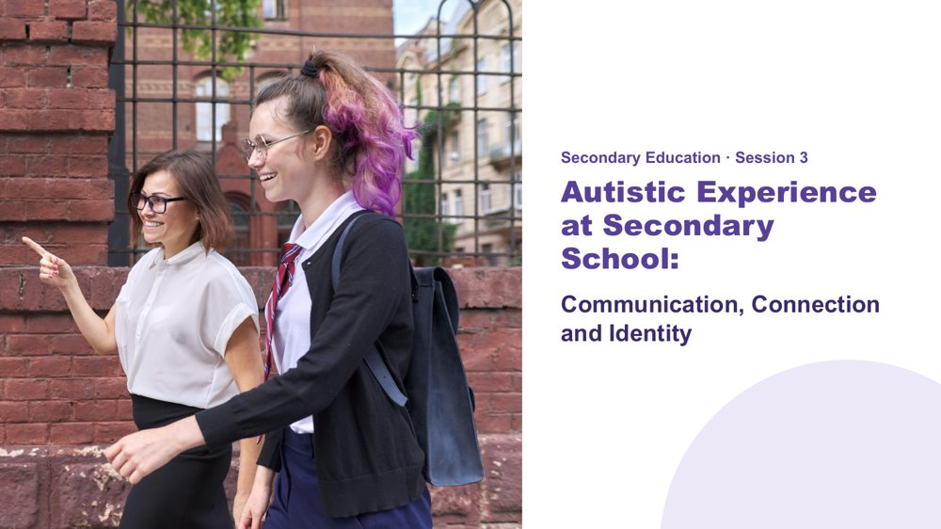 | Autistic Experience at Secondary School  SUGGESTED TIME  2 min  CLOCK  11:00 - 11:02  PARTICIPANT GUIDE  Page 10 - Session 3 summary

Welcome participants back and introduce communication, connection and capacity across a secondary school day.
WHAT TO DO  - Welcome participants back from the break.  - Explain that this session applies the ideas so far to the secondary school day.  - Ask participants to bring back the two or three students they have in mind.  - Outline the session: communication and connection, a day map across the timetable, masking in the teenage years, and an audit of one part of the day that runs across classes.  - Invite participants to stay curious about each student's experience rather than assuming what a behaviour means.  - Keep examples within education practice and avoid discussing identifiable incidents. | KEY MESSAGES  - A student's school day includes much more than the timetable shows.  - What one teacher sees in one period is only part of the student's day.  - Communication, connection, demand and belonging all affect each other across the day.

Thread Builds on the picture of the students started in Sessions 1 and 2, and leads into the design work in Session 4 after lunch.

SESSION 3 | Autistic Experience at Secondary School | SLIDE 2 of 28

 | Communication  SUGGESTED TIME  1 min  CLOCK  11:02 - 11:03

Open the communication section.
WHAT TO DO  - Introduce the communication section: multimodal communication, understanding and expressing, and AAC.  - Explain that speech is not the only valid way to communicate, and that how much a student speaks does not tell us how much they understand.  - Ask participants to think about where, across the secondary day, the students they have in mind need to understand or be understood: asking for help, sharing an idea, making a choice, joining in, saying no, letting someone know something is wrong, or understanding a change. | KEY MESSAGES  - Communication access belongs in lesson and task design, in every subject.  - Students may need different ways to understand, respond, ask, pause or decline.  - Keep explanations practical and refer specialist questions through the appropriate channel.

KEEP IN MIND
- Use only examples suitable for secondary education.
- Avoid presenting one communication approach as suitable for every student.

SESSION 3 | Autistic Experience at Secondary School | SLIDE 3 of 28

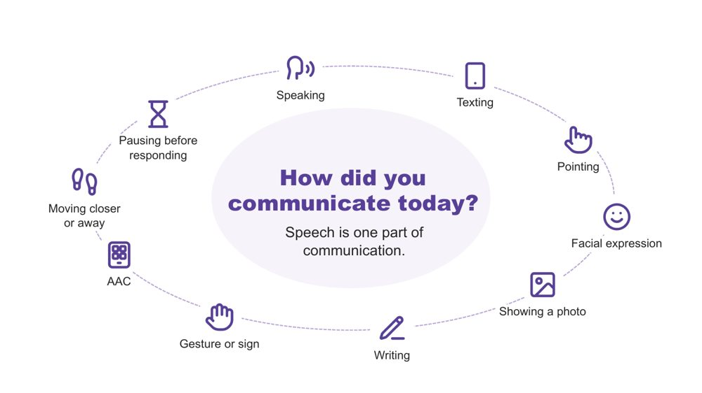 | How did you communicate today?  SUGGESTED TIME  2 min  CLOCK  11:03 - 11:05

A quick warm-up showing that everyone communicates in many ways, every day.
WHAT TO DO  - Invite a quiet think: three ways participants have communicated since waking.  - Pause for about 20 seconds.  - Invite two or three people to share one. Sharing is optional.  - Reflect back the variety you hear, for example a text message, a wave, a look, or taking a moment before answering. | KEY MESSAGES  - Everyone communicates in many ways, every day. Speech is one part of communication.

YOU MIGHT SAY
Let's start with a quick, quiet think. Since you woke up this morning, how have you communicated? See if you can think of three different ways.
Would two or three people be happy to share one?
We all move between different ways of communicating, often without noticing. Every way on this slide is real communication. No way is more valid than another.

KEEP IN MIND
- Keep this brief (1 - 1.5 minutes). It is a warm-up, not a discussion.
- Do not use percentages or claims about how much of communication is spoken or non-spoken.

Background Many students have heard "use your words" or "just ask" at school. This is a reminder for educators that pointing, a device, a message, a look or moving away are all ways of communicating.

SESSION 3 | Autistic Experience at Secondary School | SLIDE 4 of 28

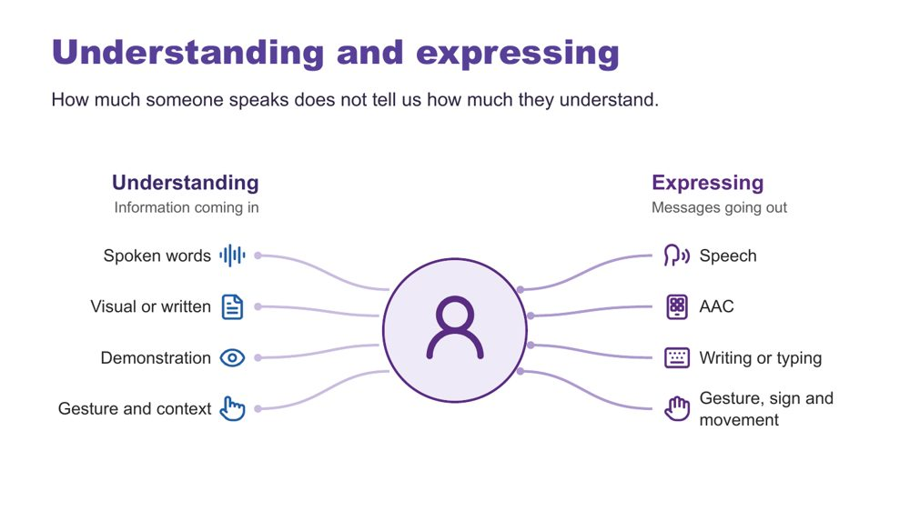 | Understanding and expressing  SUGGESTED TIME  2 min  CLOCK  11:05 - 11:07

Separate understanding (receptive) from expressing (expressive) communication.
WHAT TO DO  - Explain that Autistic people have varied communication profiles.  - Explain that someone may express a great deal but need support to understand spoken information, and someone else may understand more than they can easily express.  - Note that communication can change depending on the person, place, demands and how someone is feeling.  - Explain AAC in plain terms (see the background notes).  - Ask what communication access the room and the task provide. | KEY MESSAGES  - How much someone speaks does not tell us how much they understand.  - Do not assume fluent speech means full understanding. Do not assume limited speech means limited understanding.  - Expressive and receptive communication do not necessarily look the same.

KEEP IN MIND
- Do not teach gestalt language processing (GLP) or Natural Language Acquisition stages here. It is background only.
- Do not ask participants to identify or diagnose a student as a gestalt language processor.
- Refer individual assessment or intervention questions to the student's speech pathologist or relevant team.

Background Receptive communication means how a person receives and makes sense of information. In secondary school this includes instructions from several teachers a day, subject-specific vocabulary, questions, class discussion, assessment information, corridor and break-time language, notices, changes to the timetable and information about what is happening next. Expressive communication means how a person shares messages, ideas, feelings and choices through any communication method. AAC (augmentative and alternative communication) may include gesture, signs, a communication board or book, typing or a communication device; some people use it alongside speech and some instead of speech. Echolalia means repeating words or phrases, immediately or later, and can have communicative meaning. Gestalt language processing is a term used in a proposed account of learning language through larger phrases or chunks; the two terms are not interchangeable. Hutchins et al. (2024) question the evidence for these categories and stages. This does not diminish the value of repeated or scripted language: consider the possible context, intent and meaning, listen before correcting the form, and notice when and where it occurs and what follows. A student does not need a GLP label before their communication is respected or supported.
RESOURCES
- Hutchins et al. (2024) - https://doi.org/10.1177/23969415241249944

SESSION 3 | Autistic Experience at Secondary School | SLIDE 5 of 28

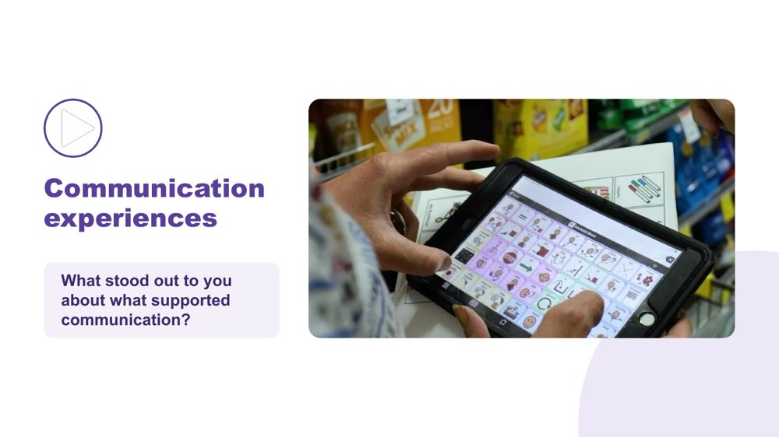 | Communication experiences  SUGGESTED TIME  4 min  CLOCK  11:07 - 11:11  GROUPING  Whole room

Hear Autistic people describe what helps them communicate.
WHAT TO DO  - Check captions are switched on.  - Read the prompt: "As you watch, notice what supports communication. Choose one idea that stands out to you."  - Play the video (around 2.5 minutes).  - Click once to reveal the question.  - Take one response, or two if time allows.  - Use the optional prompts only if the room is quiet. | KEY MESSAGES  - There is no single Autistic communication profile. Autistic people describe what helps them communicate in many different ways.  - A student's AAC needs to be available where communication happens, in every period and with every teacher, not only during a specific activity or therapy session.

YOU MIGHT SAY
As you watch, notice what supports communication. Choose one idea that stands out to you.
What stood out to you about what supported communication?

ACTIVITY | Video and brief whole-room response whole room · 4 minutes
What stood out to you about what supported communication?
- Watch the clip.
- Take one or two responses.
Bring the room back
- What communication strengths did you notice?
- What did another person do that helped?
- What difference did the environment or available communication method make?

KEEP IN MIND
- Let the voices in the video lead. Avoid summarising or generalising what speakers said.
- Use accurate, edited captions (not auto-generated only) and have a transcript available.
- If the video is set to play on click, the question appears on the following click.

Background AAC adds to or provides an alternative to speech. In secondary school this may include signs, communication boards or books, typing, text-based tools and speech-generating devices, and it may be used alongside speech. It needs to be available in every class, not only in some rooms or with some teachers. The educator's role is not to assess or prescribe AAC. The focus is recognising and supporting the student's ways of communicating and working with the student, family and relevant team.

SESSION 3 | Autistic Experience at Secondary School | SLIDE 6 of 28

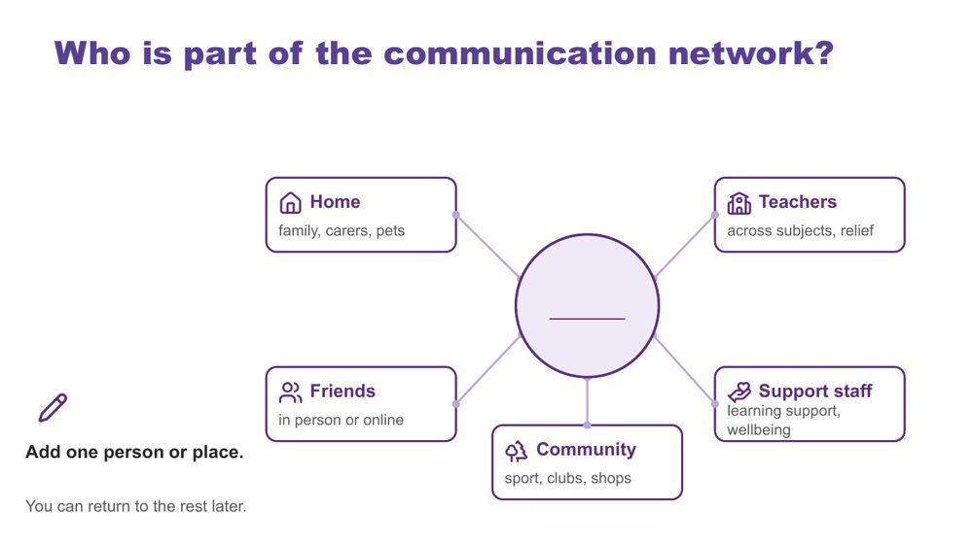 | Who is part of the communication network?  SUGGESTED TIME  3 min  CLOCK  11:11 - 11:14  GROUPING  On your own  PARTICIPANT GUIDE  Page 11 - Who is part of the communication network?

Map the people and places around one of the students participants have in mind.
WHAT TO DO  - Ask participants to put one of the students they have in mind in the centre of page 11 of the Participant Guide or a sheet of paper.  - Invite them to add one person or place, using roles rather than names.  - Allow about 1.5 minutes of quiet time.  - Offer to write for anyone who would like help.  - Share the points below while people write. | KEY MESSAGES  - Students communicate with many people in many places. Each person, at school and beyond, may see a different part of the communication picture.

YOU MIGHT SAY
Use your Participant Guide or a sheet of paper. Put one of the students you have in mind in the centre. Around them are home, friends, teachers, community and support staff.
Think about who is part of this student's communication network. Use roles rather than names. Add one person or place now. You can return to the rest later.
You can write roles, draw or use dot points.

ACTIVITY | Quiet individual mapping on your own · about 1.5 minutes of writing
Who is part of this student's communication network? Add one person or place.
- Place the student in the centre.
- Add one person or place: home, friends, teachers (across subjects, relief), community, or support staff (learning support, wellbeing).
- Use roles, not names.
Close: You can return to the rest later.

KEEP IN MIND
- Networks can be small or changing. Normalise empty boxes.
- Keep the student anonymised. Use roles, not names.
- This activity is not about deciding who understands the student best.

Background You do not need to complete every box. A box can hold many people, one person, or nobody yet. Different people may see different parts of the student's communication, and the network may look very different for another of the students. A subject teacher, a relief teacher, a year level coordinator, a learning support teacher, a wellbeing staff member and a parent may each notice something different. Friends in person or online may matter a great deal to a teenager. The parts of the network participants know little about are questions to explore with the student and their family.

SESSION 3 | Autistic Experience at Secondary School | SLIDE 7 of 28

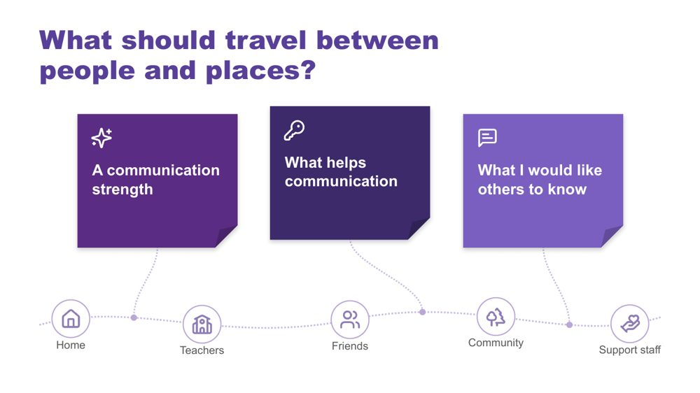 | What should travel between people and places?  SUGGESTED TIME  5 min  CLOCK  11:14 - 11:19  GROUPING  On your own  PARTICIPANT GUIDE  Page 11 - What should travel between people and places?

Name what a student's communication partners need to know so the student does not have to start again with every new person.
WHAT TO DO  - Check purple, blue and orange Post-it notes are on each table and a wall or board space is ready.  - Point to the five parts of the network on the slide: home, teachers, friends, community and support staff.  - Explain the colours.  - Allow about 2 minutes of writing.  - Invite optional sharing for about 3 minutes: add a note to the board or read one out.  - Group notes on the board by colour.  - Notice themes on the blue notes. You will return to them on the next slide. | KEY MESSAGES  - Educators, families and specialists each hold valuable knowledge about a student's communication.  - When that knowledge is shared across subjects, rooms, teachers, relief teachers and home, students do not have to start again with each new person or period.

YOU MIGHT SAY
Let's think about what should travel with one of the students you have in mind between people and places.
Purple is a communication strength. Blue is something that helps communication. Orange is something you would like others to know.
You can write one note, two or all three. You can use one of the students you have in mind, anonymised, or a made-up example. You can keep your notes private if you prefer.
If you are comfortable, add a note to the board or read one out.

ACTIVITY | Colour-coded Post-it notes with optional sharing on your own · 5 minutes (about 2 writing, about 3 sharing)
What should travel with this student between people and places?
- Purple: a communication strength.
- Blue: something that helps communication.
- Orange: something you would like others to know.
- Write one, two or all three notes.
- Add to the board or read one out, if comfortable.
Bring the room back
- What similarities do you notice?
- What strengths might be missed if we look only for speech?
- Which supports change what other people do or provide?
- What information would help a relief teacher, a new subject teacher or staff on duty at recess and lunch?
- Did another person's contribution prompt a new thought?
Close: Notice the themes on the blue notes and carry them into the next slide.

KEEP IN MIND
- Do not ask individuals to share. Sharing is optional.
- Thank every contribution without ranking it.
- If a note names a student or school, invite the writer to keep it.

Thread Session 4 returns to supports that travel across the timetable.

SESSION 3 | Autistic Experience at Secondary School | SLIDE 8 of 28

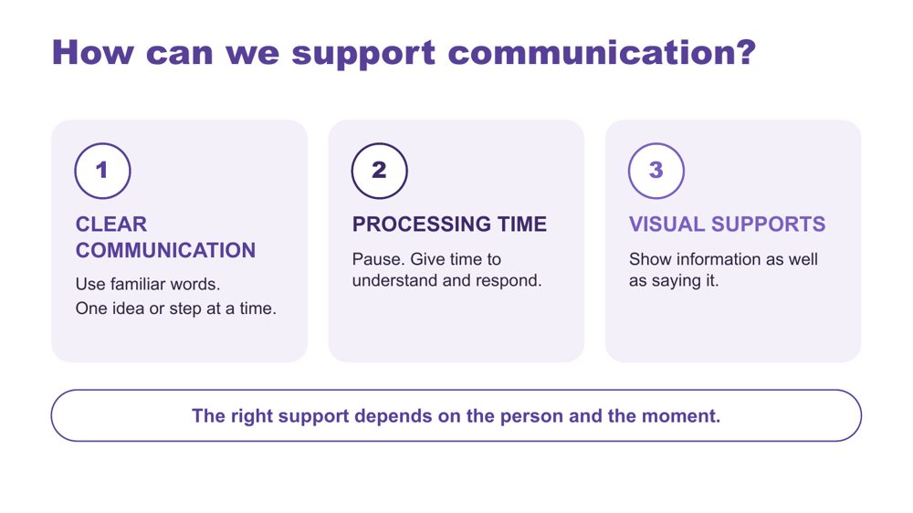 | How can we support communication?  SUGGESTED TIME  2 min  CLOCK  11:19 - 11:21

Introduce three ways to support communication across the school day.
WHAT TO DO  - Link back to the themes on the blue notes.  - Walk through the three strategies on the slide. | KEY MESSAGES  - The right support depends on the person and the moment.

YOU MIGHT SAY
There are three strategies we can use. Clear communication means using familiar words and giving one idea or step at a time. Processing time means pausing so the person has time to understand and respond. Visual supports mean showing information as well as saying it. With several teachers in a day, these work best when every teacher knows what helps and uses it. Let's look at what these can look like.

KEEP IN MIND
- These are options to match to the person, not a checklist or a guarantee.
- Avoid filling every pause with more words.
- Keep AAC available and allow responses through the person's preferred methods, including refusal.

Background Processing time is time to make sense of information, organise a response and communicate it. Clear communication means familiar, specific language in a form and amount the person can access. Communication partner guidance includes adapting language and allowing response time, and AAC guidance also includes visual supports and access across settings (ASHA, n.d.; Brady et al., 2016). There is no activity on this slide.
RESOURCES
- ASHA (n.d.) - full reference in the facilitator guide references
- Brady et al. (2016) - full reference in the facilitator guide references

SESSION 3 | Autistic Experience at Secondary School | SLIDE 9 of 28

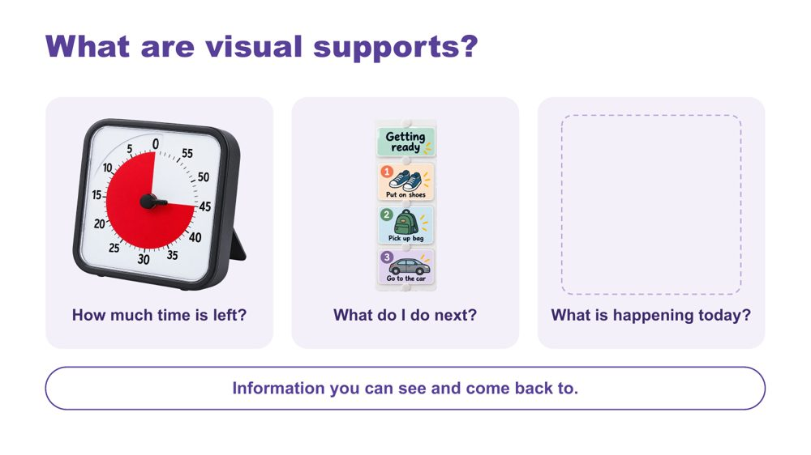 | What are visual supports?  SUGGESTED TIME  2 min  CLOCK  11:21 - 11:23

Help educators recognise what visual supports are through familiar examples.
WHAT TO DO  - Walk through the three examples: a timer, a sequence, a daily schedule.  - If time allows, ask the optional question and take one or two brief examples. | KEY MESSAGES  - Visual supports are information you can see and come back to.  - A visual support offers information, not a condition for access to a preferred activity.

YOU MIGHT SAY
Visual supports help make information clear. They give us something to look at and come back to. This timer shows how much time is left. A sequence shows what to do next. A daily schedule shows what is happening today. You might already use a calendar, shopping list or reminder on your phone. The useful format will be different for each person.
What visual information do you already use in your classes? Think about lesson steps, assessment instructions, the timetable and room changes.

KEEP IN MIND
- This is a quick introduction. There is no task on this slide.
- These images illustrate formats, not recommended products.
- Visual supports and AAC can overlap, but they are not interchangeable. Keep the person's communication methods available.
- Use the evidence to explain options, not to promise the same result for every person.

Background Visual supports can include objects, real photos, written words or symbols, on paper or a device. For adolescents, formats that look like what everyone else uses (a phone calendar, a written task list, a checklist in the learning platform) may feel more comfortable than ones that single them out. Check that the person understands the information and can access it when needed. The written sequence is an example of accessible information, not a test of compliance. Match the format to the person and invite their preferences. Optional prompts: What information would help each of these students? What format makes sense to them? Where could it stay available across the timetable?
Thread Session 4 returns to visual supports as one design option, with the Visual Supports Checklist and webinar for further learning.
RESOURCES
- Avery et al. (2025) - review of caregiver-implemented visual supports; full reference in the facilitator guide references
- ASHA AAC Practice Portal - visual schedules and other visual supports; full reference in the facilitator guide references

SESSION 3 | Autistic Experience at Secondary School | SLIDE 10 of 28

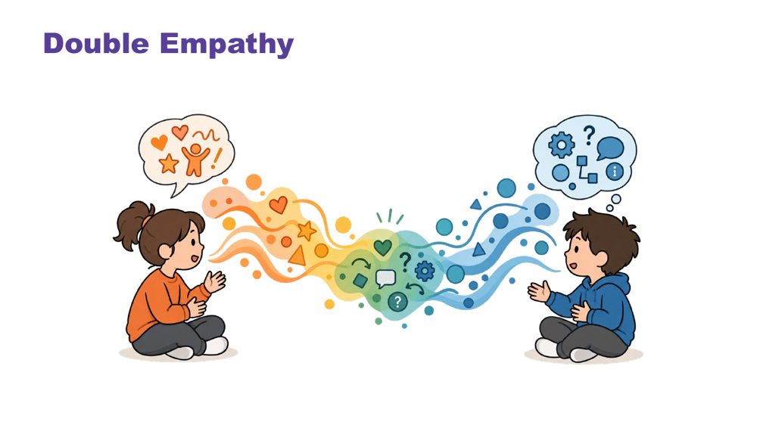 | Double empathy  SUGGESTED TIME  3 min  CLOCK  11:23 - 11:26

Explore interaction and connection without treating one social style as the standard.
WHAT TO DO  - Explain double empathy: when people have different experiences and ways of communicating, understanding one another can be more difficult in both directions.  - Ask whose expectations shape an interaction and what would make connection safer or clearer.  - Consider the expectations operating during class discussion, group work, corridors, break times, online and interactions with different teachers and peers.  - Use "how each student connects" throughout the discussion. | KEY MESSAGES  - Connection does not need to look one way.  - Interaction is shaped by expectations and context as well as by the student.  - Social misunderstanding does not automatically sit within the Autistic student.

YOU MIGHT SAY
Whose expectations are shaping this interaction?

KEEP IN MIND
- Move away from locating every social misunderstanding within the Autistic student.

SESSION 3 | Autistic Experience at Secondary School | SLIDE 11 of 28

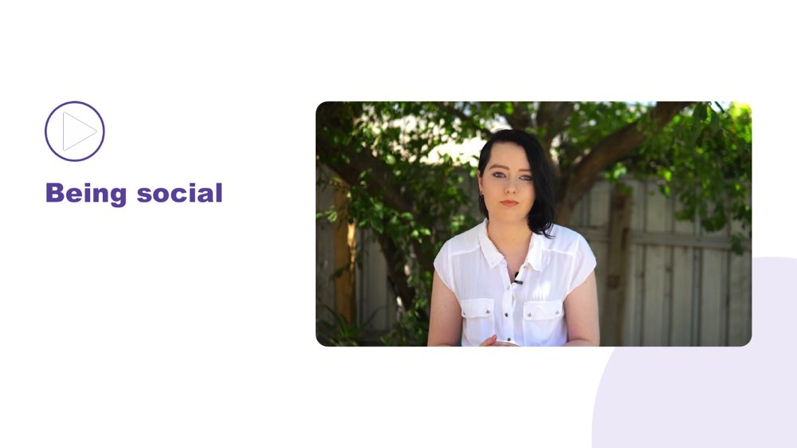 | Being social  SUGGESTED TIME  1 min  CLOCK  11:26 - 11:27

Open the section on how each student connects.
WHAT TO DO  - Introduce the move from double empathy to the many ways students connect.  - Invite participants to notice preferred people, places, activities and ways of joining without interpreting difference as absence of connection. | KEY MESSAGES  - Connection does not need to look one way.

SESSION 3 | Autistic Experience at Secondary School | SLIDE 12 of 28

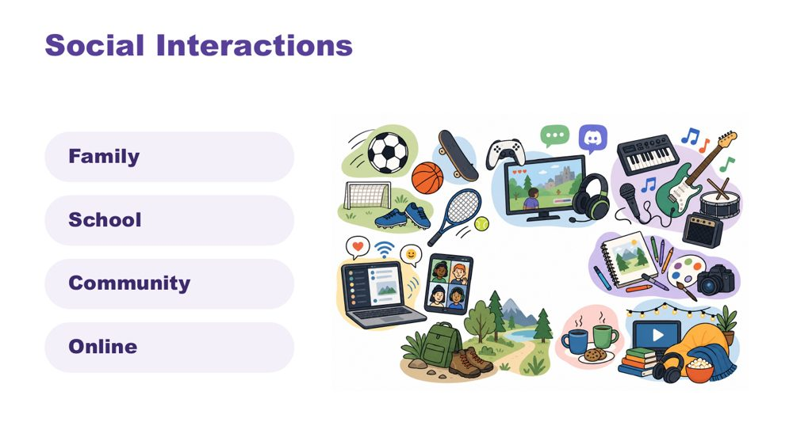 | Social interactions  SUGGESTED TIME  3 min  CLOCK  11:27 - 11:30

Widen the picture of how students interact, across family, school, community and online.
WHAT TO DO  - Identify a range of ways a student may interact, for example 1:1, parallel engagement, sharing deep knowledge of an interest (info dumping), gaming or online connection, irregular contact.  - Make connections to culture.  - Name in-person, online and third spaces without making assumptions about a student's communities. | KEY MESSAGES  - Connection can occur in person, online and in third spaces, and each student's experience is individual.  - For many adolescents, online connection and shared-interest groups are real and valued connection.

KEEP IN MIND
- Do not ask participants to disclose a student's online activity, identity or community membership.

SESSION 3 | Autistic Experience at Secondary School | SLIDE 13 of 28

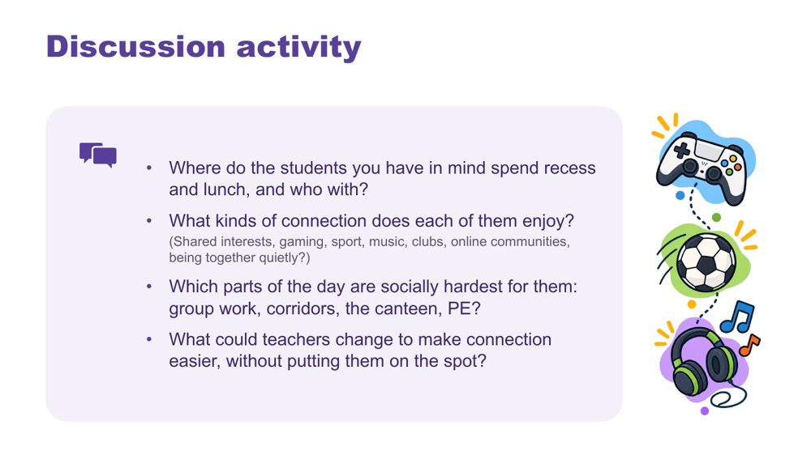 | Discussion activity: connection  SUGGESTED TIME  6 min  CLOCK  11:30 - 11:36  GROUPING  Pairs  PARTICIPANT GUIDE  Page 12 - Connection discussion

Apply the ideas about connection to the students participants have in mind.
WHAT TO DO  - Put participants in pairs.  - Give about 5 minutes to talk through the four questions on the slide. They are also on Participant Guide p. 12.  - Bring the room back and take two or three responses, focusing on what teachers could change. | KEY MESSAGES  - Connection can look different for each student, including online communities, clubs and shared interests.  - Small changes by teachers can make connection easier without singling a student out.

ACTIVITY | Guided discussion pairs · about 5 minutes
Where do the students you have in mind spend recess and lunch, and who with?
- Where do the students you have in mind spend recess and lunch, and who with?
- What kinds of connection does each of them enjoy? (Shared interests, gaming, sport, music, clubs, online communities, being together quietly?)
- Which parts of the day are socially hardest for them: group work, corridors, the canteen, PE?
- What could teachers change to make connection easier, without putting them on the spot?
Bring the room back
- What could teachers change to make connection easier, without putting them on the spot?

KEEP IN MIND
- Do not ask participants to disclose a student's online activity, identity or community membership.
- Avoid reading difference as a lack of connection. Some students prefer to spend recess and lunch alone or in a quiet space.
- Teachers may not know where a student goes at recess and lunch. That is a fair answer and a question to follow up.

Background If the room needs examples for the last question: giving group roles in advance, letting students choose partners or groups, not calling on a student without warning, and making a quiet space or club available at lunch.

SESSION 3 | Autistic Experience at Secondary School | SLIDE 14 of 28

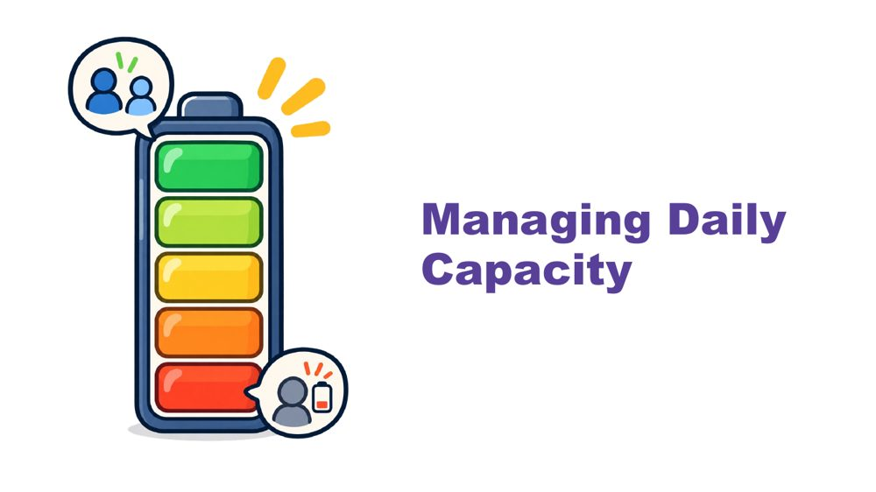 | Managing daily capacity  SUGGESTED TIME  1 min  CLOCK  11:36 - 11:37

Open the section on energy and capacity across the day.
WHAT TO DO
- Introduce the move from connection to how much energy the school day takes.

Thread Capacity language (battery, spoons) comes back on slide 17 and on the day map, where participants mark what costs energy and what gives it back.

SESSION 3 | Autistic Experience at Secondary School | SLIDE 15 of 28

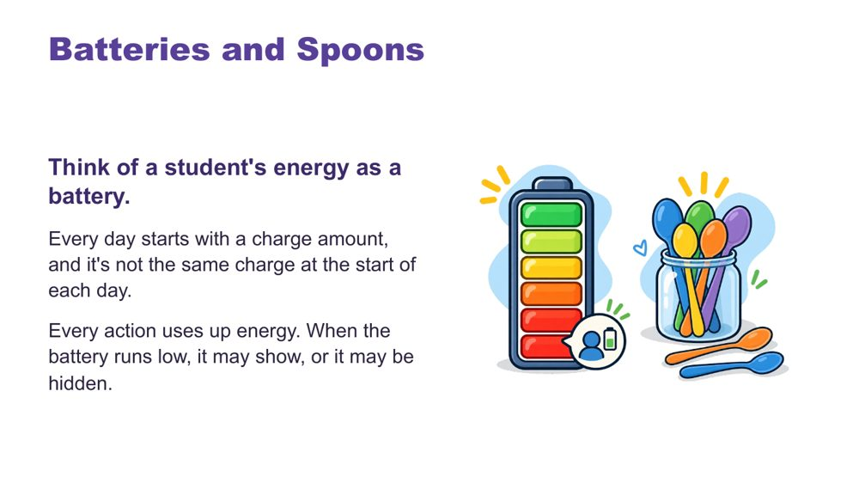 | Batteries and spoons  SUGGESTED TIME  2 min  CLOCK  11:37 - 11:39

Give a shared language for energy and capacity.
WHAT TO DO  - Talk through the battery image.  - Introduce spoons as language many in the Autistic community use.  - Finish with recharging: the right supports can restore some capacity. | KEY MESSAGES  - Each day starts with a different charge.  - The right supports can recharge.

YOU MIGHT SAY
Think of a student's energy as a battery. Every day starts with a charge amount, and it's not the same charge at the start of each day. Every action uses up energy. When the battery runs low, it may show, or it may be hidden.
In the Autistic community, many like to describe this as having a set of spoons. Each action uses up one or some spoons. When "spoons are low", actions are hard to manage.
You can recharge! The right supports can regain some battery charge or extra spoons.

SESSION 3 | Autistic Experience at Secondary School | SLIDE 16 of 28

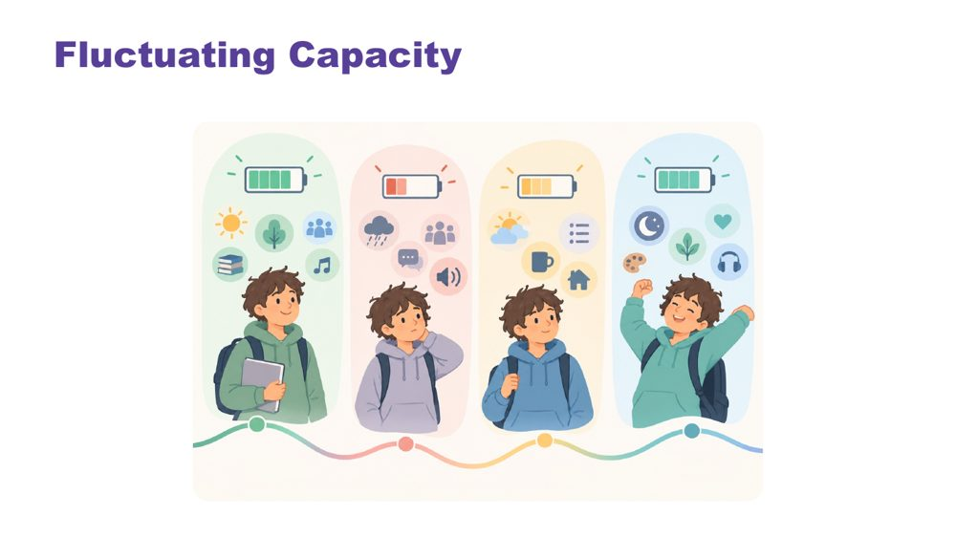 | Fluctuating capacity  SUGGESTED TIME  1 min  CLOCK  11:39 - 11:40

Show that capacity changes from day to day.
WHAT TO DO  - Explain that capacity changes with stress, energy, sensory demands and what else is happening. | KEY MESSAGES  - Capacity is not fixed. The same student may manage something one day and not the next.

YOU MIGHT SAY
Like all people, Autistic students have good days and harder days. Their ability to manage school, social situations, communication, or daily tasks may change depending on stress, energy levels, sensory demands, and what else is happening in their life. Period 6 may look nothing like period 1.

SESSION 3 | Autistic Experience at Secondary School | SLIDE 17 of 28

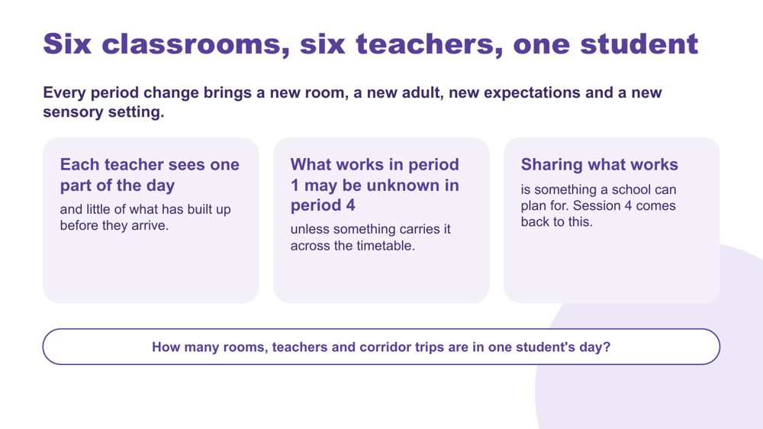 | Six classrooms, six teachers, one student  SUGGESTED TIME  5 min  CLOCK  11:40 - 11:45

Show the particular challenge of secondary school: the day is split across many rooms, teachers and expectations, and no one teacher sees all of it.
WHAT TO DO  - Read the heading and the first line.  - Ask the question at the bottom of the slide: think about one student's day from period 1 to period 6. How many rooms, teachers and corridor trips is that? Give people a moment to count.  - Point out that each teacher sees one part of the day and little of what has built up before the student arrives.  - Explain that what works in period 1 may be unknown in period 4 unless something carries it across the timetable.  - Explain that sharing what works is something a school can plan for. Session 4 comes back to this, including a one-page profile written with the student and shared with every teacher. | KEY MESSAGES  - Every period change brings a new room, a new adult, new expectations and a new sensory setting.  - Each teacher sees one part of the day and little of what has built up before they arrive.  - What works in period 1 may be unknown in period 4 unless something carries it across the timetable.  - Sharing what works is something a school can plan for.

YOU MIGHT SAY
Think about one student's day from period 1 to period 6. How many rooms, teachers and corridor trips is that?
Each of us sees one part of that day. What works in period 1 may be unknown in period 4 unless something carries it across the timetable.
Sharing what works is something a school can plan for. We will come back to this in Session 4.

KEEP IN MIND
- Teachers may hear this as more work. It usually means less: information shared once saves each teacher working it out again.
- Keep the example to an ordinary, recognisable day.

Background Moving between periods adds to the load already discussed: leaving one task, moving through busy corridors, and switching to a new subject, teacher and set of expectations. A student may manage well with one teacher and struggle with another because the information about what helps was not passed on.
Thread Leads into the day map on the next slide. Session 4 offers supports that travel and predictability across the timetable as design options.

SESSION 3 | Autistic Experience at Secondary School | SLIDE 18 of 28

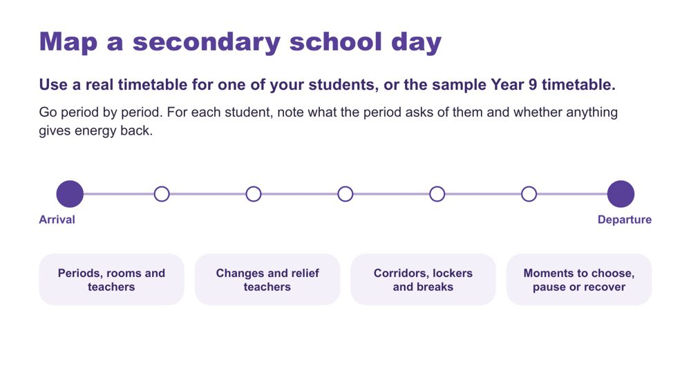 | Map a secondary school day  SUGGESTED TIME  8 min  CLOCK  11:45 - 11:53  GROUPING  On your own  PARTICIPANT GUIDE  Page 13 - Map a secondary school day

Map one secondary school day period by period, and mark what each period costs or gives back for each of the students participants have in mind.
WHAT TO DO  - Hand out the sample Year 9 timetable (PL Secondary - Session 3 - Sample Year 9 timetable) to anyone who does not have a real timetable for one of their students.  - Ask participants to use the table on Participant Guide p. 13 and go period by period, from arrival to departure. For each period, note the room, the teacher and what happens.  - For each student (columns A, B and C), mark each period: C if it costs energy, L if it lightens or gives energy back, ? if they are not sure yet.  - Point to the prompts on the slide: changes and relief teachers; corridors, lockers and breaks; moments to choose, pause or recover.  - Encourage subject teachers to map the whole day, not only their own period. The build-up across the day is what we want to see.  - Link to the battery and spoons language from earlier.  - Let people know the next slide adds more detail to the same map. | KEY MESSAGES  - No single teacher sees the whole day. The map puts it in one place.  - A ? is useful. It shows what to ask the student, family or other staff.  - The map is a working picture to extend, not a judgement of the student or school.

ACTIVITY | Individual map with optional paired discussion on your own · about 7 minutes
Use a real timetable for one of your students, or the sample Year 9 timetable. Go period by period. For each student, note what the period asks of them and whether anything gives energy back.
- Use the table on p. 13, from arrival to departure.
- For each period, note the room, the teacher and what happens.
- For each student, mark C (costs energy), L (lightens or gives energy back) or ? (not sure yet).
- Think about changes and relief teachers; corridors, lockers and breaks; moments to choose, pause or recover.
- Keep the map private unless you choose to discuss it.
Close: The map is a working picture to extend, not a judgement of the student or school.

KEEP IN MIND
- Avoid names, school identifiers or unique incidents.
- Subject teachers may map only their own period. Encourage the whole day.
- A period can be both C and L. Let participants mark both.
- Participants may notice things they do not yet know about a student's day. Mark these with ? and carry them forward.

Background The sample Year 9 timetable is for anyone who does not know a student's full timetable or would rather not use a real one. A real timetable usually gives a more useful picture if participants have one.
Thread Session 4 builds on this map.

SESSION 3 | Autistic Experience at Secondary School | SLIDE 19 of 28

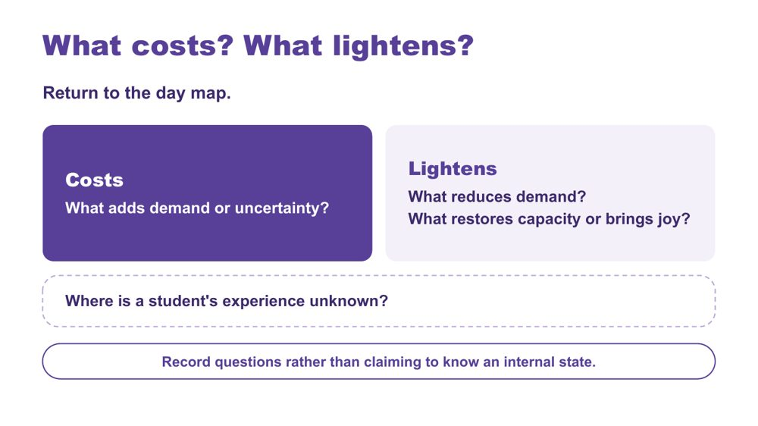 | What costs? What lightens?  SUGGESTED TIME  5 min  CLOCK  11:53 - 11:58  GROUPING  On your own  PARTICIPANT GUIDE  Page 14 - What costs? What lightens?

Extend the day map to show demand, relief and what is not yet known.
WHAT TO DO  - Ask participants to return to the day map.  - Ask them to note what adds demand or uncertainty (costs), for example crowded corridors, a relief teacher, a room change or an assessment task being handed out.  - Ask them to note what reduces demand, restores capacity or brings joy (lightens).  - Ask them to add questions where a student's experience is unknown.  - Link back to the battery language: what drains, what recharges. | KEY MESSAGES  - A single moment sits within everything that has built up across the day, good and hard.  - The map should include what lightens and restores as well as what costs.  - Record questions rather than claiming to know an internal state.

ACTIVITY | Extend the secondary day map on your own · about 4 minutes
What costs? What lightens? Where is a student's experience unknown?
- Use one mark or colour for what costs.
- Use another for what lightens or restores.
- Add questions where the student's experience is not known.
Close: Look for patterns in the day that can inform the audit of the secondary day.

KEEP IN MIND
- Do not turn the map into a score or a claim about internal state.
- Do not infer a student's internal state from a single behaviour or moment.
- Include strengths, joy, safe connection and belonging alongside costs.

Background Something can be enjoyable, valued or successfully completed and still require considerable effort. What costs or lightens will differ between students, and may differ for the same student across contexts and days.

SESSION 3 | Autistic Experience at Secondary School | SLIDE 20 of 28

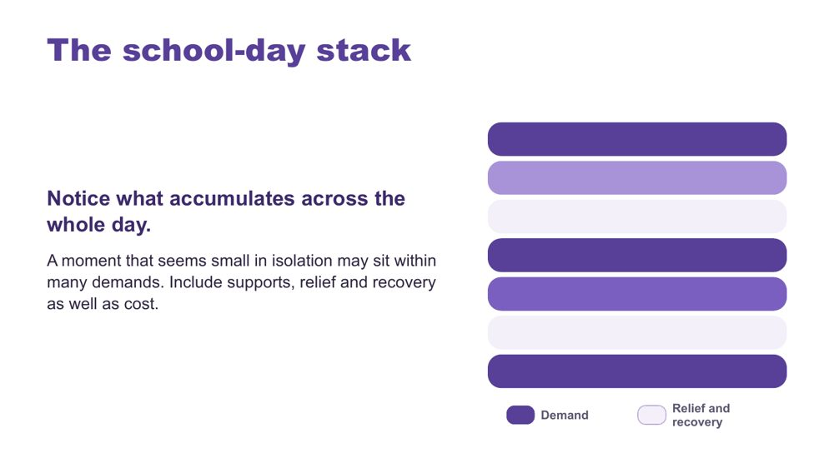 | The school-day stack  SUGGESTED TIME  2 min  CLOCK  11:58 - 12:00

Show how demand accumulates across the whole day.
WHAT TO DO  - Use the stack model as presented.  - Point out that darker bars show demand and lighter bars show relief and recovery.  - Point out that no single teacher sees the whole stack. Each sees one period of it.  - Keep the discussion qualitative. | KEY MESSAGES  - A moment that seems small in isolation may sit within many demands.  - Include supports, relief and recovery as well as cost.

KEEP IN MIND
- The stacked bars are a visual cue only. Do not score students.

SESSION 3 | Autistic Experience at Secondary School | SLIDE 21 of 28

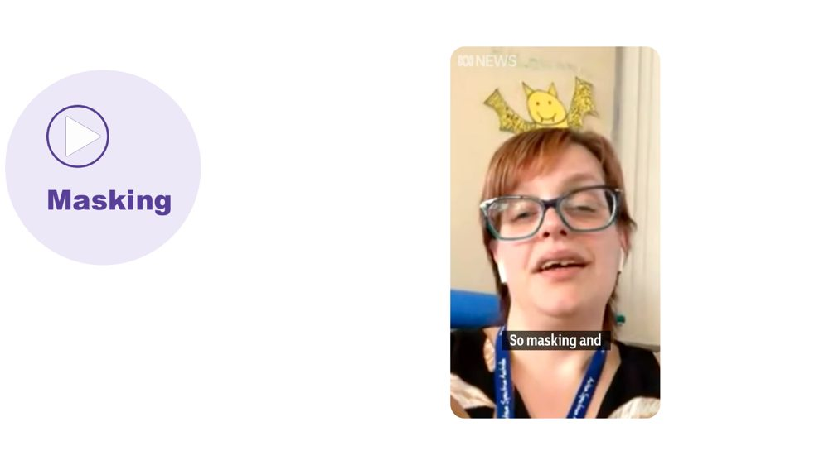 | Masking  SUGGESTED TIME  4 min  CLOCK  12:00 - 12:04

Introduce masking as another thing that draws on a student's battery.
WHAT TO DO
- Link from the stack: there are other things that can affect batteries or spoons.
- Play the masking video.

YOU MIGHT SAY
There are other things that can impact our batteries or spoons... let's watch a video about masking.

SESSION 3 | Autistic Experience at Secondary School | SLIDE 22 of 28

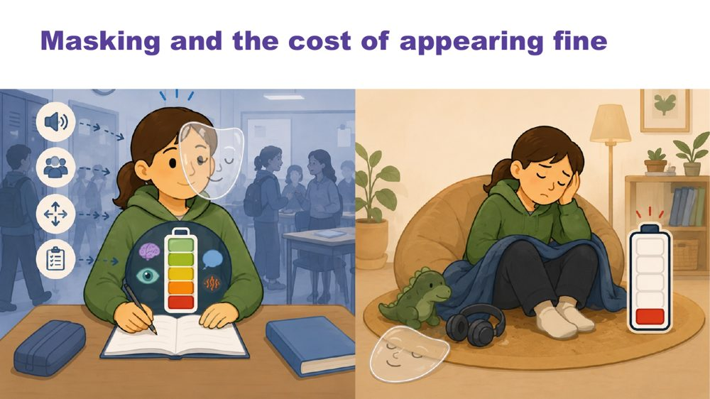 | Masking and the cost of appearing fine  SUGGESTED TIME  2 min  CLOCK  12:04 - 12:06

Name what may be missed if educators look only at outward behaviour.
WHAT TO DO  - Introduce masking in relation to identity and belonging.  - Pose the four questions to the room to think about.  - Ask what may be missed if educators look only at outward behaviour or task completion. | KEY MESSAGES  - What is visible does not tell the whole story.  - What is visible does not provide a complete account of capacity, identity or belonging.

KEEP IN MIND
- Avoid assuming that a student is coping because they are quiet, compliant or completing work.
- Include strengths, joy, safe connection and belonging alongside costs.

Background Prompts to pose: What might the student be working hard to manage or hide? Where can they be recognised and included? What supports belonging without requiring them to appear less Autistic? What does the student want others to understand?

SESSION 3 | Autistic Experience at Secondary School | SLIDE 23 of 28

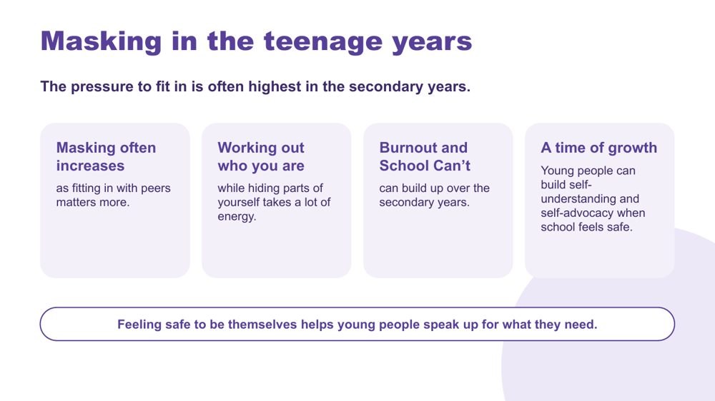 | Masking in the teenage years  SUGGESTED TIME  5 min  CLOCK  12:06 - 12:11

Look at how masking and capacity change in the teenage years, including the chance for growth.
WHAT TO DO  - Read the heading and the first line.  - Talk through the four points on the slide: masking often increases, working out who you are while hiding parts of yourself, burnout and School Can't, and a time of growth.  - Mention burnout and School Can't briefly and respectfully. Session 5 returns to working with families.  - Finish with the last line: feeling safe to be themselves helps young people speak up for what they need. | KEY MESSAGES  - The pressure to fit in is often highest in the secondary years, and masking often increases.  - Working out who you are while hiding parts of yourself takes a lot of energy.  - Burnout and School Can't can build up over the secondary years.  - Young people can build self-understanding and self-advocacy when school feels safe.

YOU MIGHT SAY
The pressure to fit in is often highest in the secondary years. Masking often increases as fitting in with peers matters more.
These are the years when young people work out who they are. Doing that while hiding parts of yourself takes a lot of energy.
Burnout and School Can't can build up over the secondary years.
It is also a time of growth. When school feels safe, young people can build self-understanding and speak up for what they need.

KEEP IN MIND
- Talk about School Can't calmly and respectfully. It is not defiance.
- Some participants may recognise a family member or themselves. Remind the room they can step out and return.
- Do not ask participants to share personal or identifying stories.

Background Many participants ask for content about the teenage years. This slide connects capacity, masking and identity to the secondary years, and leads toward student voice and self-advocacy in Sessions 5 and 6.
Thread Self-advocacy and student voice return in Session 5 (adolescents in their own meetings) and Session 6.

SESSION 3 | Autistic Experience at Secondary School | SLIDE 24 of 28

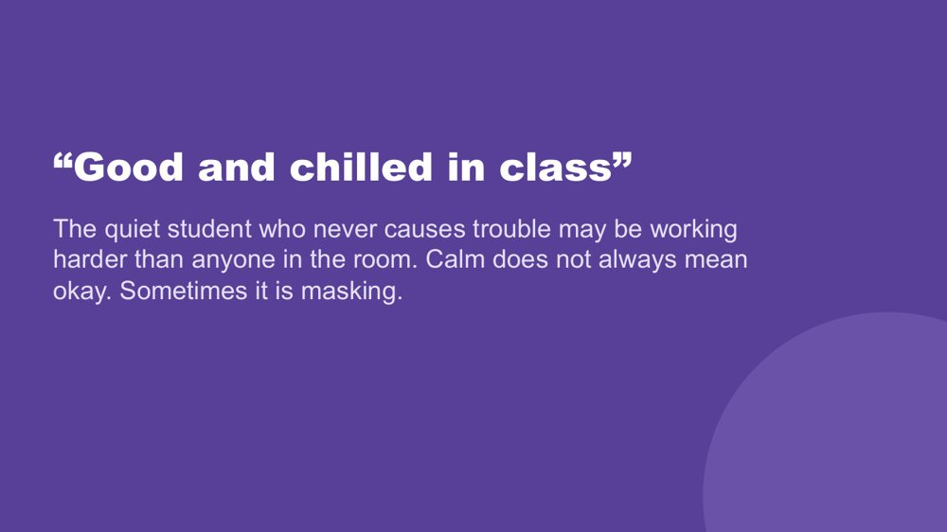 | “Good and chilled in class”  SUGGESTED TIME  2 min  CLOCK  12:11 - 12:13

Protect the students least likely to be noticed: calm and quiet do not always mean okay.
WHAT TO DO  - Read the slide.  - Ask the question and invite participants to think about it privately: who is your quietest Autistic student, and what do you actually know about their experience?  - Give people a moment to think, then move into the discussion activity. | KEY MESSAGES  - The quiet student who never causes trouble may be working harder than anyone in the room.  - Calm does not always mean okay. Sometimes it is masking.

YOU MIGHT SAY
Who is your quietest Autistic student, and what do you actually know about their experience?

KEEP IN MIND
- Some participants may feel uncomfortable with this question. You do not need to resolve that here. The discussion that follows gives them a chance to talk it through.
- Keep the question private. Do not ask for answers aloud.

Background Quiet, compliant presentations can hide unmet needs, and a student who masks well may be the last to be offered support.

SESSION 3 | Autistic Experience at Secondary School | SLIDE 25 of 28

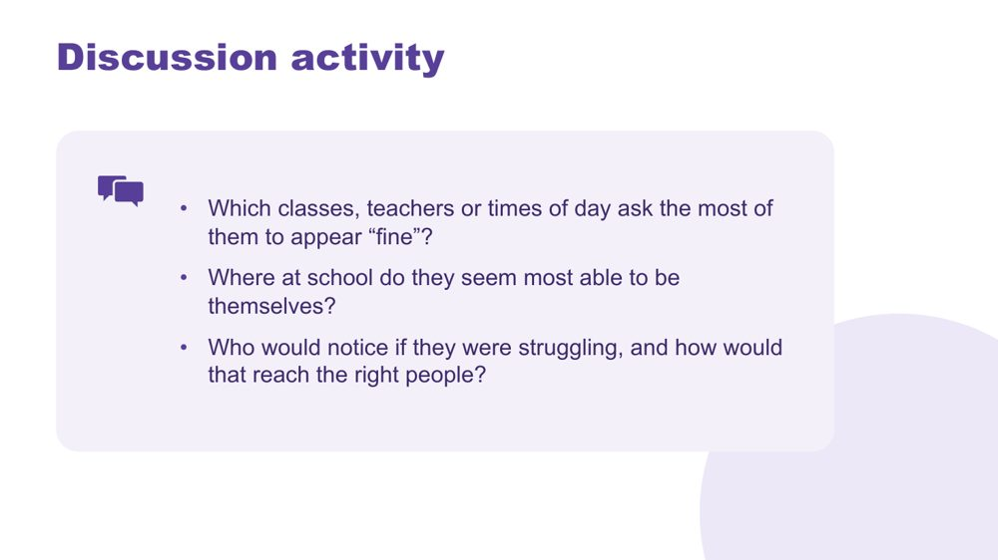 | Discussion activity: masking  SUGGESTED TIME  4 min  CLOCK  12:13 - 12:17  GROUPING  Pairs  PARTICIPANT GUIDE  Page 12 - Masking discussion

Apply masking to the students participants have in mind.
WHAT TO DO
- Put participants in pairs.
- Give about 3 minutes to talk through the three questions on the slide. They are also on Participant Guide p. 12.
- Bring the room back and take one or two responses, particularly on the last question.

ACTIVITY | Guided discussion pairs · about 3 minutes
Which classes, teachers or times of day ask the most of them to appear "fine"?
- Which classes, teachers or times of day ask the most of them to appear "fine"?
- Where at school do they seem most able to be themselves?
- Who would notice if they were struggling, and how would that reach the right people?
Bring the room back
- Who would notice if they were struggling, and how would that reach the right people?

KEEP IN MIND
- Avoid assuming that a student is coping because they are quiet, compliant or completing work.
- Keep examples anonymised.
- The last question is about how information moves between staff, such as subject teachers, the year level coordinator, learning support, wellbeing staff and home. Keep the focus on how the school shares information, not on individual staff who missed something.

SESSION 3 | Autistic Experience at Secondary School | SLIDE 26 of 28

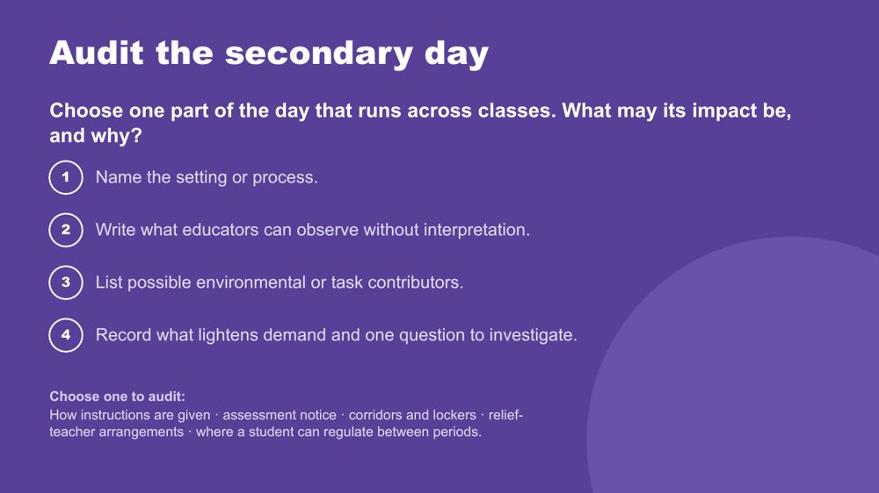 | Audit the secondary day  SUGGESTED TIME  7 min  CLOCK  12:17 - 12:24  GROUPING  On your own or in faculty or year-level pairs  PARTICIPANT GUIDE  Page 15 - Audit the secondary day

Audit one part of the day that runs across classes, matching it to its likely impacts and the reasons those impacts may occur.
WHAT TO DO  - Ask participants to choose one part of the day that runs across classes, from the options on the slide or from their map: how instructions are given, assessment notice, corridors and lockers, relief-teacher arrangements, or where a student can regulate between periods.  - Ask them to name the setting or process neutrally before describing a student's response.  - Ask them to write what educators can observe without interpretation.  - Ask why by examining the environment, task, timing, communication and expectations first.  - Ask them to record what already lightens demand and one question to investigate.  - Suggest faculty or year-level pairs audit a shared process together if that suits the room. | KEY MESSAGES  - In secondary school, corridors, lockers, relief teachers and assessment notice are part of the learning environment too.  - A timetable tells us what happens and when. The audit asks how the day moves and what it repeatedly asks of the student.

ACTIVITY | Secondary day audit on your own or in faculty or year-level pairs · about 6 minutes
Choose one part of the day that runs across classes. What may its impact be, and why?
- Name the setting or process.
- Write what educators can observe without interpretation.
- List possible environmental or task contributors.
- Record what lightens demand and one question to investigate.
Close: Select one focus to carry into the design brief after lunch.

KEEP IN MIND
- Keep all examples anonymised.
- Look at the environment, task, timing, communication and expectations before the student.
- Some participants may feel guilty during the audit. Remind them it looks at how the day is set up, not at any one teacher.

Background Options to audit: how instructions are given (once, verbally, or also written and available later); assessment notice (how much warning, how the task is explained, what scaffolding is offered); corridors and lockers (crowds, noise, time between periods); relief-teacher arrangements (what a relief teacher is told about the class); where a student can regulate between periods.
Thread Feeds the design brief in Session 4.

SESSION 3 | Autistic Experience at Secondary School | SLIDE 27 of 28

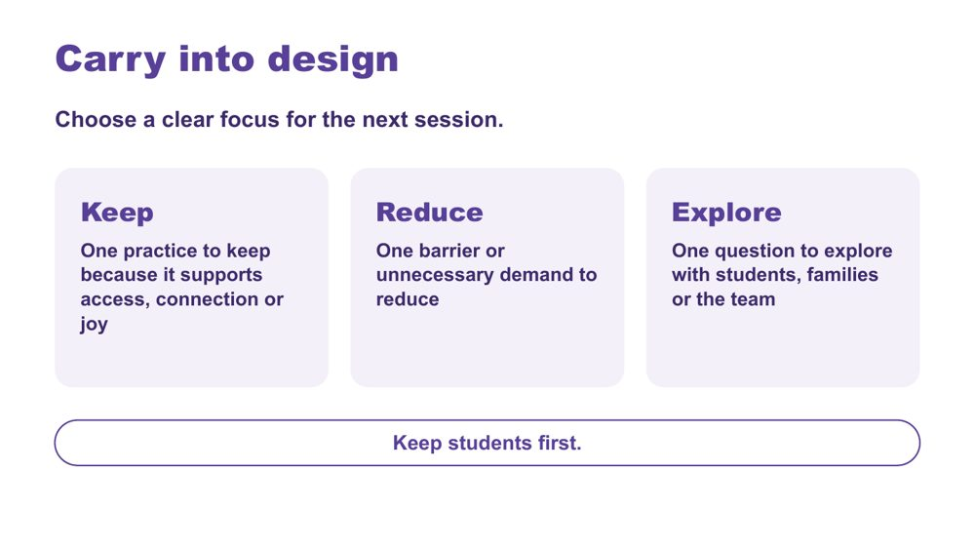 | Carry into design  SUGGESTED TIME  3 min  CLOCK  12:24 - 12:27  GROUPING  On your own  PARTICIPANT GUIDE  Page 16 - Carry into design

Consolidate the school-day inquiry and choose a focus for Session 4.
WHAT TO DO  - Invite participants to identify one practice to keep, one barrier to reduce and one question to explore.  - Ask participants to tick whether their Reduce item is a lesson, an assessment task or a handover. They will use this in Session 4.  - Keep responses private unless participants choose to share.  - Ask participants to keep their map and audit for the design activity.  - Preview the move from the secondary day map to one practical design change.  - Point out lunch at 12:30 - 1:00 and the 1:00 return. | KEY MESSAGES  - Design should protect what supports access, connection and joy as well as reduce barriers.  - Small changes to the environment, communication or rhythm of the day may create meaningful changes in access.  - Unanswered questions can guide consultation with the student, family and team.  - Keep students first.

ACTIVITY | Carry into design card (Keep, Reduce, Explore) on your own · about 2 minutes
Choose a clear focus for the next session.
- Keep: one practice to keep because it supports access, connection or joy.
- Reduce: one barrier or unnecessary demand to reduce.
- Tick: lesson, assessment task or handover.
- Explore: one question to explore with students, families or the team.
Close: Keep your map and audit for the design activity after lunch.

Thread Leads directly into the Session 4 design brief.

SESSION 3 | Autistic Experience at Secondary School | SLIDE 28 of 28

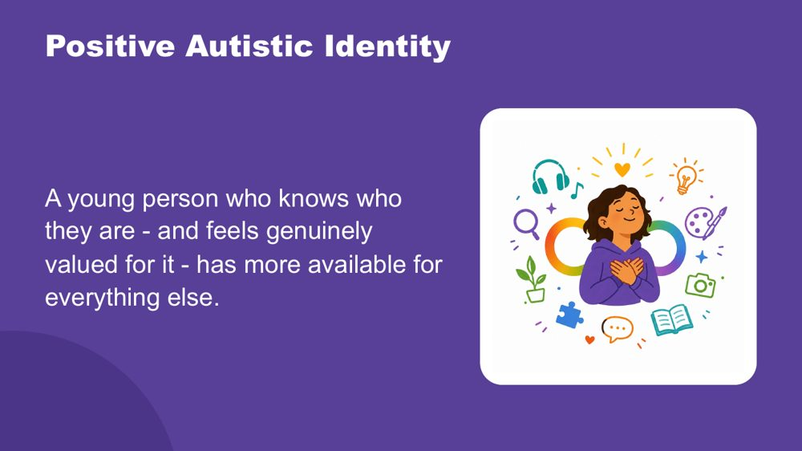 | Positive Autistic identity  SUGGESTED TIME  3 min  CLOCK  12:27 - 12:30

Close the morning by returning to the students participants have in mind, seen now with a fuller picture.
WHAT TO DO  - Let the room settle before you begin.  - Read the spoken close slowly, with the image on the screen.  - When you finish, give people a moment before releasing them to lunch. | KEY MESSAGES  - The effort is more than masking. It includes managing sensory, social, communication and executive demands every day in settings not designed for Autistic people.  - A positive Autistic identity is linked in research to better mental health and wellbeing.  - Belonging comes first. When a student does not have to manage their identity on top of everything else, they have more energy for learning and connection.  - Choice helps. Real choice over how they communicate, where they sit and when they step back reduces the load.  - Knowing other Autistic people who share their experience helps.  - Identity, belonging and choice make learning and connection more possible, so they are part of everyday teaching practice.

YOU MIGHT SAY
This morning, across Sessions 2 and 3, you have been building a picture of the students you have in mind.
How the world arrives through their senses, more fully, more specifically, less filtered. How their brain builds understanding from the detail up, focuses deeply, and thinks in ways that produce real and specific strengths. How their internal world works. How they reach toward other people, and what that costs when the conditions are not designed for them.
Managing all of that, every day, in a world that was largely built for a different nervous system, takes resources. Sensory management. Social interpretation. Executive effort. Communication across a gap. Holding it together when the signals inside are not arriving clearly. And sometimes, performing fine when fine is not what is happening.
A young person who knows who they are - and feels genuinely valued for it - has more of those resources available for everything else.
Research supports what many Autistic adults already know: a positive sense of Autistic identity is connected to better mental health, less anxiety, and greater wellbeing. Belonging is the precondition for all of it. When a young person does not need to spend resources managing their identity on top of everything else, those resources become available for learning, connection, and self-knowledge.
Agency matters too, genuine choice over how they communicate, where they sit, when they step back. And knowing that other Autistic people share their experience, that Autistic adults have found belonging and purpose, is protective in its own right.
These students are not alone in this. They are part of something.
The deepest thing you can do is support them to know themselves, and to know that who they are is worth knowing.

KEEP IN MIND
- The spoken close draws together what was covered across Sessions 2 and 3. Read it as written and let participants make their own connections. You do not need to explain it.
- Some participants may need a moment after the last line. Give them that time before moving to lunch.

Background Research on Autistic identity and wellbeing links a positive Autistic identity (knowing yourself as Autistic and valuing that) with better mental health, less anxiety and greater resilience. This is different from general self-esteem. Connection with other Autistic people adds to this. The aim is for each student to know who they are and to find people and places where that is valued, rather than to fit in. In the teenage years, when identity is forming and masking often increases, this matters even more.
Thread Links back to the opening image of Session 2, where the student comes into focus. You do not need to point this out.

SESSION  4 | 1:00 - 2:15 · 75 MINUTES · 21 SLIDES  Learning Design  Redesigning a lesson, task or handover, tested against real students

SESSION INTENT
Trios move from understanding to design by redesigning one real piece of secondary practice (a lesson, an assessment task or a handover) through an environment-first brief, a menu of support options and a universal-first accessibility check. Each person then privately tests the design against the two or three students they have in mind, which opens the continuum of support, before a gallery walk and a personal commitment.
PARTICIPANTS LEAVE WITH
- write an environment-first brief for one real lesson, assessment task or handover, free from blame or deficit labels
- match one or two support options to a known demand in that design and test it for accessibility
- check the design against the students they have in mind and locate where targeted or individual support begins on the continuum
- leave with one change to try this week in their own classes, what needs their faculty or year level team or school leaders, and who they will involve, including the student and family

RUN SHEET
Clock | Segment | Slides | Minutes
1:00 - 1:04 | Welcome and session map | 1-3 | 4
1:04 - 1:09 | Regroup | 4-5 | 5
1:09 - 1:17 | Brief | 6 | 8
1:17 - 1:32 | Options | 7-12 | 15
1:32 - 1:40 | Universal first | 13-14 | 8
1:40 - 1:50 | Design | 15 | 10
1:50 - 1:57 | Check | 16 | 7
1:57 - 2:05 | Continuum | 17-19 | 8
2:05 - 2:15 | Gallery and commit | 20-21 | 10

PREPARE
☐ Signs for three corners of the room: A lesson, An assessment task, A handover.
☐ A3 trio sheet (PL Secondary - Session 4 - A3 trio sheet): one per trio, sections 1 - 4 used across the session.
☐ "My students" card: one per person, for the private check and the commitment.
☐ Printed option cards on each table (Executive functioning meets assessment, Predictability across the timetable, Supports that travel, Visual supports).
☐ Post-it notes and wall space to display A3 designs for the gallery walk.
☐ Ask participants to bring their Session 3 secondary day map, secondary day audit and Carry into design card.
☐ Visual Supports Checklist and details of the visual supports webinar.
☐ Current official NCCD information to point participants to.

SESSION 4 | Learning Design | SLIDE 1 of 21

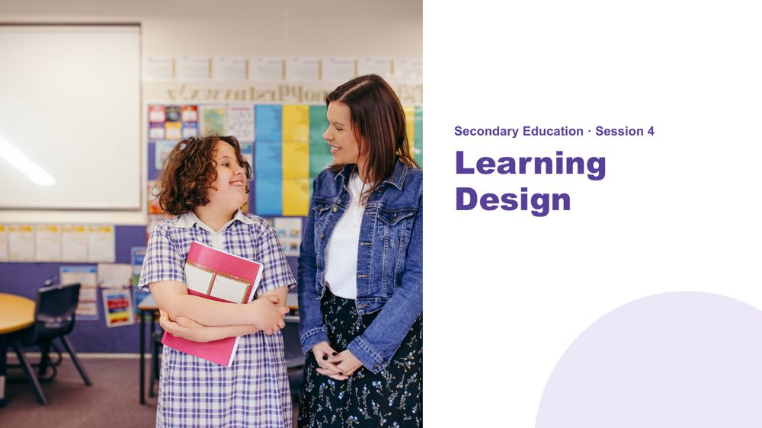 | Session 4 / Learning Design  SUGGESTED TIME  2 min  CLOCK  1:00 - 1:02  PARTICIPANT GUIDE  Page 17 - Session 4 summary

Shift from understanding experience to designing access across a secondary school day.
WHAT TO DO  - Welcome participants back from lunch.  - Ask them to have their Session 3 secondary day map, day audit and Carry into design card to hand.  - Explain that this session moves from understanding students to designing the environment, task and routine around them.  - Explain that the session will produce one small change to a lesson, an assessment task or a handover that can be tried and reviewed.  - Keep the focus on environment, task and routine rather than changing the student. | KEY MESSAGES  - What we know about students informs design; it is not a list of deficits.  - A practical change should respond to a barrier or access question.

Thread Picks up the secondary day map, the audit of the secondary day and the Carry into design card from Session 3.

SESSION 4 | Learning Design | SLIDE 2 of 21

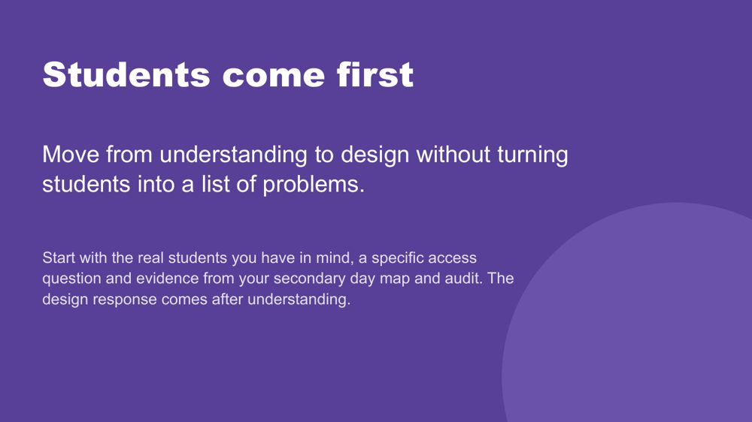 | Students come first  SUGGESTED TIME  1 min  CLOCK  1:02 - 1:03

Set the principle that understanding real students comes before any design response.
WHAT TO DO  - Point to the students participants have in mind and the secondary day map from Session 3.  - Name that the session designs one lesson, assessment task or handover, then checks that design against the two or three students each person has in mind.  - Remind participants to include only what is known, and to hold unknowns as questions.  - Ask participants to separate an observation from an interpretation, and a question from a conclusion. | KEY MESSAGES  - The student comes before the strategy.  - A design brief connects what matters for students with what can change in the environment, task or routine.  - Use the costs from the day map as things the design needs to address, and strengths and interests as things to build on.  - Unknowns remain questions for consultation.

KEEP IN MIND
- Do not use what is known about students to diagnose, rank or reduce them to support needs.

Thread Draws on the secondary day map and audit from Session 3.

SESSION 4 | Learning Design | SLIDE 3 of 21

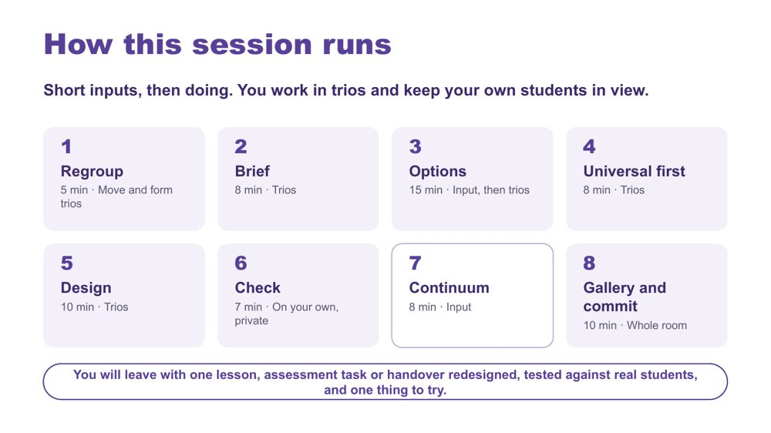 | How this session runs  SUGGESTED TIME  1 min  CLOCK  1:03 - 1:04

Show the rhythm of the afternoon: short inputs, then doing, in trios.
WHAT TO DO  - Walk the eight stages briefly: Regroup, Brief, Options, Universal first, Design, Check, Continuum, Gallery and commit.  - Name that each person keeps their own students in view while the trio designs together.  - Name the end point: one lesson, assessment task or handover redesigned, tested against real students, and one thing to try. | KEY MESSAGES  - Short inputs, then doing.

YOU MIGHT SAY
We move, we work in trios on one real lesson, task or handover, we listen briefly for options, we design, we test the design against our own students, and we finish with a gallery and a commitment.

Background The eight stages total about 71 minutes; the other 4 minutes cover the welcome and session map (slides 1 to 3).

SESSION 4 | Learning Design | SLIDE 4 of 21

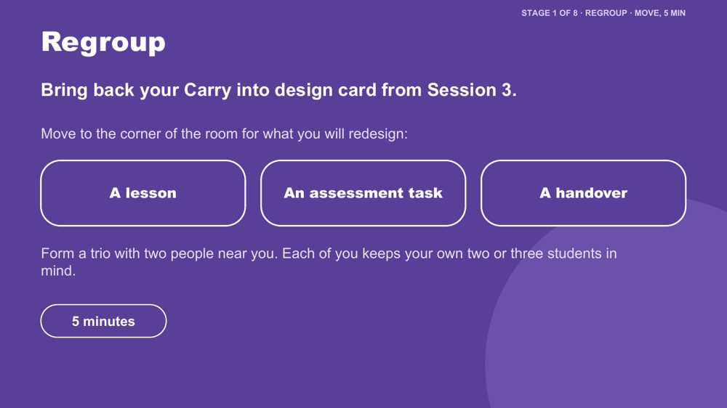 | Regroup  SUGGESTED TIME  4 min  CLOCK  1:04 - 1:08  GROUPING  Trios

Get the room moving after lunch and form trios around design targets people already recognise.
WHAT TO DO  - Ask participants to find their Session 3 Carry into design card, especially the "Reduce" line: the barrier or unnecessary demand they chose to carry into design.  - Point to the three corners: a lesson, an assessment task, a handover.  - Ask people to move to the corner that best matches what their card points to.  - Ask them to form trios with people nearby. A trio with mixed subjects is useful, because the design has to work across the timetable.  - Split a crowded corner; fold anyone on their own into the nearest trio.  - Hand out one A3 trio sheet per trio and one personal "My students" card per person. | KEY MESSAGES  - The trio designs together; each person tests the design against their own students later.

ACTIVITY | Corners-of-the-room regroup trios · 5 minutes (including the slide 5 reminder)
Move to the corner for what you will redesign and form a trio.
- Bring back your Carry into design card from Session 3.
- Move to the corner for what you will redesign: a lesson, an assessment task or a handover.
- Form a trio with two people near you.
- Each person keeps their own two or three students in mind.
Close: Every trio has an A3 trio sheet and every person has a "My students" card.

Background A handover is anything that carries knowledge about a student from one person or place to another: between subject teachers, to a relief teacher, from one year to the next, or between learning support and the classroom.
Thread Uses the Session 3 Carry into design card.

SESSION 4 | Learning Design | SLIDE 5 of 21

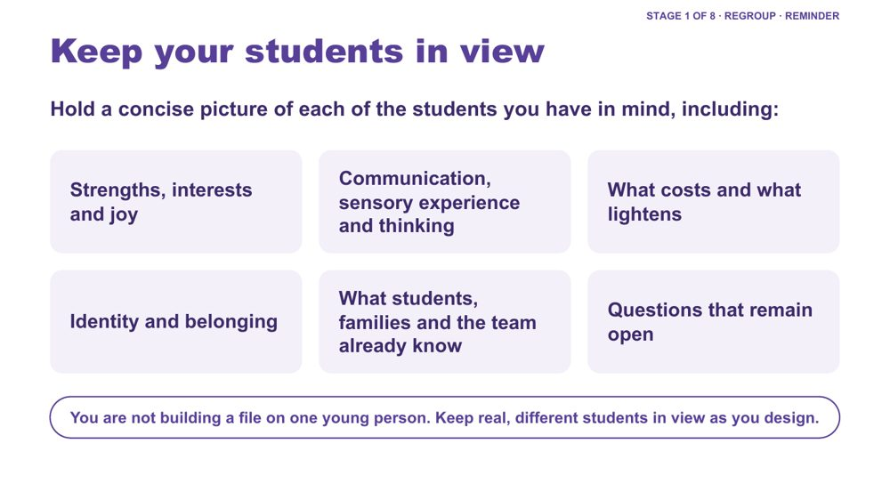 | Keep your students in view  SUGGESTED TIME  1 min  CLOCK  1:08 - 1:09

A quick reminder to hold a concise picture of each student in mind while designing.
WHAT TO DO  - Keep this to about one minute, inside the Regroup stage.  - Run through the areas on the slide as prompts, not a form to fill in.  - Name that participants will use these students in Stage 6, the private check. | KEY MESSAGES  - You are not building a file on one young person. Keep real, different students in view as you design.  - Include strengths, interests and joy, communication, sensory experience, thinking, costs, lighteners, identity and belonging only where these are known or framed as questions.

KEEP IN MIND
- Do not use this to diagnose, rank or reduce students to support needs.
- Remember the quiet student described as "good and chilled in class". A calm student is not always evidence that a design is working.

Thread Recalls masking and "good and chilled in class" from Session 3.

SESSION 4 | Learning Design | SLIDE 6 of 21

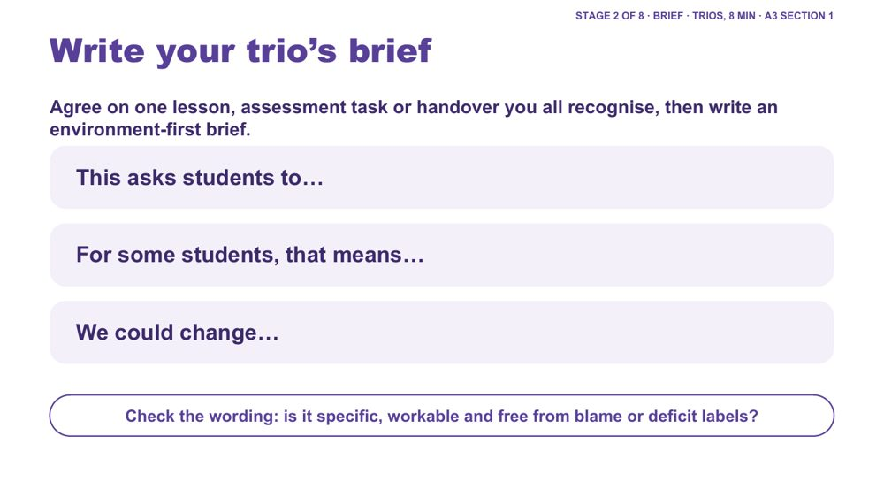 | Write your trio's brief  SUGGESTED TIME  8 min  CLOCK  1:09 - 1:17  GROUPING  Trios  PARTICIPANT GUIDE  Page 18 - Our brief

Agree one lesson, assessment task or handover and write an environment-first design brief for it.
WHAT TO DO  - Ask trios to agree on one lesson, assessment task or handover they all recognise; it may come from one person's Carry into design card.  - Ask them to complete the three stems together on the A3 sheet, section 1.  - Check that the brief points to something within educator or school influence.  - Prompt trios to remove any wording that blames or labels students, for example "disorganised" or "unmotivated". | KEY MESSAGES  - A design brief connects what matters for students with what can change in the environment, task or routine.  - Unknowns remain questions for consultation.

ACTIVITY | Trio design brief on the A3 sheet, section 1 trios · 8 minutes
Agree on one lesson, assessment task or handover you all recognise, then write an environment-first brief.
- Agree on one lesson, assessment task or handover you all recognise.
- Complete: "This asks students to..."
- Complete: "For some students, that means..."
- Complete: "We could change..."
- Check the wording: is it specific, workable and free from blame or deficit labels?
Close: Keep this one brief active for the rest of the session.

KEEP IN MIND
- Watch for observation drifting into interpretation, or questions presented as conclusions.

SESSION 4 | Learning Design | SLIDE 7 of 21

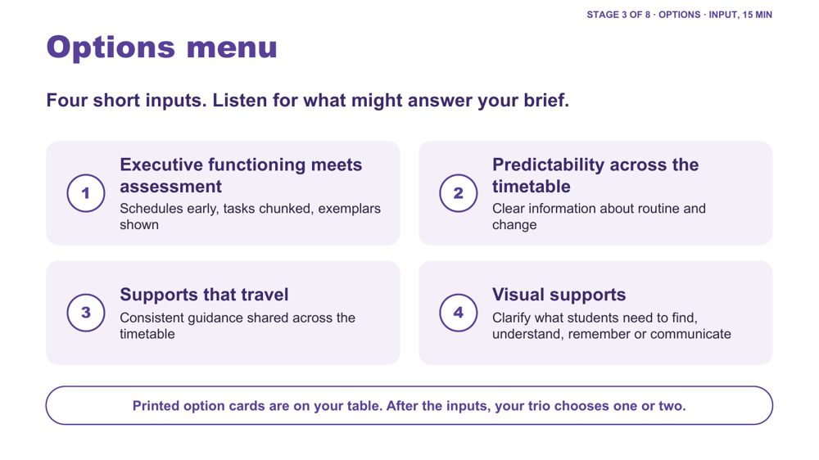 | Options menu  SUGGESTED TIME  1 min  CLOCK  1:17 - 1:18

Frame the four short inputs as a menu that trios listen to with their brief in front of them.
WHAT TO DO  - Ask trios to put their brief in front of them.  - Ask them to listen for which option might answer "This asks students to..."  - Point to the printed option cards on each table: they repeat the four headings and key questions so trios can hold and sort them.  - Keep each of the four inputs to two or three minutes. | KEY MESSAGES  - Listen for what might answer your brief.

SESSION 4 | Learning Design | SLIDE 8 of 21

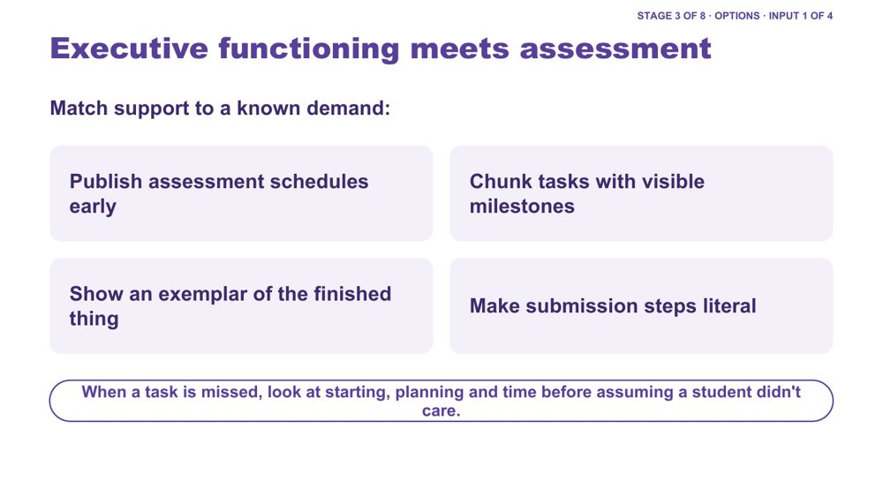 | Executive functioning meets assessment  SUGGESTED TIME  3 min  CLOCK  1:18 - 1:21

Option 1 of 4: executive functioning supports matched to the known demands of assessment.
WHAT TO DO  - Keep this input to about two or three minutes.  - Open with a short example: a capable student misses an assessment task and gets a zero. Ask the room what might be going on besides motivation.  - Go through the four design moves on the slide: publish assessment schedules early, chunk tasks with visible milestones, show an exemplar of the finished thing, make submission steps literal.  - Explain the idea behind them: if a student finds it hard to hold steps in mind or to get started, put that information in the room instead, for example written first steps, instructions that stay visible after they are spoken, and a visible clock or timer.  - Point to the line at the bottom of the slide: when a task is missed, look at starting, planning and time before assuming a student didn't care.  - Ask trios to think about homework: how much of the load is organisation and time rather than the subject itself?  - Link examples to the day map and the trio's brief rather than presenting a strategy checklist. | KEY MESSAGES  - In secondary, success can depend as much on organisation, planning and time as on subject knowledge.  - Support should answer a known demand or question.  - These supports do not change what is being assessed. They help students get organised enough to show what they know.  - A support should reduce unnecessary demand rather than increase compliance pressure.

YOU MIGHT SAY
When a task is missed, look at starting, planning and time before assuming a student didn't care.

KEEP IN MIND
- Avoid assuming that the same support works across students, subjects or contexts.
- If someone says "that's just good teaching", agree. That is the idea behind universal design, which comes next.
- Assessment policy questions may be beyond one teacher's decision. Suggest who in the school they could take them to.

Background Exemplars connect to detail-first thinking from Session 2: seeing the finished thing first helps a student build the whole picture. Exam access also fits here: preparation routines, managing load, and adjustments planned well before the exam.
Thread Draws on thinking and executive functioning from Session 2.

SESSION 4 | Learning Design | SLIDE 9 of 21

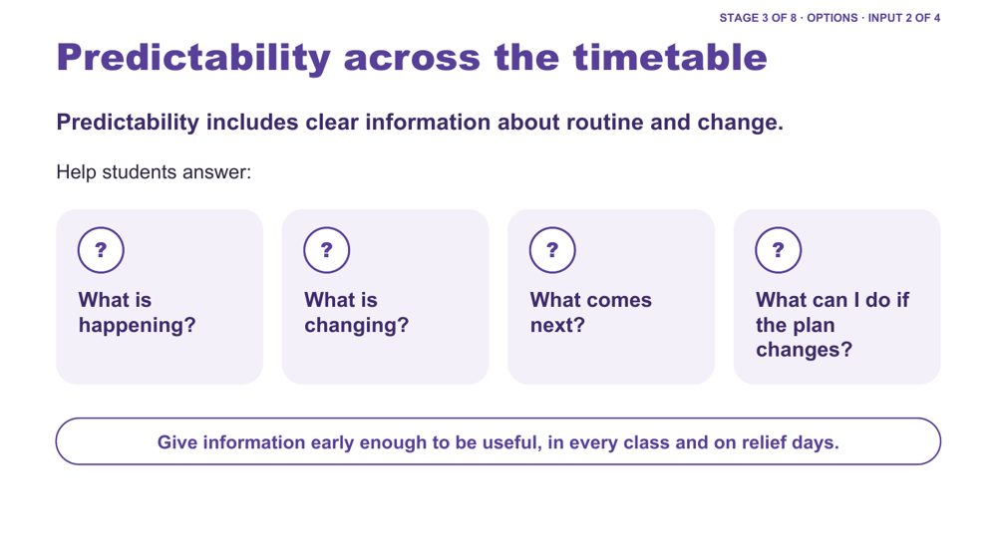 | Predictability across the timetable  SUGGESTED TIME  3 min  CLOCK  1:21 - 1:24

Option 2 of 4: predictability as access to information about routine and change.
WHAT TO DO  - Keep this input to about two or three minutes.  - Frame predictability as access to information, not making every day the same or removing unexpected change.  - Draw attention to how much information in a secondary day is spoken, implied or held by adults, and how it can change from one period to the next.  - Connect back to the audit of the secondary day: when something changes, how do students find out?  - Use the four questions on the slide to examine what information is available to students.  - Mention relief days: a relief plan that keeps the class's usual routines is part of predictability.  - If needed, use the example below. | KEY MESSAGES  - Predictability is access to information, not a promise that nothing will change.  - Clear information about change can be just as important as information about routine.  - In practice, predictability means keeping routines consistent, giving warning before transitions, and telling students about changes in more than one way.  - Useful supports are reviewed through experience and feedback.

YOU MIGHT SAY
If I couldn't rely on remembering what someone had told me, how would I know what was happening across today's timetable?
Predictability is not the absence of change. It includes having accessible information when change happens.

Background Secondary example if needed: a Year 9 student arrives at period 3 to find a relief teacher, a different room and a changed task. How would they know before they arrive? Is the change shown somewhere they can check, such as the class page or the timetable app? Does the relief plan keep the class's usual start routine? Can they see what happens next? Do they have an accessible way to ask a question or say they need more information or support? Students may otherwise be expected to listen, remember, infer or ask in order to know what is happening.
Thread Links back to the audit of the secondary day in Session 3.

SESSION 4 | Learning Design | SLIDE 10 of 21

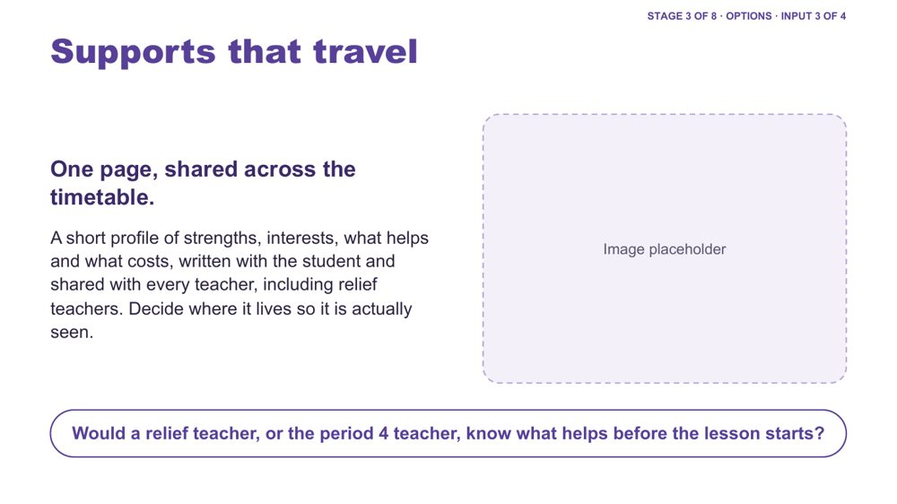 | Supports that travel  SUGGESTED TIME  2 min  CLOCK  1:24 - 1:26

Option 3 of 4: supports that stay consistent across subjects, teachers, rooms and relief days.
WHAT TO DO  - Keep this input to about two minutes.  - Refer back to "Six classrooms, six teachers, one student" from Session 3. A shared profile is one response to it.  - Describe the one-page profile: strengths, interests, what helps and what costs, written with the student and shared with every teacher, including relief teachers.  - Ask the question on the slide: would a relief teacher, or the period 4 teacher, know what helps before the lesson starts?  - Ask where the profile will be kept so people actually see it, and who updates it.  - Separate useful guidance from unnecessary personal detail. | KEY MESSAGES  - A support that works in one lesson may not work if the next teacher doesn't know about it.  - The profile is written with the student and belongs to them. It is not a file about them.  - One shared profile saves each teacher having to work it out separately.

YOU MIGHT SAY
Would a relief teacher, or the period 4 teacher, know what helps before the lesson starts?

KEEP IN MIND
- Profiles can get lost in shared drives. Agree where it will be kept and who will update it.
- Keep the student involved in what is written and shared.

Background What travels: what needs to stay consistent across subjects, teachers, rooms and changes. Who needs the guidance, where it will sit, how a relief teacher will access it, who updates it and how the student will contribute.
Thread Answers "Six classrooms, six teachers, one student" and the "What should travel between people and places?" wall from Session 3; student voice is developed in Session 5.

SESSION 4 | Learning Design | SLIDE 11 of 21

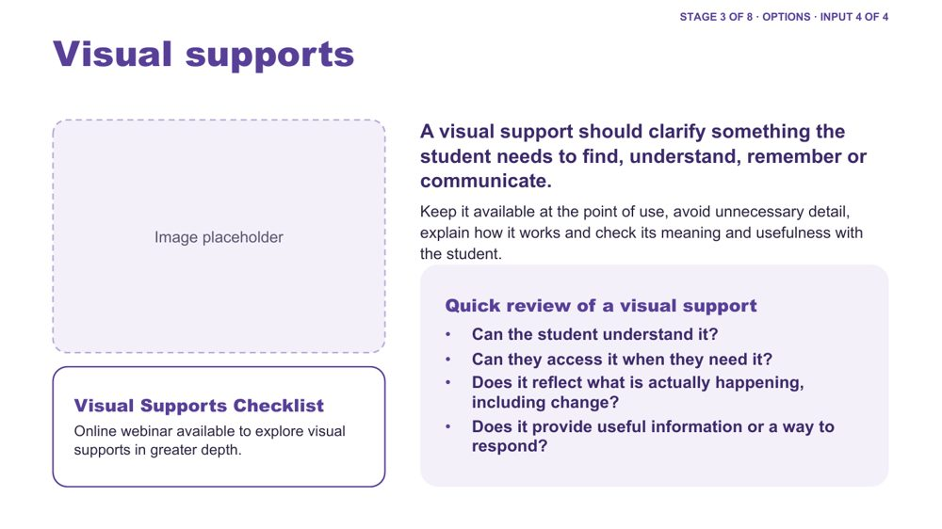 | Visual supports  SUGGESTED TIME  3 min  CLOCK  1:26 - 1:29  PARTICIPANT GUIDE  Page 19 - Quick review of a visual support

Option 4 of 4: visual supports that clarify what students need to find, understand, remember or communicate.
WHAT TO DO  - Keep this input to about two or three minutes.  - Start with what information students need, not with a particular visual tool.  - Note that a support is not automatically accessible because it is visual: check students understand what it represents and can use it.  - In secondary, visual supports can look like written instructions that stay on the board or class page, task maps, checklists and assessment calendars. Check they are respectful and suit the student's age.  - Link back to receptive and expressive communication: a visual support may help a student understand, while AAC gives ways to communicate.  - For students who use AAC, ask how information is made accessible and how they can respond; keep their communication system available in every class, during transitions and changes.  - Use the four quick-review questions on the slide to review an example briefly.  - Point participants to the Visual Supports Checklist and the online webinar for further learning. | KEY MESSAGES  - Visual supports can make information visible, available and able to be revisited.  - A visual support is useful only when it improves access for the intended student or group.  - Visual supports should support access, communication and agency, not simply compliance.  - Start with what the student needs to know and how they can respond, rather than which visual you want to use.

YOU MIGHT SAY
We're introducing some key principles around visual supports here, but this is a much bigger area than we can cover in this part of the session. You'll have access to a Visual Supports Checklist to help you think through supports in your own setting. There is also an online webinar that explores visual supports in greater depth if you'd like to extend your learning.
What information does the student need here, and how can they respond?

KEEP IN MIND
- Avoid prescribing one format for all Autistic students.
- Some young people will avoid a support that marks them out in front of peers. Designing it for the whole class can help.
- Do not assume access to AAC means spoken instructions, schedules or changes are automatically understood.
- Do not read the absence of a spoken response as absence of understanding, preference, opinion or a response.
- The checklist is not a prescription; it gives questions for reflection, personalisation and consultation.

Background Examples of visual supports include photographs, symbols, written words, checklists, maps, task maps, choice supports, visual schedules and assessment calendars. Visual information can sit alongside spoken communication rather than replacing it. The checklist prompts: Purpose, Meaning, Access, The real day, Communication and agency, Review. Its closing question: Does this support give this student useful information they can understand, access and act on?
Thread Links back to receptive and expressive communication from Session 3.
RESOURCES
- Visual Supports Checklist - referenced in the notes (no link given)
- Online webinar on visual supports - referenced in the notes (no link given)

SESSION 4 | Learning Design | SLIDE 12 of 21

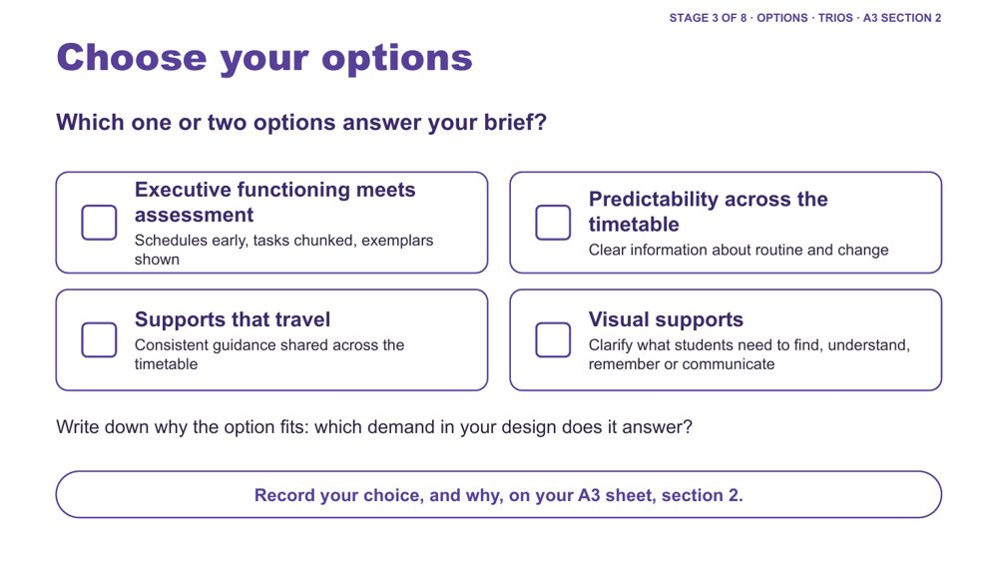 | Choose your options  SUGGESTED TIME  3 min  CLOCK  1:29 - 1:32  GROUPING  Trios  PARTICIPANT GUIDE  Page 18 - Options we chose

Trios choose one or two options that answer a specific demand in their lesson, assessment task or handover.
WHAT TO DO  - Ask trios to pick one or two options, not all four.  - Ask them to note why each option answers a specific demand in their design.  - Ask them to record the choice, and why, on the A3 sheet, section 2. | KEY MESSAGES  - The point is matching support to a known demand, not collecting strategies.

ACTIVITY | Trio decision on the A3 sheet, section 2 trios · about 3 minutes
Which one or two options answer your brief?
- Sort the printed option cards against your brief.
- Choose one or two options.
- Write down which demand in your design each option answers.
- Record your choice, and why, on the A3 sheet, section 2.

KEEP IN MIND
- Discourage choosing all four options.

SESSION 4 | Learning Design | SLIDE 13 of 21

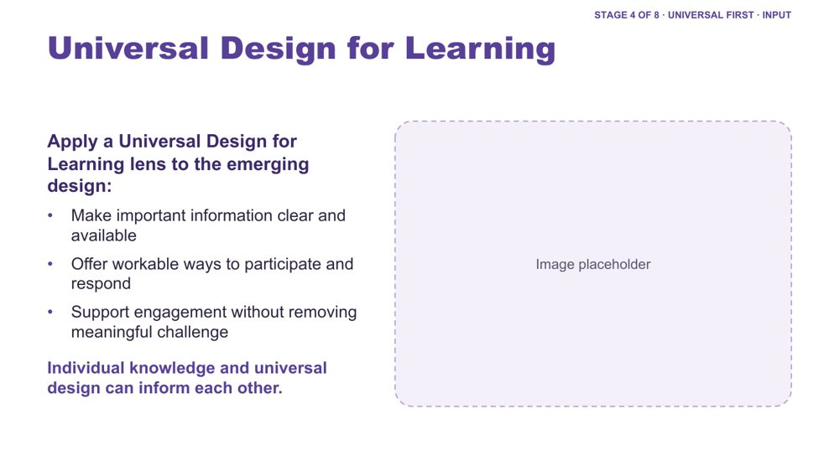 | Universal Design for Learning  SUGGESTED TIME  2 min  CLOCK  1:32 - 1:34

Frame a Universal Design for Learning lens before the trios' accessibility check.
WHAT TO DO  - Keep this input to about two minutes.  - Introduce Universal Design for Learning using the three points on the slide.  - Ask for one quick example from the room for any of the points, for example more than one way to show learning in an assessment task.  - Name that individual knowledge and universal design can inform each other. | KEY MESSAGES  - Universal design and individual knowledge can inform each other.  - The presence of a resource does not guarantee access.

SESSION 4 | Learning Design | SLIDE 14 of 21

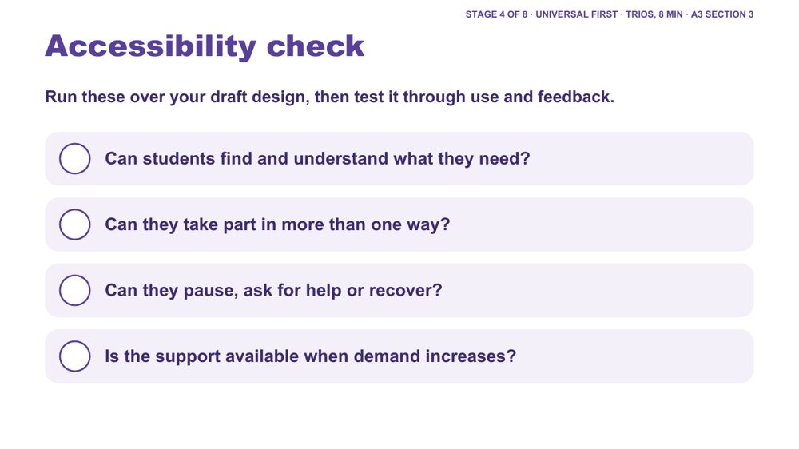 | Accessibility check  SUGGESTED TIME  6 min  CLOCK  1:34 - 1:40  GROUPING  Trios  PARTICIPANT GUIDE  Page 19 - Universal first

Trios test their draft design against four accessibility questions.
WHAT TO DO  - Ask trios to run the four questions over their draft design.  - Ask them to tick each on the A3 sheet, section 3.  - Where the answer is "not yet", ask them to adjust the design before moving on.  - Ask whether participation, help, pause and recovery are available in more than one way, and whether that holds with a different teacher or on a relief day. | KEY MESSAGES  - Accessibility is tested through use and feedback, not assumed from the presence of a resource.

ACTIVITY | Trio check on the A3 sheet, section 3 trios · about 6 minutes (8 minutes with the UDL input)
Run these over your draft design, then test it through use and feedback.
- Can students find and understand what they need?
- Can they take part in more than one way?
- Can they pause, ask for help or recover?
- Is the support available when demand increases?
- Where the answer is "not yet", adjust the design.

SESSION 4 | Learning Design | SLIDE 15 of 21

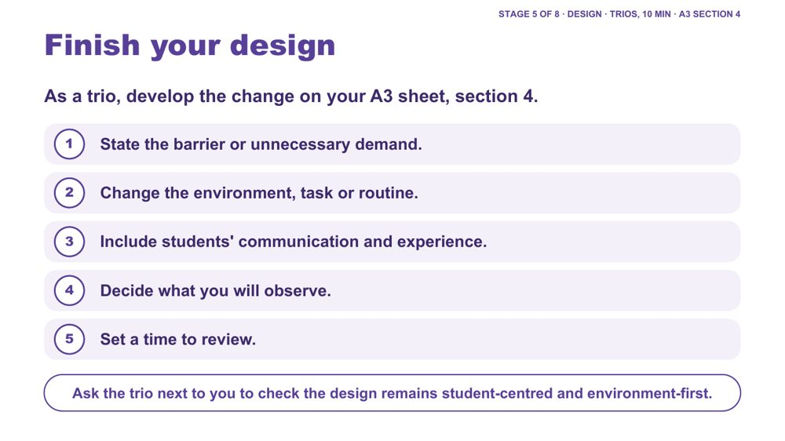 | Finish your design  SUGGESTED TIME  10 min  CLOCK  1:40 - 1:50  GROUPING  Trios  PARTICIPANT GUIDE  Page 20 - Our design

Trios develop one practical change to their lesson, assessment task or handover, ready to try and review.
WHAT TO DO  - Ask trios to work through the five steps on the A3 sheet, section 4.  - Ask them to name the barrier or demand before choosing a strategy.  - Prompt them to identify what can change in the environment, task, information, timing or routine.  - Keep the change small enough to try and observe. Something a teacher could try this week is a good size.  - For a handover or assessment task, ask who else needs to know: other subject teachers, relief teachers, learning support, the year level coordinator.  - Near the end, ask each trio to have the trio next to them check the design remains student-centred and environment-first. | KEY MESSAGES  - The measure of success should be access, not compliance.

ACTIVITY | Trio design on the A3 sheet, section 4, with a neighbouring-trio check trios · 10 minutes
As a trio, develop the change on your A3 sheet.
- State the barrier or unnecessary demand.
- Change the environment, task or routine.
- Include students' communication and experience.
- Decide what you will observe.
- Set a time to review.
- Ask the trio next to you to check the design remains student-centred and environment-first.
Close: Prepare a one-sentence description of the change and the access question it addresses.

KEEP IN MIND
- Avoid making students' compliance the success measure.

Background Small, free changes might be instructions written as well as spoken, a two-minute warning before packing up, or showing the finished exemplar first. Some changes need a decision beyond one classroom, such as assessment policy or timetabling. Ask trios to note these; they come back in the commit at the end of the session.

SESSION 4 | Learning Design | SLIDE 16 of 21

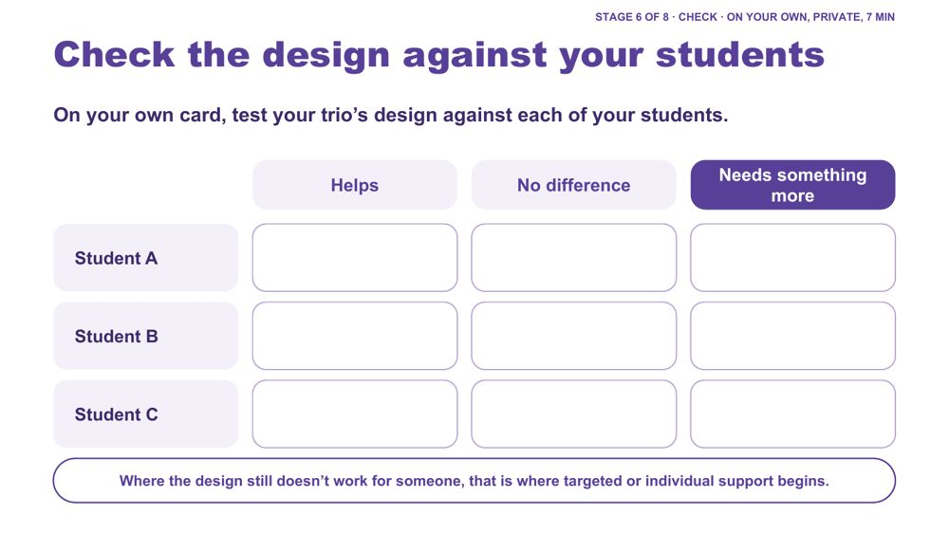 | Check the design against your students  SUGGESTED TIME  7 min  CLOCK  1:50 - 1:57  GROUPING  On your own  PARTICIPANT GUIDE  Page 21 - My students check (or the "My students" card)

Each person privately tests the trio's design against each of the students they have in mind.
WHAT TO DO  - Ask each person to use their own "My students" card, privately.  - Ask them to mark each student (Student A, B, C) as Helps, No difference or Needs something more.  - Name that a trio brings six to nine real students to one design: this is where the broad, mixed picture of autism shows up.  - Invite trios to share only what they choose, for example how many "needs something more" marks the design collected, without describing students.  - Invite one or two examples of "needs something more" to open the continuum discussion. | KEY MESSAGES  - Where the design still doesn't work for someone, that is where targeted or individual support begins.  - The same design will work differently for different Autistic students.

ACTIVITY | Private check on the "My students" card on your own · 7 minutes
On your own card, test your trio's design against each of your students.
- List your students as Student A, B and C.
- Mark each: Helps, No difference or Needs something more.
- Share with your trio only what you choose.
Bring the room back
- How many "needs something more" marks did your design collect?
Close: Where it helps, the universal design is doing its job. Where it makes no difference or a student needs something more, that leads into the continuum of support.

KEEP IN MIND
- Keep it private: no names or identifying details, initials or letters only.
- A student who seems fine may be masking. "No difference" is worth a second look.

Background This keeps individual students in view without building a profile of one young person.
Thread Leads straight into the continuum of support (Stage 7).

SESSION 4 | Learning Design | SLIDE 17 of 21

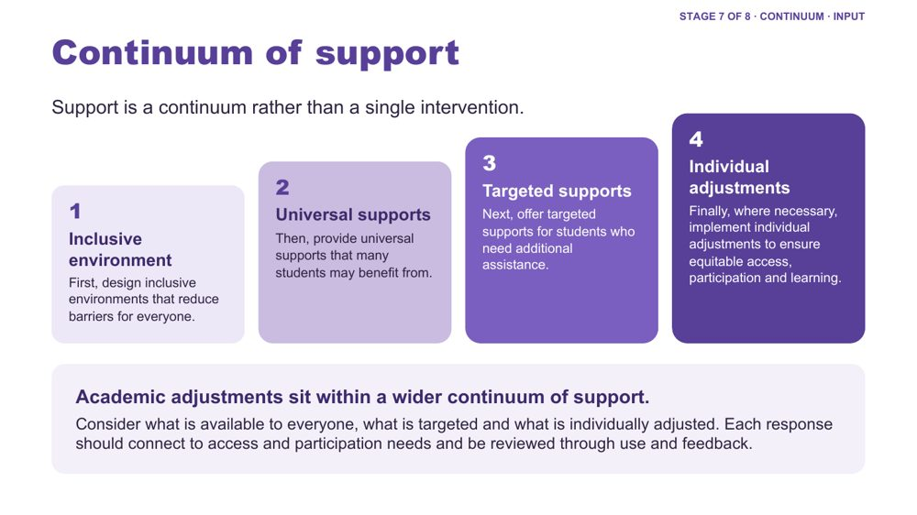 | Continuum of support  SUGGESTED TIME  4 min  CLOCK  1:57 - 2:01

Show what happens when the check shows "needs something more": a continuum from inclusive environment to individual adjustments.
WHAT TO DO  - Open from the "needs something more" examples just shared.  - Walk the four layers: inclusive environment, universal supports, targeted supports, individual adjustments.  - Use one example per layer from the background below.  - Ask what is available to everyone, what is targeted and what is individually adjusted.  - Explain the order: design for everyone first, then add targeted and individual support where it is needed.  - Connect adjustments to evidence from the secondary day map, consultation and the design process. | KEY MESSAGES  - Support is a continuum rather than a single intervention.  - Academic adjustments respond to access and participation needs.  - Each response should connect to access and participation needs and be reviewed through use and feedback.

KEEP IN MIND
- Do not imply that diagnosis alone determines an adjustment.

Background Inclusive environment: predictable routines across classes, clear expectations, assessment schedules published early, and a school culture where different ways of participating are accepted and valued. Universal supports: instructions in verbal, written and visual forms, flexible ways to demonstrate learning, exemplars, a class page where tasks stay available. Targeted supports: a small group receives pre-teaching of key vocabulary, a structured organisation checklist or check-ins on assessment milestones. Individual adjustments: a personalised adjustment plan, for example a quieter space for assessments, additional processing time, a task broken into visible steps and alternative ways to demonstrate learning.

SESSION 4 | Learning Design | SLIDE 18 of 21

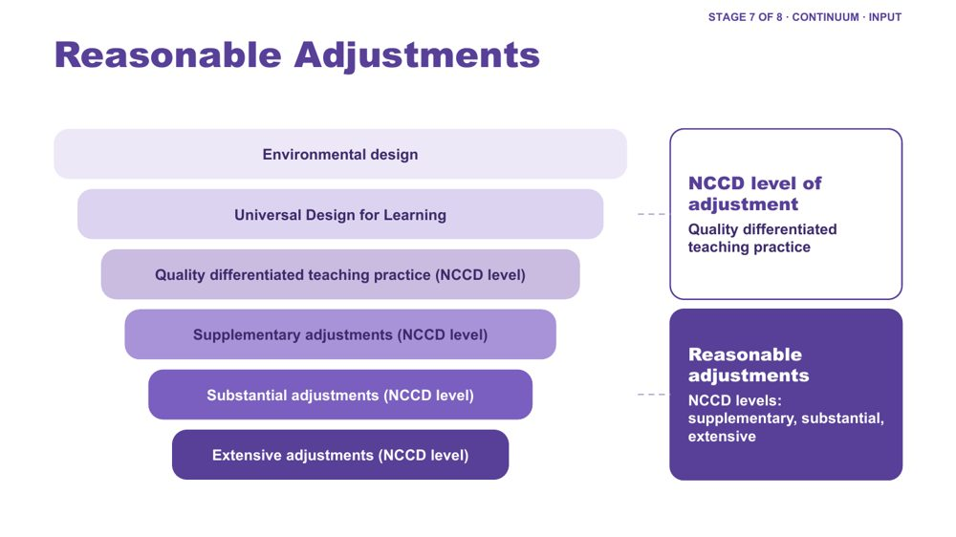 | Reasonable Adjustments  SUGGESTED TIME  2 min  CLOCK  2:01 - 2:03

Place reasonable adjustments and NCCD levels within the layers of inclusive design.
WHAT TO DO  - Walk the funnel from environmental design and UDL through quality differentiated teaching practice (an NCCD level of adjustment) to supplementary, substantial and extensive adjustments (the other three NCCD levels of adjustment).  - Give the definition of reasonable adjustments from the background below.  - Distinguish reasonable adjustments (the support actions) from the NCCD (the process for collecting information about them). | KEY MESSAGES  - Adjustments are individualised, strengths based, remove barriers, practical and effective, based on informed decision making, and empowering and enabling.  - Supports and adjustments build student capability, confidence, self-advocacy and independence, not dependence on adults.

YOU MIGHT SAY
Reasonable adjustments are changes or supports that help students access and participate in education in a way that works for them.

KEEP IN MIND
- Do not give legal advice or present the workshop as a substitute for school or system processes.

Background Adjustments align to the curriculum. Schools consider the needs of the student as well as the impact on staff, other students and available resources. A student is included in the NCCD when they have a disability as defined under the Disability Discrimination Act (DDA), the school has provided reasonable adjustments to address their educational needs, and evidence exists that the adjustments have been provided and monitored. The NCCD helps schools demonstrate compliance with the DSE, monitor the effectiveness of adjustments, ensure students receive appropriate support, and inform planning and resource allocation.

SESSION 4 | Learning Design | SLIDE 19 of 21

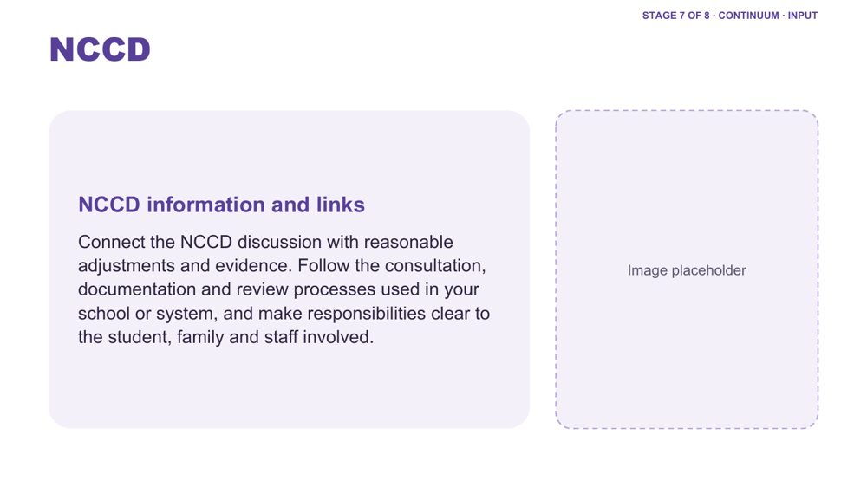 | NCCD  SUGGESTED TIME  2 min  CLOCK  2:03 - 2:05

Direct participants to current official NCCD information and their local processes.
WHAT TO DO  - Direct participants to current official NCCD information.  - Connect the NCCD discussion with reasonable adjustments and evidence.  - Invite participants to follow the consultation, documentation and review processes used in their school or system.  - Encourage them to make responsibilities clear to the student, family and staff involved. | KEY MESSAGES  - Academic adjustments respond to access and participation needs.  - Use current official NCCD information.  - Follow school and system requirements for local processes.  - Local processes and current official guidance remain important.

KEEP IN MIND
- Do not give legal advice or present the workshop as a substitute for school or system processes.
- Do not imply that diagnosis alone determines an adjustment.

Thread Consultation and the NCCD Meetings Tool Kit are developed further in Session 5.

SESSION 4 | Learning Design | SLIDE 20 of 21

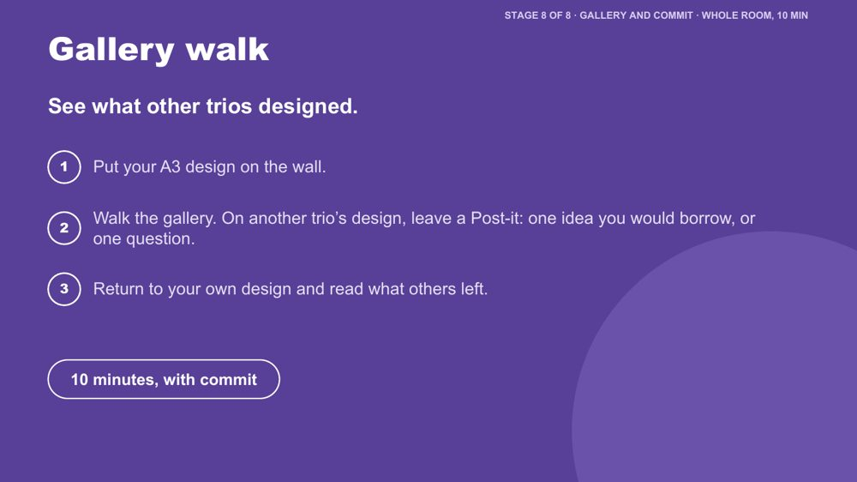 | Gallery walk  SUGGESTED TIME  6 min  CLOCK  2:05 - 2:11  GROUPING  Whole room

Every design is seen and ideas travel between trios.
WHAT TO DO  - Ask each trio to put their A3 design on the wall.  - Ask people to walk the gallery and leave a Post-it on another trio's design: one idea they would borrow, or one question.  - Allow about 6 minutes for the walk.  - Ask trios to return to their own design and read what others left.  - Move to the commit slide. | KEY MESSAGES  - Ideas travel between trios.

ACTIVITY | Gallery walk with Post-its whole room · about 6 minutes
See what other trios designed.
- Put your A3 design on the wall.
- Walk the gallery. On another trio's design, leave a Post-it: one idea you would borrow, or one question.
- Return to your own design and read what others left.

KEEP IN MIND
- Keep designs anonymised: no student names or identifying details on the wall.

Thread Echoes the Session 3 Post-it wall ("What should travel between people and places?").

SESSION 4 | Learning Design | SLIDE 21 of 21

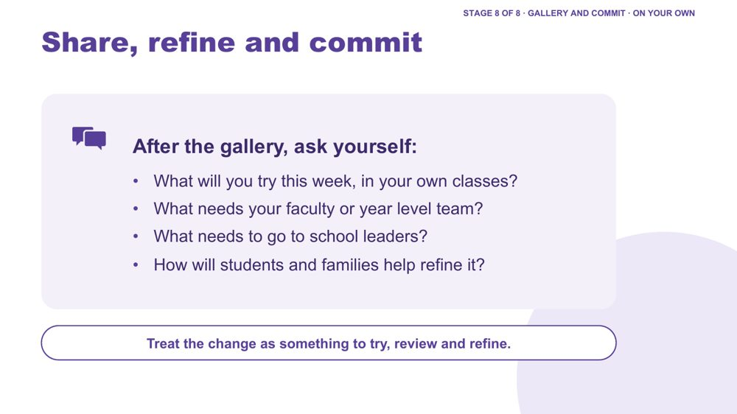 | Share, refine and commit  SUGGESTED TIME  4 min  CLOCK  2:11 - 2:15  GROUPING  On your own  PARTICIPANT GUIDE  Page 21 - Commit (or the bottom of the "My students" card)

Refine the design and decide on realistic next steps: in your own classes this week, with your faculty or year level team, and with school leaders.
WHAT TO DO  - Ask participants to turn to the Commit activity in their guide (p. 21).  - Read the four questions on the slide: What will you try this week, in your own classes? What needs your faculty or year level team? What needs to go to school leaders? How will students and families help refine it?  - Ask them to fill in the three boxes: This week, in my own classes; With my faculty or year level team; To raise with school leaders. Then the two below: Who I will involve, including the student and family; and How students and families will help refine it.  - Explain why there are three levels. Many barriers in secondary, such as assessment policy, timetabling and reporting, sit beyond one classroom. Naming which level a change belongs to is useful, and it does not mean the design has failed. The "this week" box should still be something they can do in their own classes.  - For anyone who prefers to keep it private, the bottom of the "My students" card still has "One thing I will try" and "Who I will involve".  - Invite optional sharing in pairs or with the whole group.  - Encourage consultation with students, families and relevant school colleagues rather than presenting the design as finished.  - Mention that their "this week" change can be their Start on the action card in Session 6.  - Move into Session 5 on working in partnership. | KEY MESSAGES  - A design change is something to try, review and refine.  - Student and family knowledge can refine what educators notice and try.

ACTIVITY | Personal commitment in the guide (p. 21), or privately on the "My students" card on your own · about 4 minutes
What will you try this week, in your own classes? What needs your faculty or year level team? What needs to go to school leaders? How will students and families help refine it?
- This week, in my own classes.
- With my faculty or year level team.
- To raise with school leaders.
- Who I will involve, including the student and family.
- How students and families will help refine it.
Close: Treat the change as something to try, review and refine.

KEEP IN MIND
- Keep any public example anonymised.

Thread Leads into Session 5 on partnership, including adolescents in their own meetings. The "this week" change can be the Start on the Session 6 action card.

Session 4 · Hidden slides
These slides stay in the deck but are hidden, so they do not show when presenting. Unhide one in PowerPoint (right-click the slide, then Unhide Slide) if you want it back.
Slide | Title | Why it is hidden
22 | Design one change | Folded into Regroup: the design targets (now a lesson, an assessment task or a handover) are the corners of the room.
23 | Identifying and reducing barriers in practice | Folded into the options menu to keep inputs short; its questions also suit the accessibility check.
24 | Inclusive Design | The fuller Reasonable Adjustments funnel in Stage 7 covers the same layers.
25 | Differentiation | Cut for time in the workshop version; UDL carries this idea.
26 | Designing inclusive learning environments | Cut for time in the workshop version.
27 | A continuum of support example | Condensed: its examples are in the Continuum of support notes (slide 17).
28 | What are reasonable adjustments? | Condensed: its definition and notes are on the Reasonable Adjustments slide (slide 18).
29 | Environmental / Audits | Overlaps the audit of the secondary day, which now sits at the end of Session 3.
30 | Let's discuss - Inclusive Checklist for Supporting Autistic Students | A second activity competing with the main design task; the printed checklist could still be offered as a resource.
31 | Supporting Frameworks/Guidance | Cut for time; consultation and the NCCD Meetings Tool Kit are covered in Session 5.
32 | Disability Standards for Education (DSE) 2005 | Cut for time; consultation and the NCCD Meetings Tool Kit are covered in Session 5.
33 | Activity: Determining supports and adjustments | Cut for time; determining adjustments is picked up through consultation and the NCCD Meetings Tool Kit in Session 5.
34 | Record - Monitor - Review | Appendix reference on reviewing adjustments; not in the workshop flow.
35 | Student Consultation | Appendix reference on consulting students; not in the workshop flow (its content is on Session 5 slide 12, Consulting students and families).
36 | Parent/Carer Consultation | Appendix reference on consulting families; not in the workshop flow (its content is on Session 5 slide 12, Consulting students and families).

SESSION  5 | 2:15 - 3:15 · 60 MINUTES · 18 SLIDES  Working in Partnership  Who should I involve in this journey?

SESSION INTENT
Strengthen home-school partnership by keeping the student at the centre, recognising that the student, family, support staff and school each hold part of the picture, and examining how power shapes consultation. In secondary, students can take part in, and over time lead, their own meetings. Participants leave with practical consultation moves and a question ready for their Session 6 conversation plan.
PARTICIPANTS LEAVE WITH
- explain why the student sits at the centre of every partnership, and name the collaboration principles all partners share
- identify where power sits in home-school meetings and one process change the school could make
- open a conversation with a parent or student by asking and listening before offering solutions
- use practical ways to consult students and families, including asking in the person's preferred way and discussing capacity without blame
- describe how adolescents can be prepared to take part in, and over time lead, their own meetings
- prepare the opening question and shared purpose for one purposeful conversation

RUN SHEET
Clock | Segment | Slides | Minutes
2:15 - 2:22 | Opening: the student at the centre | 1-3 | 7
2:22 - 2:34 | Collaboration and power | 4-6 | 12
2:34 - 2:39 | Student voice video | 7 | 5
2:39 - 2:53 | Partnership activity and the first two minutes | 8-9 | 14
2:53 - 3:05 | Consulting well, adolescents in their own meetings, and capacity | 10-14 | 12
3:05 - 3:10 | Tools and supports | 15-17 | 5
3:10 - 3:15 | Bridge to Session 6 | 18 | 5

PREPARE
☐ Post-it notes and pens for every participant (slide 6).
☐ Butcher's paper on the wall headed Home, School and Solutions, if using the wall option (slide 6).
☐ Student voice video (Adon) cued and sound checked (slide 7).
☐ Participant Guide p. 24 ready for each table: the Partnership activity grid (slide 8) and The first two minutes scenarios (slide 9).
☐ Phone numbers and services on slide 17 checked as current.
☐ Participant Guide pp. 22 - 25 ready to point to.

SESSION 5 | Working in Partnership | SLIDE 1 of 18

 | Working in Partnership  SUGGESTED TIME  1 min  CLOCK  2:15 - 2:16

Open the partnership session and connect it to the design work.
WHAT TO DO  - Name the shift from what educators can redesign to how home and school can understand and act together.  - Everything designed in Session 4 was based on what teachers can see and work out for themselves. This session is about hearing from the people who know the student best.  - Pick up the "Who I will involve" line participants wrote on their Session 4 'My students' card.  - Keep the student at the centre of the conversation.  - Acknowledge that participants may bring both productive and difficult partnership experiences.  - Remind the room that sharing is voluntary and examples stay anonymised (initials or roles only). | KEY MESSAGES  - Partnership is part of understanding and support, not an additional task after decisions are made.  - The student, family, support staff and school may each hold different parts of the picture.

KEEP IN MIND
- Energy is lower in the afternoon. This session relies on discussion and examples rather than a lot of new content.

Thread Picks up the "Who I will involve" line from the Session 4 'My students' card (Participant Guide p. 21).

SESSION 5 | Working in Partnership | SLIDE 2 of 18

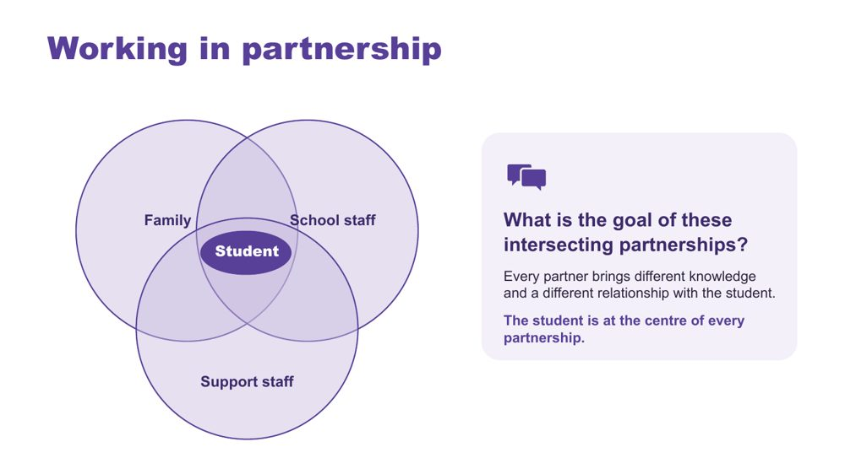 | Working in partnership  SUGGESTED TIME  3 min  CLOCK  2:16 - 2:19  PARTICIPANT GUIDE  Page 22 - Session 5 summary

Show where the partnerships around a student intersect, with the student at the centre of every one.
WHAT TO DO  - Introduce the Venn: family, school staff and support staff, with the student at the centre.  - Explain that every partner brings unique knowledge, expertise and perspectives, and a different relationship with the student and with each other.  - Name the secondary picture: there are more people involved. Six or more subject teachers, a year level coordinator, learning support, support staff, and sometimes a relief teacher.  - Ask the group: What is the goal of these intersecting partnerships?  - Steer the discussion so the point is made that the student is at the centre of all partnerships.  - Acknowledge support staff directly. They often see more of the student across the day than any one teacher, and their knowledge is not always asked for or credited.  - Ask who is missing from the picture and how the student's own communication can be included.  - Point participants to Where partnerships converge in the Participant Guide (p. 22). | KEY MESSAGES  - Positive partnership keeps the student at the centre.  - No single person holds the complete picture. In secondary it is spread across more people.  - Every partner brings different knowledge and a different relationship with the student.  - The student knows things no assessment captures: what it feels like, what helps and what is hard.  - The family sees things over time that school may not: how the student is after school, how Sunday nights go, the strategy that worked in primary school.

YOU MIGHT SAY
What is the goal of these intersecting partnerships?

KEEP IN MIND
- Use the elements as discussion prompts rather than a complete definition.

Background With session time limited, this slide is a chance to see where all the partnerships converge and what is needed for success across all of them. Observation only shows a teacher the outside of a student's experience. Asking the student and family fills in more of the picture, and their views are also part of the evidence for NCCD.
Thread Draws on sensory and thinking (Session 2), communication, capacity and masking across the secondary day (Session 3) and the Session 4 design and continuum of support.

SESSION 5 | Working in Partnership | SLIDE 3 of 18

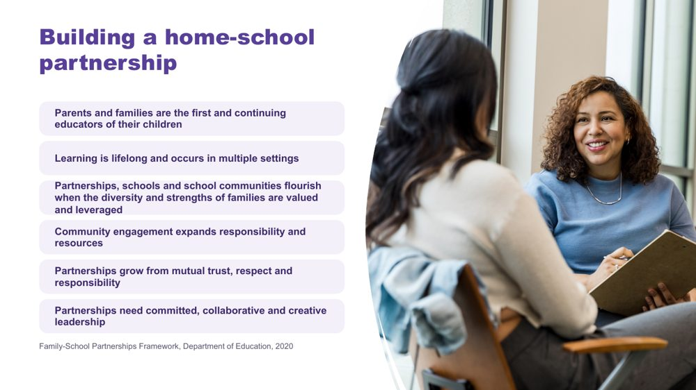 | Building a home-school partnership  SUGGESTED TIME  3 min  CLOCK  2:19 - 2:22

Make positive partnership concrete in educator practice using the Family-School Partnerships Framework principles.
WHAT TO DO  - Walk through the six Framework principles briefly.  - Position family knowledge and school knowledge as different, useful perspectives.  - Name the secondary reality: families have fewer informal contacts (no school gate conversations, and many teachers), so contact often narrows to reports and problems. Ask: who is the family's main point of contact?  - Name what makes partnership visible in practice: a shared purpose, respectful listening, student voice and communication, clear accessible information, and agreed next steps, responsibilities and follow-up. | KEY MESSAGES  - The student, family and school may each see different parts of experience. Partnership helps these perspectives inform understanding, design, action and review from the beginning.  - Listening, clarity and shared next steps can be observed in practice.

KEEP IN MIND
- Avoid implying that agreement is required before listening or respect are possible.

RESOURCES
- Family-School Partnerships Framework - Department of Education, Australian Government - https://www.education.gov.au/supporting-family-school-community-partnerships-learning/family-school-partnerships/family-school-partnerships-framework

SESSION 5 | Working in Partnership | SLIDE 4 of 18

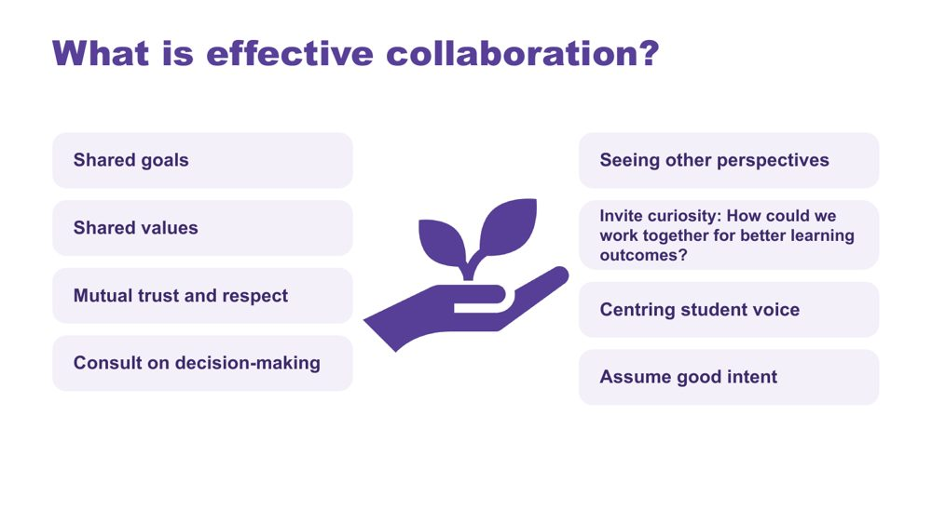 | What is effective collaboration?  SUGGESTED TIME  3 min  CLOCK  2:22 - 2:25

Name the collaboration principles that strong partnerships share, whoever is at the table.
WHAT TO DO  - Introduce the importance of collaboration: for Autistic students in secondary there are multiple collaboration points across multiple partnerships, and across multiple teachers.  - Explain that the key collaboration skills are the same across all groups, and are vital for strong partnerships.  - Ask the group: What are some of the key principles for effective collaboration to occur?  - Build the discussion to cover: shared goals, shared values, mutual trust and respect, consulting on decision-making, seeing other perspectives, inviting curiosity, centring student voice, assuming good intent.  - Click to show the points on the slide once the room has contributed. | KEY MESSAGES  - The collaboration skills needed are the same across every partnership around the student.

YOU MIGHT SAY
What are some of the key principles for effective collaboration to occur?
How could we work together for better learning outcomes?

Background The team added this slide because it works well with all parties and helps people see each other's perspectives.

SESSION 5 | Working in Partnership | SLIDE 5 of 18

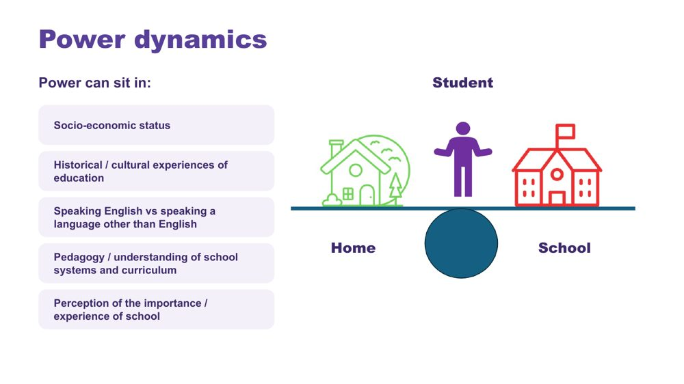 | Power dynamics  SUGGESTED TIME  3 min  CLOCK  2:25 - 2:28

Help participants notice how agendas, language, authority and decision-making shape consultation.
WHAT TO DO  - Introduce the seesaw: school, home and the student.  - Ask participants to think of their last difficult family meeting. Who chose the room, the time and the agenda? Give people a moment to think before moving on.  - Name where power can sit: socio-economic status, historical and cultural experiences of education, speaking English or another language, understanding of school systems and curriculum, and perceptions of the importance of school.  - Ask the power questions below to examine practice, not to blame individual participants.  - Invite educators to identify where school language, timing or process may create a barrier. | KEY MESSAGES  - Power is present in meeting structures, language and decision pathways.  - In most school meetings the school chooses the place, the time, the agenda and the language, and the family is often outnumbered.  - By secondary, many families have been to a lot of these meetings. Some arrive worried or on guard because of earlier experiences, at this school or another one.

YOU MIGHT SAY
Who sets the agenda?
Whose knowledge is heard?
Who can make decisions?
Is the student included in a way that works for them?
What could the school change about the process?

KEEP IN MIND
- Avoid describing a family as difficult, disengaged or unrealistic without examining the context and process.
- Some participants will have had genuinely difficult or hostile meetings with families. Acknowledge that partnership works both ways, then come back to what the school can change.

SESSION 5 | Working in Partnership | SLIDE 6 of 18

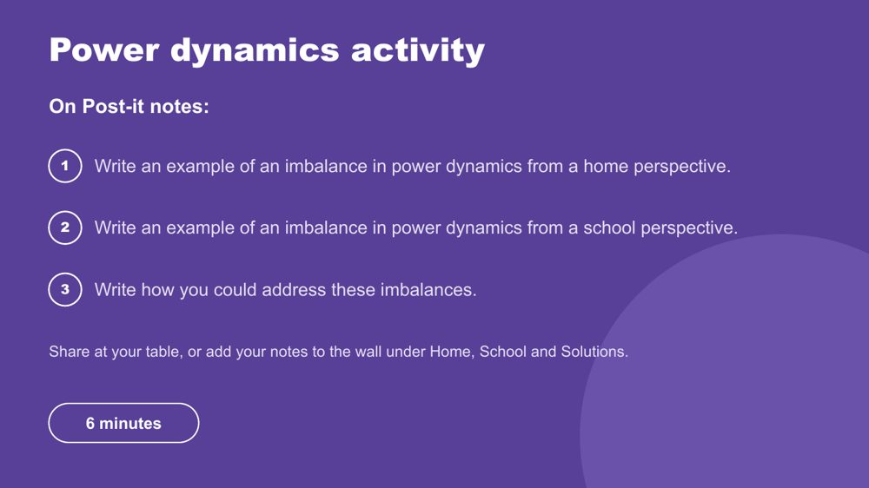 | Power dynamics activity  SUGGESTED TIME  6 min  CLOCK  2:28 - 2:34  GROUPING  Table groups  PARTICIPANT GUIDE  Page 23 - Power dynamics

Prompt educators to reflect honestly on perceived and real power imbalances in the home-school relationship.
WHAT TO DO  - Make sure every participant has Post-it notes and a pen.  - Direct participants to the three instructions on the slide.  - Choose a sharing option that suits the room (see steps).  - Support tables to look for solutions rather than place blame.  - Take feedback from a few participants at the end. | KEY MESSAGES  - Power can be structural, historical, cultural, conscious and unconscious.  - Status can be perceived as an imbalanced power dynamic, regardless of intent.

ACTIVITY | Post-it note reflection table groups · 6 minutes
Where do power imbalances sit in the home-school relationship, and how could you address them?
- On one Post-it, write an example of an imbalance in power dynamics from a home perspective.
- On a second, write an example from a school perspective.
- On a third, write how you could address these imbalances.
- Option 1: share Post-it notes with your table.
- Option 2 (movement break): take your Post-it notes to another person in the room to share.
- Option 3: place Post-it notes on butcher's paper on the wall under Home, School and Solutions.
Bring the room back
- Who sets the agenda?
- Whose knowledge is heard?
- Who can make decisions?
- What could the school change about the process?
Close: Ask participants to keep one process change for their family-conversation plan.

KEEP IN MIND
- This may be challenging for some participants, who may have found themselves in positions of power or lack of power at different times in their career. Guide individuals to seek solutions and not place blame.

Background Educators are immersed in the culture of education, including a shared understanding of acronyms (e.g. NAPLAN, NCCD, IEP) and secondary systems (subject selection, pathways, senior certificate requirements) which families may not be able to access as easily. Some people will purposely and naturally endow teachers with higher status, which can be a cultural or personal attitude. External providers and professionals can also affect the power dynamic between those working with and supporting Autistic students. In secondary, the student sits in the power picture too: adolescents are often discussed in meetings they were not invited to.
Thread The process change chosen here carries into the bridge reflection (slide 18) and the Session 6 conversation plan.

SESSION 5 | Working in Partnership | SLIDE 7 of 18

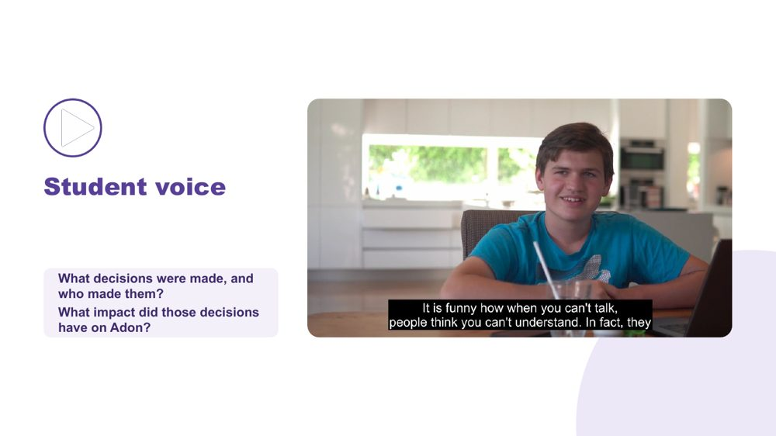 | Student voice  SUGGESTED TIME  5 min  CLOCK  2:34 - 2:39  PARTICIPANT GUIDE  Page 23 - Student voice

Show what happens when a student is not listened to or consulted.
WHAT TO DO  - Introduce the video as an example of a student who is neither listened to nor consulted.  - Ask participants, while watching, to pay attention to what decisions were made and who made them.  - Play the video.  - Ask the group: What impact did those decisions have on Adon?  - Connect to the students participants have in mind: how are their preferences asked and heard, and by which of their teachers? | KEY MESSAGES  - Students should have a say in decisions about them, at their level and in a way that works for them.  - Ask students the questions their way: what helps? what's hard? what should teachers know?  - Record their answers in their own words.  - For adolescents, being asked is the starting point. Taking part in their meetings, and over time leading them, comes next (slide 13).

YOU MIGHT SAY
While watching, pay attention to what decisions were made and who made them.
What impact did those decisions have on Adon?

SESSION 5 | Working in Partnership | SLIDE 8 of 18

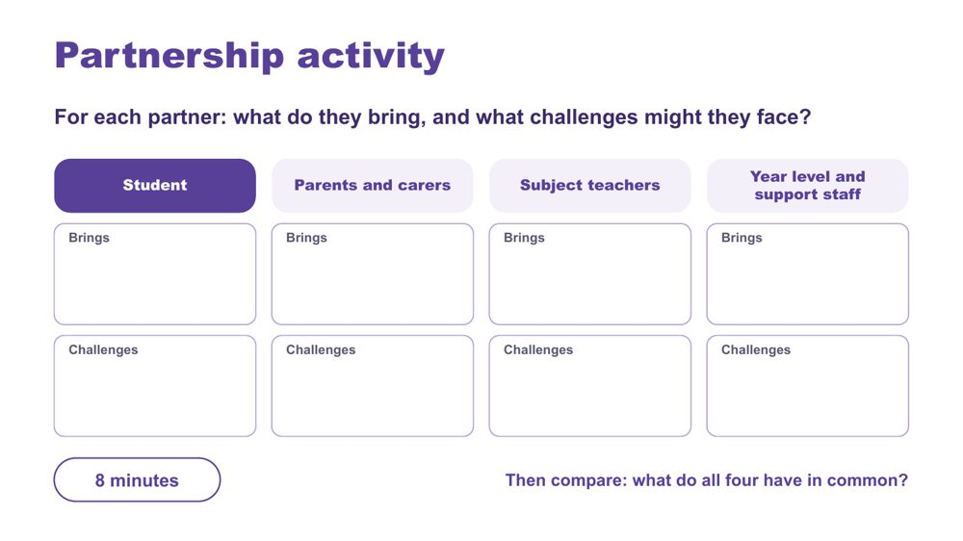 | Partnership activity  SUGGESTED TIME  8 min  CLOCK  2:39 - 2:47  GROUPING  Table groups  PARTICIPANT GUIDE  Page 24 - Partnership activity

Compare what each partner brings and the challenges they may face, and find what they share.
WHAT TO DO  - Make sure each table has the Partnership activity grid in the Participant Guide (p. 24).  - Ask table groups to record what each partner brings and what challenges they might face: the student, parents and carers, subject teachers, and year level and support staff.  - For subject teachers, prompt the secondary picture: each one sees the student for a few periods a week, in one subject.  - For year level and support staff, prompt what year level coordinators, learning support staff, and learning support officers or teacher aides see across the day and the year that a single subject teacher may not.  - Ask tables to compare: what do all four have in common?  - Take thoughts on similarities and differences, list the commonalities, and ask what would make the partnership more successful. | KEY MESSAGES  - Understanding the challenges and strengths of each partner can help build trust and confidence in the relationship.  - There are similarities and differences between what each partner brings to the partnership.  - Everyone has the student at the centre and student voice is included.  - At the heart of all interactions there should be an assumption of good intent regarding the outcomes for the student.

ACTIVITY | Table group partnership grid table groups · 8 minutes
For each partner: what do they bring, and what challenges might they face?
- Work through the four partners: student, parents and carers, subject teachers, and year level and support staff.
- For each, note what they bring and what challenges they might face.
- Compare: what do all four have in common?
Bring the room back
- What are the similarities and differences across the four partners?
- What would make the partnership more successful?
Close: List the commonalities the room names and link them to the collaboration principles on slide 4.

SESSION 5 | Working in Partnership | SLIDE 9 of 18

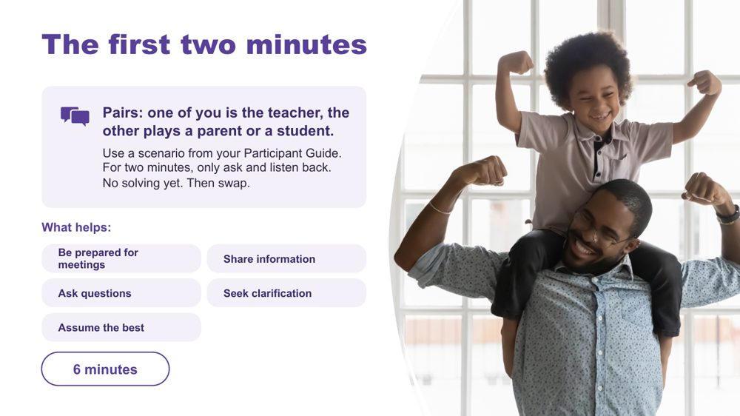 | The first two minutes  SUGGESTED TIME  6 min  CLOCK  2:47 - 2:53  GROUPING  Pairs  PARTICIPANT GUIDE  Page 24 - The first two minutes

Practise opening a conversation with a parent or student by asking and listening before offering solutions.
WHAT TO DO  - Put people into pairs and direct them to the three scenarios on p. 24 of the Participant Guide.  - Explain the task: one person is the teacher, the other plays the parent or student in a scenario they choose. For two minutes the teacher only asks questions and says back what they have heard. No suggestions or solutions yet.  - Keep it low-stakes. Nobody performs for the room and it does not need to be good acting. Anyone who would rather not role-play can write what they would ask and say in the first two minutes instead, then compare with their partner.  - Call time at two minutes. Give people a moment to jot notes, then swap roles and use a different scenario.  - Point to the What helps list on the slide as a reminder of what the teacher is aiming for.  - Bring the room back with: What did asking first bring out? Take 2-3 responses. Then ask: What made it hard not to jump to solutions? You do not need to comment on each answer.  - Close by asking everyone to write one question they will use to open a real conversation (the third box on p. 24). It can go straight into their bridge notes at the end of this session. | KEY MESSAGES  - Asking first gives the parent or student room to say what matters to them before the school decides what the problem is.  - Listening back, saying what you heard in your own words, shows you have understood and lets the other person correct you.  - Wanting to fix things quickly is normal for teachers. Holding off for two minutes often brings out information you would otherwise miss.  - What helps: be prepared for meetings, share information, ask questions, seek clarification, assume the best.

YOU MIGHT SAY
For two minutes, only ask and listen back. No solving yet.
What did asking first bring out?
What made it hard not to jump to solutions?

ACTIVITY | Paired practice pairs · 6 minutes
For two minutes, only ask and listen back. No solving yet. Then swap.
- Choose a scenario from p. 24. One person is the teacher, the other plays the parent or student.
- Scenario 1: a parent says their son in Year 8 has come home upset every afternoon this week. He won't say why, but he mentioned Science.
- Scenario 2: a parent says their daughter has stopped handing in homework. She says she doesn't know what the teachers want.
- Scenario 3: a Year 10 student has been asked to a meeting about adjustments for assessments, and isn't sure they want anyone to know.
- For two minutes, the teacher only asks and listens back. No solving yet.
- Swap roles and use a different scenario.
- If you would rather not role-play, write what you would ask and say in the first two minutes, then compare with your partner.
- Note your answers in the three boxes on p. 24: What did asking first bring out? What made it hard not to jump to solutions? A question I will use to open.
Bring the room back
- What did asking first bring out?
- What made it hard not to jump to solutions?
Close: Ask everyone to write one question they will use to open a real conversation.

KEEP IN MIND
- Some participants find role-play uncomfortable. Offer the writing option at the start so it is a real choice, and keep the pairs working privately.
- Scenario 3 is about a student who may not want others to know about their needs or adjustments. If it comes up in the debrief, acknowledge that who knows is the student's choice, and that this is part of what the teacher is listening for.
- Keep to the scenarios. If people start talking about real students, remind them to use initials or roles only.

Background Teachers are often expected to come to a meeting with answers, so asking and listening first takes practice. The scenarios are deliberately incomplete: the teacher does not yet know what is going on, which is why they need to ask. Other things that help with families: send the agenda beforehand, welcome a support person, open with a strength, share notes or minutes, and follow up in writing ('as we agreed...'). Try to make sure the first contact about a student each term is not about a problem. If a meeting has gone badly, name it, offer a fresh start and make the next meeting fairer. Family engagement in learning works best when schools support families, as the experts in their young person, to take part in equal partnership with the school (Barker & Harris, 2020).
Thread The opening question written here feeds the Session 5 bridge (slide 18: What question will open the conversation?) and the opening sentence in the Session 6 conversation plan (p. 28).
RESOURCES
- Barker, B., & Harris, D. (2020). Parent and Family Engagement: An Implementation Guide for School Communities. Canberra: ARACY
- Tett, L. & Macleod, G. (2020) Enacting home-school partnerships: the roles of headteachers, family-learning practitioners and parents, Cambridge Journal of Education, 50:4, 451-468 https://doi.org/10.1080/0305764X.2020.1722062

SESSION 5 | Working in Partnership | SLIDE 10 of 18

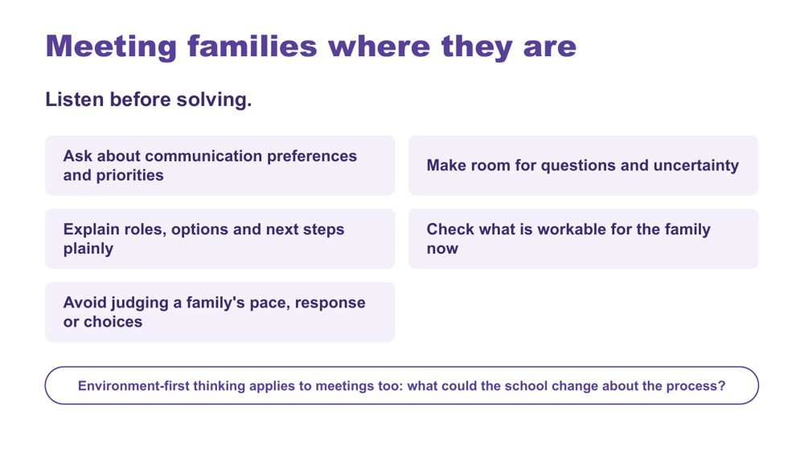 | Meeting families where they are  SUGGESTED TIME  2 min  CLOCK  2:53 - 2:55

Emphasise listening before solving, and making room for questions, uncertainty and different priorities.
WHAT TO DO  - Read the six practices briefly.  - Emphasise listening before solving, as in the first two minutes, and making room for questions, uncertainty and different priorities.  - Remind the room of masking from Session 3: families often see what school does not, such as a student falling apart at home after holding it together all day, or dreading Sunday night before the school week. This is one of the main reasons partnership matters.  - Ask in the way that suits the person: written questions sent in advance, a phone call instead of a meeting, a walk instead of sitting at a table, an interpreter booked before it is needed.  - Invite educators to identify where school language, timing or process may create a barrier.  - Finish with the line at the bottom of the slide: environment-first thinking applies to meetings too. | KEY MESSAGES  - Power is present in meeting structures, language and decision pathways.  - Meeting families where they are begins with listening and clarity.  - Environment-first thinking also applies to consultation processes.

YOU MIGHT SAY
What could the school change about the process?

KEEP IN MIND
- Avoid judging a family's pace, response or choices.
- Avoid describing a family as difficult, disengaged or unrealistic without examining the context and process.

SESSION 5 | Working in Partnership | SLIDE 11 of 18

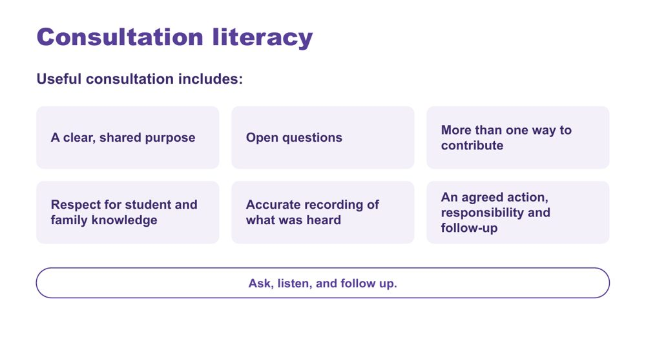 | Consultation literacy  SUGGESTED TIME  2 min  CLOCK  2:55 - 2:57  PARTICIPANT GUIDE  Page 25 - Consultation checklist

Introduce consultation literacy through asking well, listening and following up.
WHAT TO DO  - Walk through what useful consultation includes.  - Compare two questions: 'Any concerns?' and 'What does a good morning look like?' Ask what each one would bring out.  - Point out that following up is easy to skip: tell the family and student what you did with what they told you. It makes them more likely to tell you things next time.  - Frame the list as a check participants can use before and after a meeting.  - Finish with the line on the slide: ask, listen, and follow up. | KEY MESSAGES  - Ask, listen, and follow up.  - Ask specific questions, and ask in the way that suits the person.  - Views that are recorded and acted on are good practice, and they are also evidence.  - Tools should support consultation rather than replace listening and student voice.

SESSION 5 | Working in Partnership | SLIDE 12 of 18

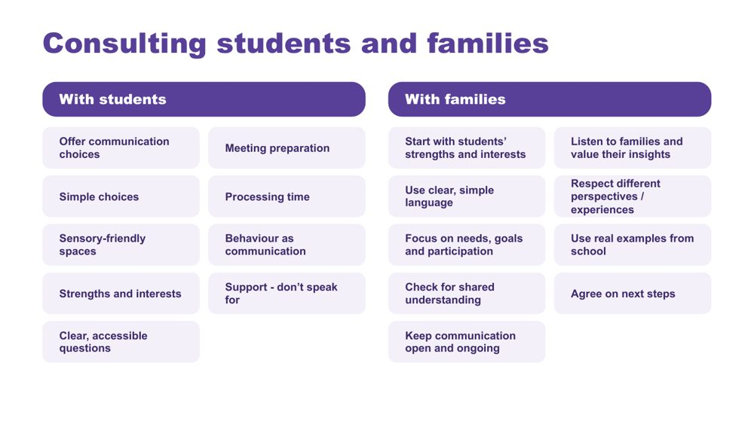 | Consulting students and families  SUGGESTED TIME  2 min  CLOCK  2:57 - 2:59

Give practical ways to consult students and families so every voice can be heard.
WHAT TO DO  - Take the two columns in turn: with students, then with families.  - With students: presume competence, provide communication supports, offer choices, allow time, and act on what students tell us. Adolescents can prepare their own contribution: a written list, a one-page profile, or a trusted adult who supports them to speak rather than speaking for them.  - With families: start with the student's strengths, interests and what works well, and listen to families' knowledge of their young person without making assumptions.  - Ask participants to pick one practice from each column to try with the students they have in mind. | KEY MESSAGES  - Listen, adapt, give choices, and make it easy for every student to have a voice.  - Ensure trusted supporters assist communication without replacing the student's voice.  - Use plain language and explain educational terms clearly.  - Focus on the student's needs and goals, not just their diagnosis.  - Recognise that some parents will be neurodivergent themselves.

Background Student consultation: provide multiple communication options (AAC, visuals, writing, drawing, video, symbols); prepare students in advance with questions, agendas and meeting information; use supported decision-making with simple choices and extra processing time; create sensory-friendly environments; recognise that behaviour is communication and can indicate preferences; build on strengths, interests and preferences; use accessible, strengths-based questions. Family consultation: be respectful of different cultures, experiences and family perspectives; use real examples from school to discuss supports and adjustments; check everyone has the same understanding; agree clear next steps and how progress will be reviewed; keep communication open and ongoing.
Thread Content comes from the hidden Student Consultation and Parent/Carer Consultation slides in the Session 4 deck (slides 35 and 36). Leads into slide 13, adolescents in their own meetings.

SESSION 5 | Working in Partnership | SLIDE 13 of 18

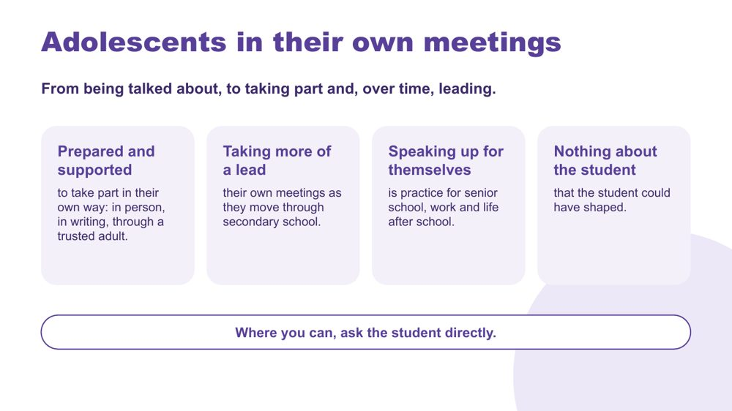 | Adolescents in their own meetings  SUGGESTED TIME  3 min  CLOCK  2:59 - 3:02  PARTICIPANT GUIDE  Page 22 - Session 5 summary (Adolescents in their own meetings)

Show how, in secondary, students can move from being talked about to taking part in, and over time leading, their own meetings.
WHAT TO DO  - Read the line at the top of the slide: from being talked about, to taking part and, over time, leading.  - Walk through the three cards: prepared and supported to take part in their own way (in person, in writing, through a trusted adult); taking more of a lead in their own meetings as they move through secondary school; speaking up for themselves as practice for senior school, work and life after school.  - Give examples of taking part: attending for part of the meeting, a written contribution read aloud, a one-page profile, questions sent in advance, a trusted adult who speaks with them.  - Link to Session 3: students are more likely to speak up for themselves where they feel safe. A student who masks all day may need a safe setting and some preparation first.  - Finish on the line at the bottom of the slide: where you can, ask the student directly. | KEY MESSAGES  - Adolescents can take part in their own meetings when they are prepared and supported, and can take more of a lead as they move through secondary school.  - Taking part can look different for each student: in person, in writing, or through a trusted adult.  - Speaking up for themselves now is practice for senior school, work and life after school, so teaching it is part of transition planning.

YOU MIGHT SAY
Nothing about the student that the student could have shaped.
Where you can, ask the student directly.

KEEP IN MIND
- Being in the room without preparation is not real participation. Do not present attendance at a difficult meeting as the goal on its own.
- Avoid treating a student's choice not to attend, or to contribute in writing, as a lack of self-advocacy.
- Keep an eye on time: Session 6 needs its full time.

Background In secondary, the question moves from whether the student was asked, to how the student can be prepared to be in the room and to lead where they choose to.
Thread Builds on the Adon video (slide 7) and Session 3 on adolescence and masking; carries into the Session 6 conversation plan, where the student themselves is one of the options.

SESSION 5 | Working in Partnership | SLIDE 14 of 18

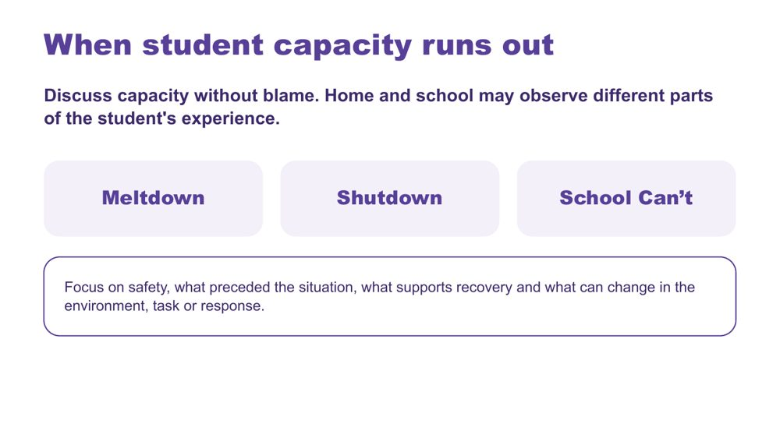 | When student capacity runs out  SUGGESTED TIME  3 min  CLOCK  3:02 - 3:05

Introduce meltdown, shutdown and School Can't within partnership discussion, without blame.
WHAT TO DO  - Introduce the three terms without presenting them as wilful behaviour: a meltdown is an outward response to overwhelm, not a tantrum or a choice; a shutdown is an inward response to overwhelm, quiet and easily missed; School Can't is not truancy or defiance.  - Be explicit about the difference between a meltdown and a tantrum. Mistaking one for the other is common in schools and has real consequences for the student.  - Name the secondary pattern: shutdown in a Year 9 class can look like disengagement or a student who seems 'good and chilled', and School Can't often builds through the secondary years (dreading Sunday nights, partial days).  - Connect back to the morning: capacity gets used up across a day with six teachers. Ask 'what ran out, and when?' rather than 'how do I stop this?'  - Ask what information, listening and environmental change would help the team respond more safely and usefully.  - Point to the focus line: safety, what preceded the situation, what supports recovery and what can change in the environment, task or response. | KEY MESSAGES  - Capacity should be discussed without blame.  - Home and school may observe different parts of the student's experience. Families often see how much the student has left at the end of the day; school sees what used it up. Together they give a fuller picture.  - Use non-blaming language and the workshop safety guidance.

KEEP IN MIND
- Do not frame meltdown, shutdown or School Can't as wilful misbehaviour or a failure of parenting.
- Keep the tone informative and calm: no crisis stories or videos of distress.
- If people ask for behaviour-management techniques, point them back to Session 4: design and prevention.
- Do not offer clinical, diagnostic, legal or crisis guidance beyond the material.

Background This content is placed late in the day, within partnership, on purpose, so the day does not start from distress. When home and school share what they see, they are more likely to notice early that a student is running low on capacity.
Thread Builds on capacity and accumulated demands from Sessions 2 and 3.

SESSION 5 | Working in Partnership | SLIDE 15 of 18

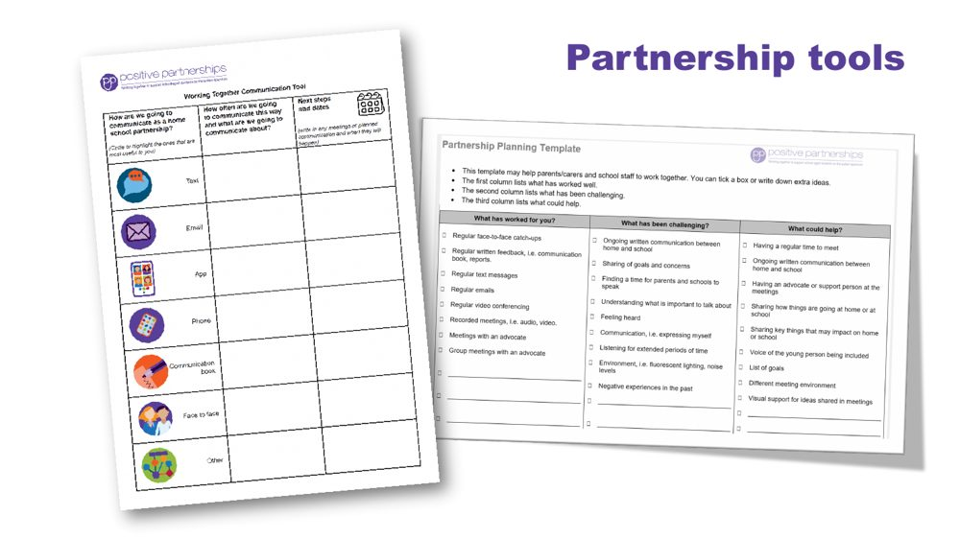 | Partnership tools  SUGGESTED TIME  2 min  CLOCK  3:05 - 3:07

Demonstrate the Partnership tools and explain how they are used.
WHAT TO DO  - Show the Partnership tools and explain how each is used.  - Frame the tools as supports for consultation, not replacements for listening. | KEY MESSAGES  - Tools should support consultation rather than replace listening and student voice.

SESSION 5 | Working in Partnership | SLIDE 16 of 18

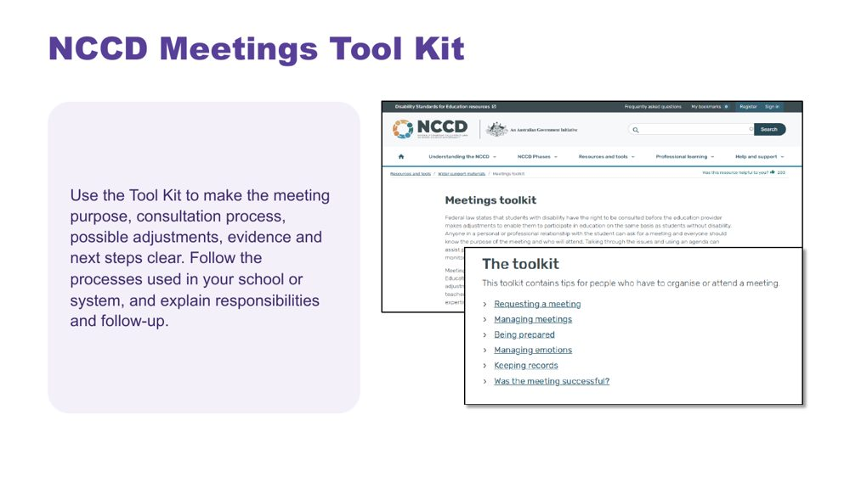 | NCCD Meetings Tool Kit  SUGGESTED TIME  2 min  CLOCK  3:07 - 3:09

Introduce the NCCD Meetings Tool Kit and direct participants to official NCCD information.
WHAT TO DO  - Explain how the Tool Kit makes the meeting purpose, consultation process, possible adjustments, evidence and next steps clear.  - Remind participants to follow the processes used in their school or system.  - Emphasise explaining responsibilities and follow-up to families.  - Note that consulted views, recorded and acted on, are part of the evidence for levels of adjustment.  - Direct participants to official NCCD information. | KEY MESSAGES  - NCCD information must be current and official.

SESSION 5 | Working in Partnership | SLIDE 17 of 18

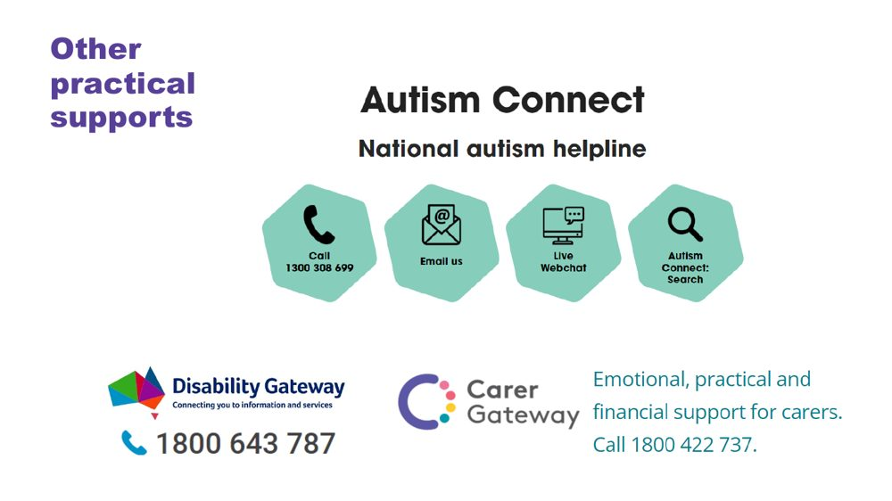 | Other practical supports  SUGGESTED TIME  1 min  CLOCK  3:09 - 3:10

Introduce the support pathways included in the workshop.
WHAT TO DO  - Briefly introduce the Positive Partnerships support options and other supports on the slide.  - Point participants to Participant Guide p. 30 for resources. | KEY MESSAGES  - Introduce the Positive Partnerships support options included with the workshop.

KEEP IN MIND
- Check phone numbers and services are current before delivery.

SESSION 5 | Working in Partnership | SLIDE 18 of 18

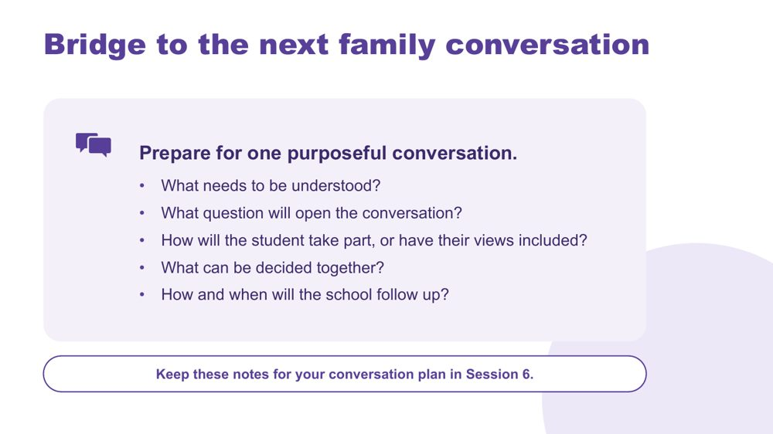 | Bridge to the next family conversation  SUGGESTED TIME  5 min  CLOCK  3:10 - 3:15  GROUPING  On your own  PARTICIPANT GUIDE  Page 25 - Bridge to the next family conversation

Identify the question and shared purpose participants will take into the Session 6 conversation plan.
WHAT TO DO  - Ask participants to return to the students they have in mind and their Session 4 design change (a lesson, an assessment task or a handover).  - Invite them to work through the prompts on the slide privately. The opening question from the first two minutes (slide 9) can go straight in.  - Keep the focus on preparation rather than scripting what the family or student should say.  - Ask participants to carry one process change from the power reflection into the plan.  - Ask how the student will take part in the conversation, or have their views included.  - Preview the closing session on belonging, capacity, joy and practical next steps. | KEY MESSAGES  - Prepare for one purposeful conversation.

YOU MIGHT SAY
Keep these notes for your conversation plan in Session 6.

ACTIVITY | Private bridge reflection on your own · 4 minutes, plus 1 minute to preview Session 6
Prepare for one purposeful conversation.
- What needs to be understood?
- What question will open the conversation?
- How will the student take part, or have their views included?
- What can be decided together?
- How and when will the school follow up?
Close: Keep these notes available for the conversation plan in Session 6.

Thread Connects to the Session 4 'My students' card ("Who I will involve") and the conversation plan in Session 6 (Participant Guide p. 28).

SESSION  6 | 3:15 - 4:00 · 45 MINUTES · 11 SLIDES  Flourishing & Full Circle  One change, one purposeful conversation

SESSION INTENT
Bring the day full circle through belonging, capacity and joy, then leave each participant with one change to a lesson, assessment task or handover and one purposeful conversation with a family, a student, or a colleague who teaches them. Keep the close grounded: no new content, protected time for planning, resources and feedback.
PARTICIPANTS LEAVE WITH
- connect the day's lens, learning design and partnership through belonging, capacity and joy
- name one strategy to start, one to continue and one to reconsider, each with a way to know it worked
- plan a real conversation with a student's family, the student, or a colleague who teaches them (a handover conversation), to happen within two weeks
- know where continuing learning and community sit beyond the day

RUN SHEET
Clock | Segment | Slides | Minutes
3:15 - 3:19 | Opening and flourishing frame | 1-2 | 4
3:19 - 3:27 | Bringing it all together | 3 | 8
3:27 - 3:43 | Action card and conversation plan | 4-5 | 16
3:43 - 3:51 | Student voice and final reflection | 6-7 | 8
3:51 - 3:55 | Connections and resources | 8-9 | 4
3:55 - 4:00 | Feedback and farewell | 10-11 | 5

PREPARE
☐ Participant Guide p. 27 (Start · Continue · Reconsider action card) and p. 28 (Plan the next conversation)
☐ Participant Guides open to pp. 26 - 30; participants' Session 4 Commit notes (p. 21, 'This week, in my own classes') and Session 5 bridge notes
☐ Session 4 gallery wall still up, if possible
☐ Video queued and tested (Caitlin, or the fallback clip)
☐ Feedback link and QR code confirmed; accessible alternative ready

SESSION 6 | Flourishing & Full Circle | SLIDE 1 of 11

 | Flourishing & Full Circle  SUGGESTED TIME  1 min  CLOCK  3:15 - 3:16

Bring the day together and prepare for practical action.
WHAT TO DO  - Name the final session as a return to the students and questions participants began with this morning.  - Explain that participants will consolidate one design change and one conversation with a family, a student or a colleague who teaches them.  - Protect enough time for individual planning, resources and feedback.  - Keep the closing grounded rather than adding new content.  - Slow the pace a little. There is no new content in this session: it is about pulling the day together and planning next steps. | KEY MESSAGES  - The day closes by connecting understanding with action.  - One thoughtful next step is more useful than an unmanageable list.

KEEP IN MIND
- Do not let earlier sessions run into this one. Participants need this time to plan what they will do.

SESSION 6 | Flourishing & Full Circle | SLIDE 2 of 11

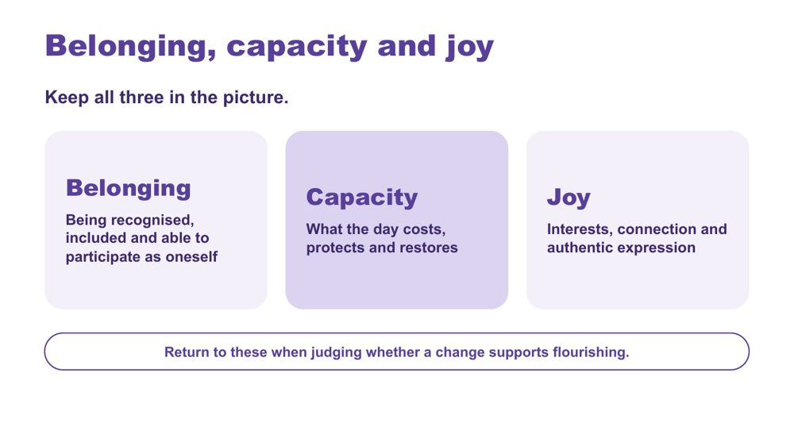 | Belonging, capacity and joy  SUGGESTED TIME  3 min  CLOCK  3:16 - 3:19

Bring together the workshop lens, learning design and partnership through belonging, capacity and joy.
WHAT TO DO  - Present belonging, capacity and joy as one connected picture, not three separate checks.  - Optionally link the day's three practical strands: a neurodiversity-affirming lens that begins with the person; learning design across the secondary day shaped by student experience; positive partnership that brings student, family and school knowledge together.  - Connect the lens, learning design across the secondary day and positive partnership without repeating the full day.  - Invite participants to notice whether their design change supports belonging or joy as well as reducing a barrier.  - Point to the last line on the slide: return to these three when judging whether a change supports flourishing. | KEY MESSAGES  - Belonging, capacity and joy belong alongside access and participation.  - Learning design and partnership should stay connected to each student's whole experience, across every period and every teacher.

YOU MIGHT SAY
Belonging, capacity and joy run through all three.

KEEP IN MIND
- Avoid presenting grades, attendance, quiet compliance or conventional independence as the only evidence of flourishing. A student who seems 'good and chilled' may be masking.

Thread Capacity picks up Session 3's 'What costs? What lightens?' thinking; the whole frame is the test for the Session 4 design change and the Session 5 partnership planning.

SESSION 6 | Flourishing & Full Circle | SLIDE 3 of 11

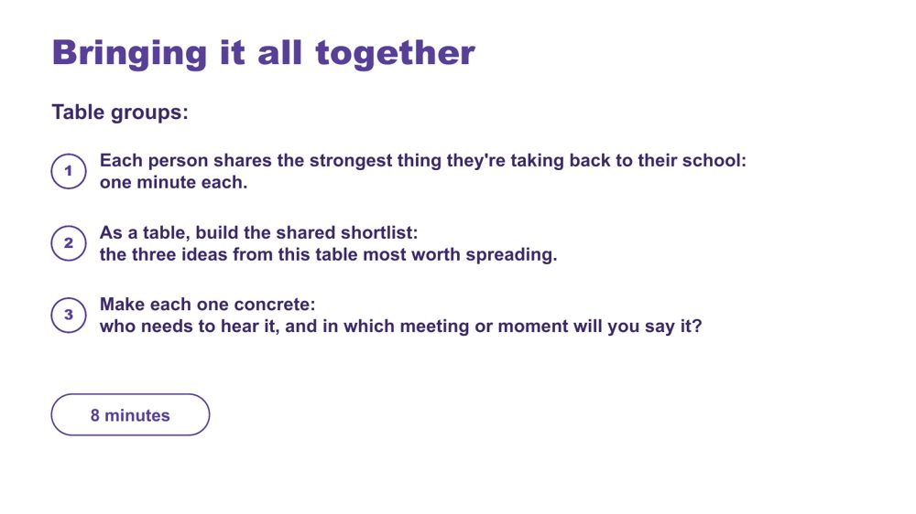 | Bringing it all together  SUGGESTED TIME  8 min  CLOCK  3:19 - 3:27  GROUPING  Table groups  PARTICIPANT GUIDE  Page 26 - Bringing it all together

Surface the strongest ideas at each table and make the most useful ones concrete enough to spread back at school.
WHAT TO DO
- Move participants into table groups.
- Keep time: one minute per person, then the shortlist. The one-minute round means everyone gets a turn.
- Remind tables they can draw on what they saw on the gallery wall in Session 4.
- Push each table to name a real person and a real meeting or moment for each shortlisted idea: the actual faculty meeting, year level meeting or staff briefing, the actual colleague.
- If a table has leaders and teachers together, a leader who hears a teacher's idea may be able to help make it happen.

ACTIVITY | Table sharing and shortlist table groups · 8 minutes
What is the strongest thing you're taking back to your school?
- Each person shares the strongest thing they're taking back to their school: one minute each.
- As a table, build the shared shortlist: the three ideas from this table most worth spreading.
- Make each one concrete: who needs to hear it, and in which meeting or moment will you say it?

Thread The shortlist builds on the Session 4 gallery walk.

SESSION 6 | Flourishing & Full Circle | SLIDE 4 of 11

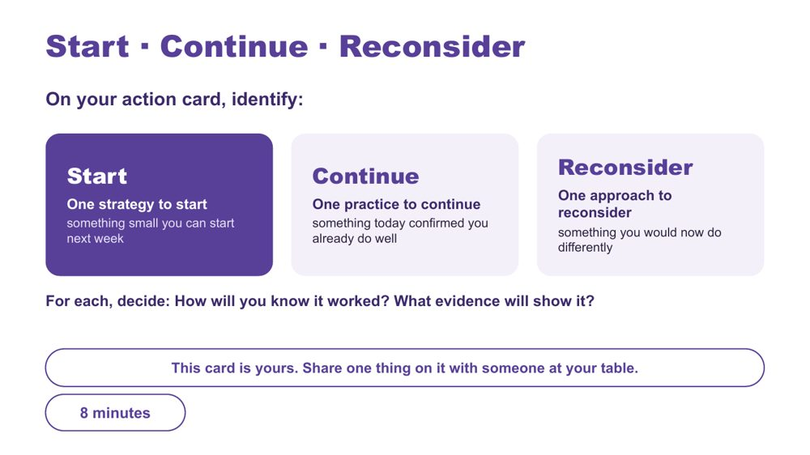 | Start · Continue · Reconsider  SUGGESTED TIME  8 min  CLOCK  3:27 - 3:35  GROUPING  On your own  PARTICIPANT GUIDE  Page 27 - Start · Continue · Reconsider

Turn the day into one specific, environment-first action for a lesson, assessment task or handover, alongside a practice to keep and one to rethink.
WHAT TO DO  - Ask participants to have their Session 4 Commit notes (p. 21) in front of them, especially the 'This week, in my own classes' box.  - Ask what matters most now, rather than for a summary of every topic.  - Point to the note at the bottom of p. 27: their Session 4 "this week" change can be their Start. They add how they will know it worked.  - Offer the stems for an environment-first Start: I will... / The barrier or demand I am addressing is... / I will notice... / I need to consult... / I will review this on...  - Check that each Start sits within the participant's influence and does not require a student to appear less Autistic.  - Encourage participants to include when they will consult the student, family or team.  - Close by asking each person to tell one person at their table what's on the card. | KEY MESSAGES  - Use access, participation or experience as the measure, not outward compliance.  - Choose one insight, question or design opportunity specific enough to guide practice and small enough to begin.

ACTIVITY | Individual action planning on your own · 8 minutes
What matters most now, and what is one change you will take forward?
- On the action card, identify one strategy to start: something small you can start next week. Your Session 4 "this week" change can be your Start.
- Identify one practice to continue: something today confirmed you already do well.
- Identify one approach to reconsider: something you would now do differently.
- For each, decide: How will you know it worked? What evidence will show it?
- If time allows, note beside your Start the barrier or demand it addresses, who to consult and when to review it.
- Tell one person at your table what's on the card.
Close: Ask participants to keep the action small, testable and open to revision.

KEEP IN MIND
- Do not let 'what they will notice' become outward compliance.
- The card is theirs: sharing is with one person only, and optional beyond that.
- Keep 'reconsider' free of blame: it is about what they would change in light of what they know now.

Thread Picks up the Session 4 Commit activity (p. 21 - 'This week, in my own classes').

SESSION 6 | Flourishing & Full Circle | SLIDE 5 of 11

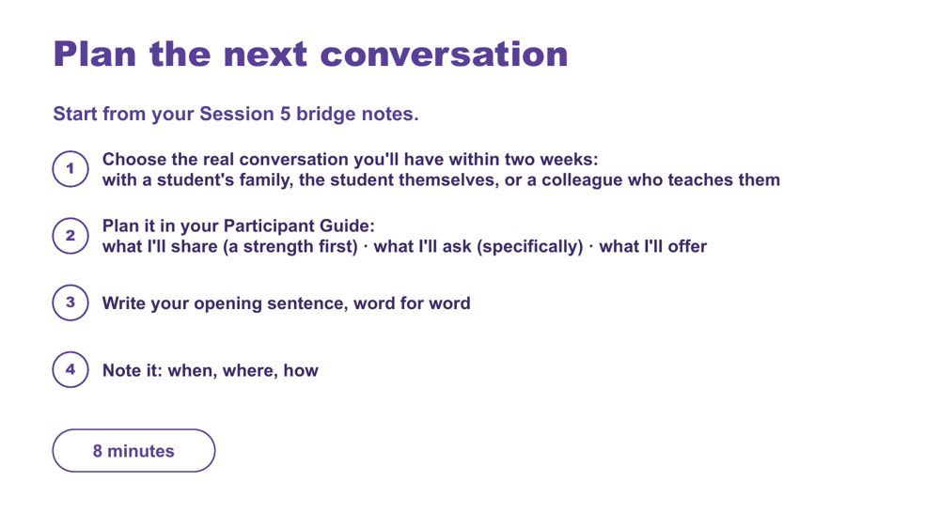 | Plan the next conversation  SUGGESTED TIME  8 min  CLOCK  3:35 - 3:43  GROUPING  On your own  PARTICIPANT GUIDE  Page 28 - Plan the next conversation

Prepare one purposeful, power-aware conversation within two weeks: with a student's family, the student themselves, or a colleague who teaches them.
WHAT TO DO
- Ask participants to open their Session 5 bridge notes.
- Name the three options: a student's family, the student themselves, or a handover conversation with a colleague who teaches them. The colleague option is a real choice in secondary: keeping things consistent across six or more teachers is part of partnership too.
- Encourage people towards the family or student option where they can. A conversation with a colleague is often the easier choice.
- Ask them to define the purpose before writing questions or next steps.
- Point back to the bridge prompts on p. 25: what needs to be understood, how student voice will be included, what can be decided together and how the school will follow up.
- For a handover conversation, use the Session 3 question: what should travel between people and places? Plan how the student's own voice travels too.
- The strength-first rule and the word-for-word opener apply whoever the conversation is with.
- Ask participants to apply the process change they identified during the power-dynamics reflection.
- Keep all notes anonymised (initials or roles only) and sharing voluntary.
- If time allows, add: write the purpose in one sentence (what you need to understand, rather than what you need the other person to accept); plan how the student's communication and preferences will be included; write two open questions and what you will listen for; name one possible shared next step, leaving room for the conversation to change it, and how you will follow up. The Session 5 bridge notes on p. 25 already hold most of this, and the opening question from the first two minutes (p. 24) can become the opening sentence.

ACTIVITY | Individual conversation planning on your own · 8 minutes
Plan one real conversation you will have within two weeks.
- Choose the real conversation you'll have within two weeks: with a student's family, the student themselves, or a colleague who teaches them (a handover conversation).
- Plan it in your Participant Guide: what I'll share (a strength first), what I'll ask (specifically), what I'll offer.
- Write your opening sentence, word for word.
- Note it: when, where, how.
Close: Invite participants to check that the plan is clear, respectful and genuinely open to family and student knowledge, including in a handover.

KEEP IN MIND
- Avoid scripting the family's or student's response.
- Avoid treating the meeting as a way to secure agreement with a finished school plan.
- A handover conversation should not become a conversation about the student without the student's voice in it.

Thread Starts from the Session 5 bridge notes (p. 25 - Bridge to the next family conversation), the power-dynamics reflection (p. 23) and, for a handover, Session 3 (p. 11 - What should travel between people and places?).

SESSION 6 | Flourishing & Full Circle | SLIDE 6 of 11

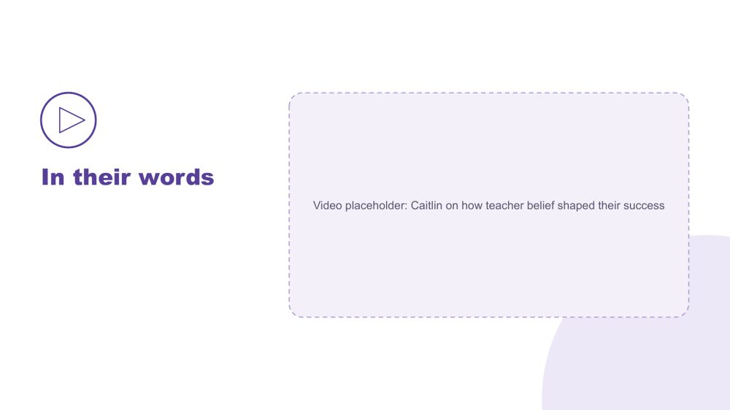 | In their words  SUGGESTED TIME  4 min  CLOCK  3:43 - 3:47

Hear, in a student's own words, how teacher belief shaped their success.
WHAT TO DO
- Play the video.
- Move straight to the final reflection without discussion, so people have a moment with what they heard.

SESSION 6 | Flourishing & Full Circle | SLIDE 7 of 11

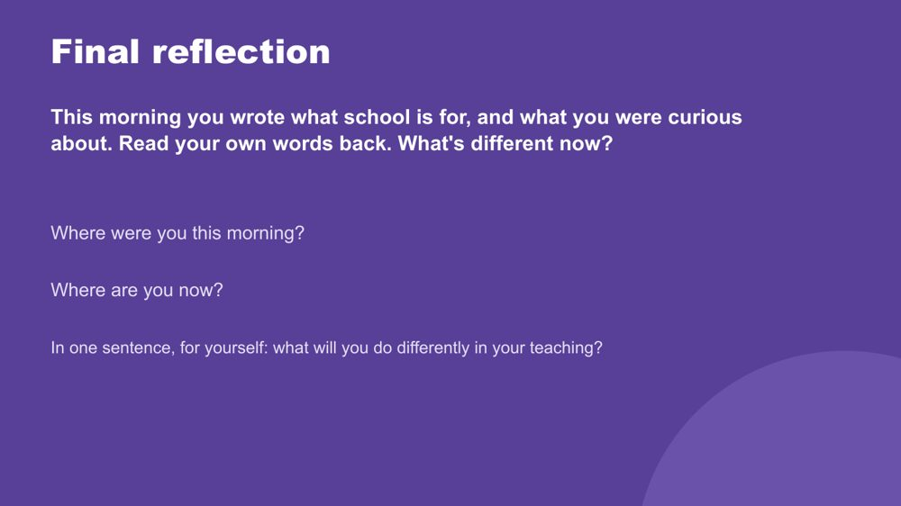 | Final reflection  SUGGESTED TIME  4 min  CLOCK  3:47 - 3:51  PARTICIPANT GUIDE  Page 29 - Final reflection

Return participants to where they started this morning and name, privately, what has shifted.
WHAT TO DO
- Ask participants to find what they wrote this morning (p. 5 - My starting point) and read their own words back.
- Ask: What's different now?
- Give quiet time for the two prompts: Where were you this morning? Where are you now?
- Some people may feel they have gone backwards because they now see how much they didn't know. Let them know kindly that this is a normal part of learning, and a sign of progress.
- Ask each person to answer the last question in one sentence, to themselves.
- Keep it private; no sharing is needed. Give people quiet time to think.

YOU MIGHT SAY
In one sentence, for yourself: what will you do differently in your teaching?

Thread Returns to Session 1 (p. 5 - My starting point).

SESSION 6 | Flourishing & Full Circle | SLIDE 8 of 11

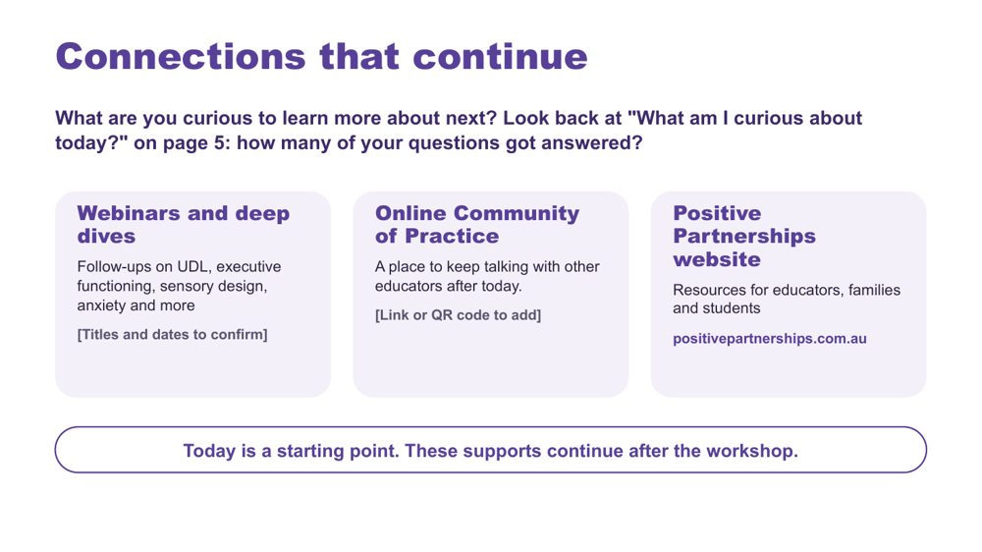 | Connections that continue  SUGGESTED TIME  3 min  CLOCK  3:51 - 3:54  PARTICIPANT GUIDE  Page 30 - Connections that continue

Introduce continuing professional learning and community pathways.
WHAT TO DO  - Ask: What are you curious to learn more about next?  - Point participants back to "What am I curious about today?" (Participant Guide p. 5, My starting point): how many of their morning questions got answered?  - Explain how to access each pathway: webinars and deep dives, the Online Community of Practice and the Positive Partnerships website.  - Mention that today's wall photos will be posted in the Community of Practice this week.  - Keep this brief and practical. | KEY MESSAGES  - The workshop is one point in continuing professional learning, reflection and partnership.  - Choose the pathway that fits your next question.

YOU MIGHT SAY
Today is a starting point. These supports continue after the workshop..

RESOURCES
- Positive Partnerships website - positivepartnerships.com.au

SESSION 6 | Flourishing & Full Circle | SLIDE 9 of 11

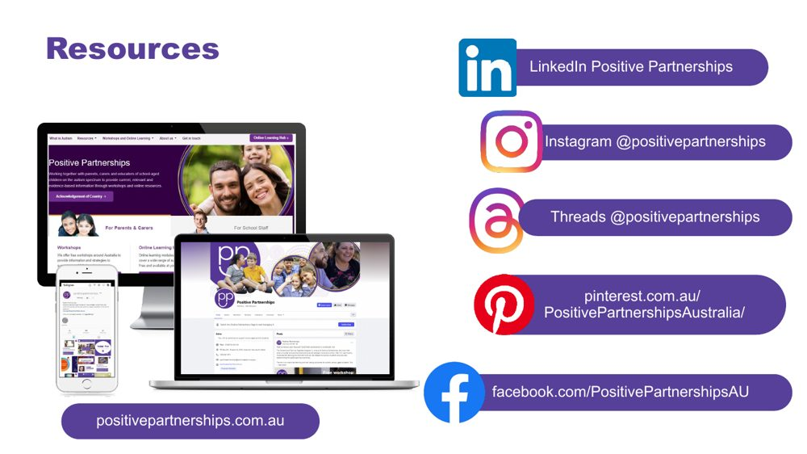 | Resources  SUGGESTED TIME  1 min  CLOCK  3:54 - 3:55

Show where to follow Positive Partnerships online.
WHAT TO DO
- Leave the slide up briefly so participants can note or photograph the handles.

RESOURCES
- Positive Partnerships website - positivepartnerships.com.au
- Facebook - facebook.com/PositivePartnershipsAU
- Instagram - @positivepartnerships
- Threads - @positivepartnerships
- LinkedIn - Positive Partnerships
- Pinterest - pinterest.com.au/PositivePartnershipsAustralia/

SESSION 6 | Flourishing & Full Circle | SLIDE 10 of 11

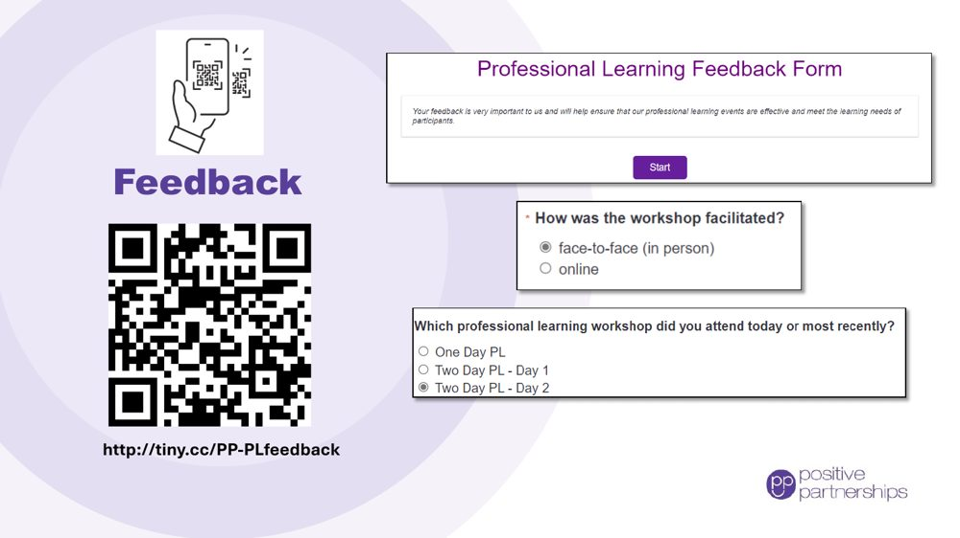 | Feedback  SUGGESTED TIME  4 min  CLOCK  3:55 - 3:59

Collect participant feedback.
WHAT TO DO
- Explain why feedback is being collected and how it is used.
- Show how to access the form (link and QR code).
- Allow protected time for completion in the room.
- Provide an accessible alternative if the process includes one.

RESOURCES
- Feedback form - http://tiny.cc/PP-PLfeedback

SESSION 6 | Flourishing & Full Circle | SLIDE 11 of 11

 | Good luck on your journey  SUGGESTED TIME  1 min  CLOCK  3:59 - 4:00

Close warmly and return participants to student-centred curiosity.
WHAT TO DO  - Thank participants for their attention, questions and professional reflection.  - Invite them to stay curious and students at the centre.  - Remind participants to take their action card and conversation plan.  - State the relevant follow-up and contact arrangements. | KEY MESSAGES  - Stay curious.  - Keep students at the centre.  - Small, informed changes can be reviewed and refined in partnership.

